Unit 5 Lesson 14: Working with Pyramids

1 Volume Matching (Warm up)

Student Task Statement
Here is a pyramid.
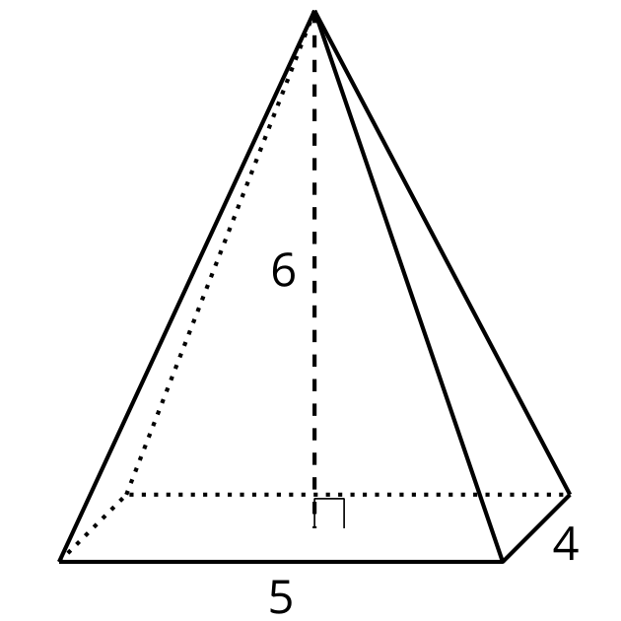
Which, if either, of these solids has the same volume as the pyramid?

A
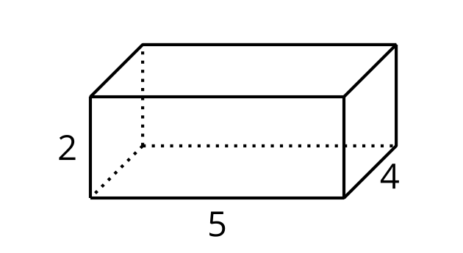

B
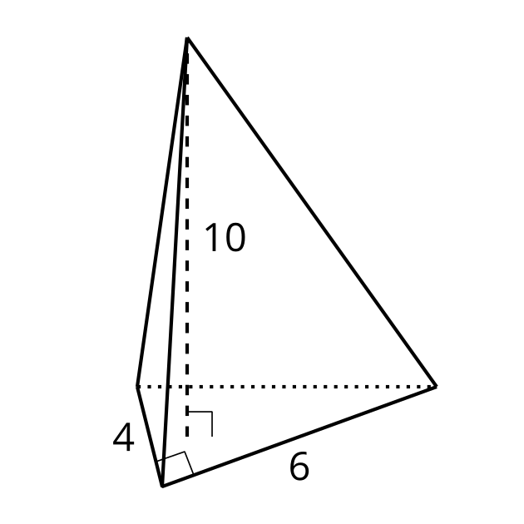

2 Practice with Pyramids

Student Task Statement
- Calculate the volume of each solid. Round your answers to the nearest tenth if necessary.

- A
- 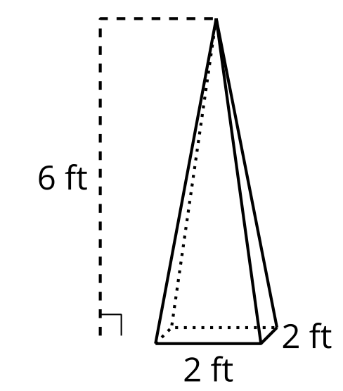

- B
- 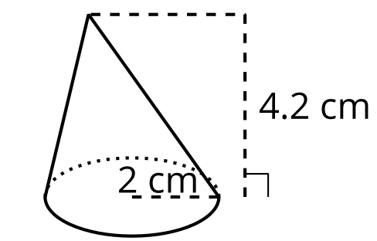

- C
- 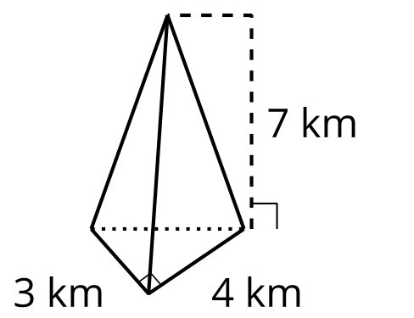

- D: height 12 cm; area of base 32 cm²
- 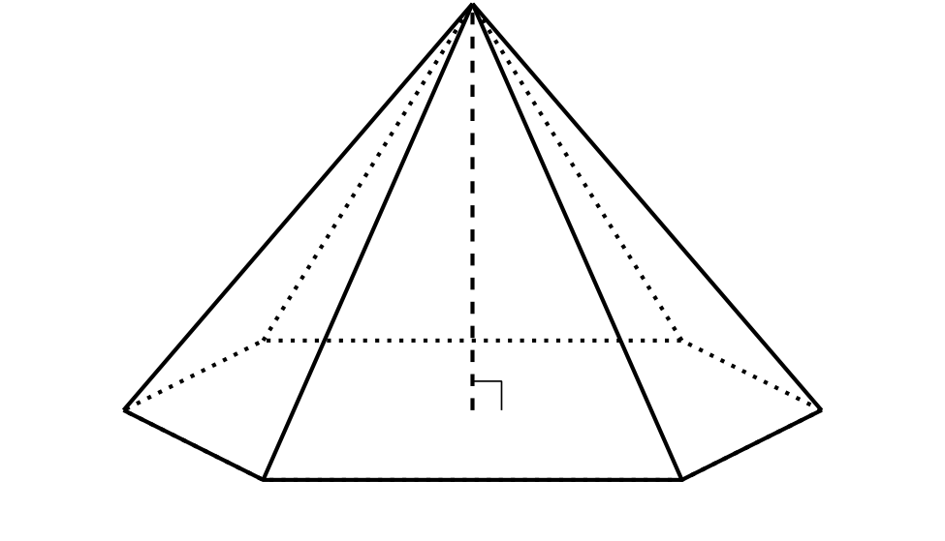
- A particular cone has radius $r$ and height $h$.
  - Write an expression for the volume of this cone in terms of $r$ and $h$.
  - What is the height of a cone whose volume is $16π$ cubic units and whose radius is 3 units?
  - What is the radius of a cone whose volume is $16π$ cubic units and whose height is 3 units?

3 An Icy Pyramid

Student Task Statement
A caterer is making an ice sculpture in the shape of a pyramid for a party. The caterer wants to use 12 liters of water, which is about 720 cubic inches. The sculpture must be 15 inches tall. The caterer needs to decide how large to make the base, which can be any shape. Draw and label the dimensions of 2 different bases that would work.
© CC BY 2019 by Illustrative Mathematics®

