Unit 2 Lesson 13: Area and Properties of Operations

WU Number Talk: Parentheses (Warm up)

Student Task Statement
Find the value of each expression mentally.
- $5×\left(7+4\right)$
- $\left(5×7\right)+\left(5×4\right)$
- $\left(5×7\right)+\left(5×\frac{1}{4}\right)$
- $\left(5×7\right)−\left(5×\frac{1}{4}\right)$

1 Card Sort: Diagrams and Expressions

Student Task Statement
Your teacher will give you and your partner a set of cards.
- Sort the cards in a way that makes sense to you.
- Match each expression to an appropriate diagram. Some diagrams match more than one expression.
- Work with your partner to find the area of each shaded region. Explain or show your reasoning.

2 Write Expressions

Student Task Statement
Write as many expressions as you can to match the area of the shaded region in each diagram.

- 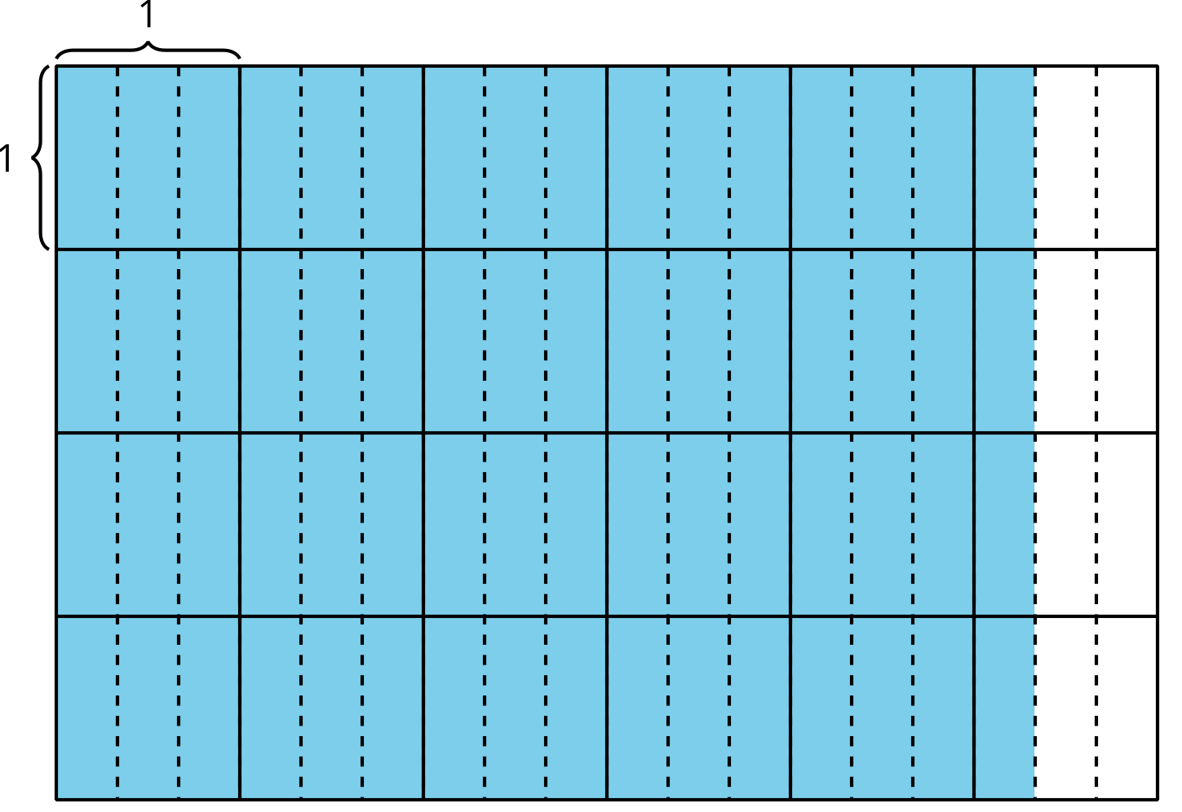

- 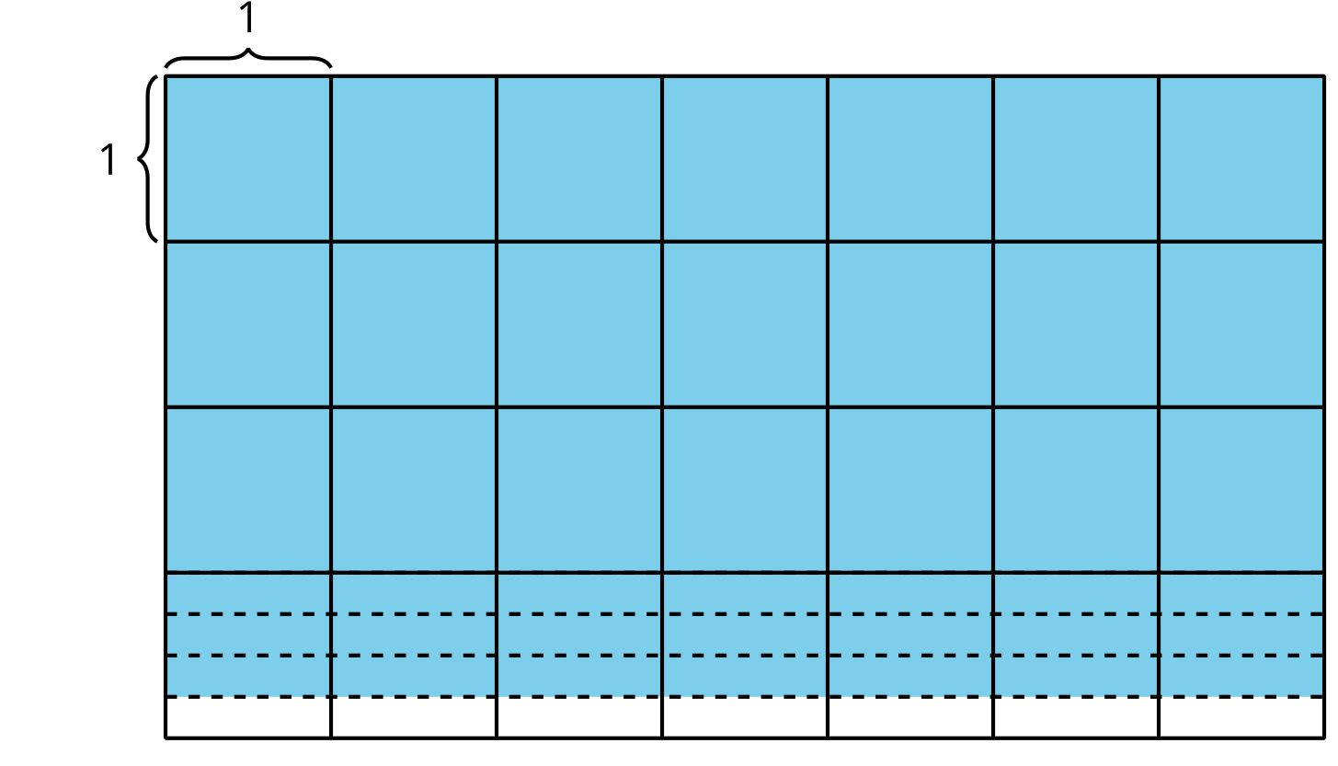
© CC BY 2021 Illustrative Mathematics®

