Unit 7 Lesson 7: Put Together Flat Shapes

WU Notice and Wonder: Dogs (Warm up)

Student Task Statement
What do you notice?
What do you wonder?
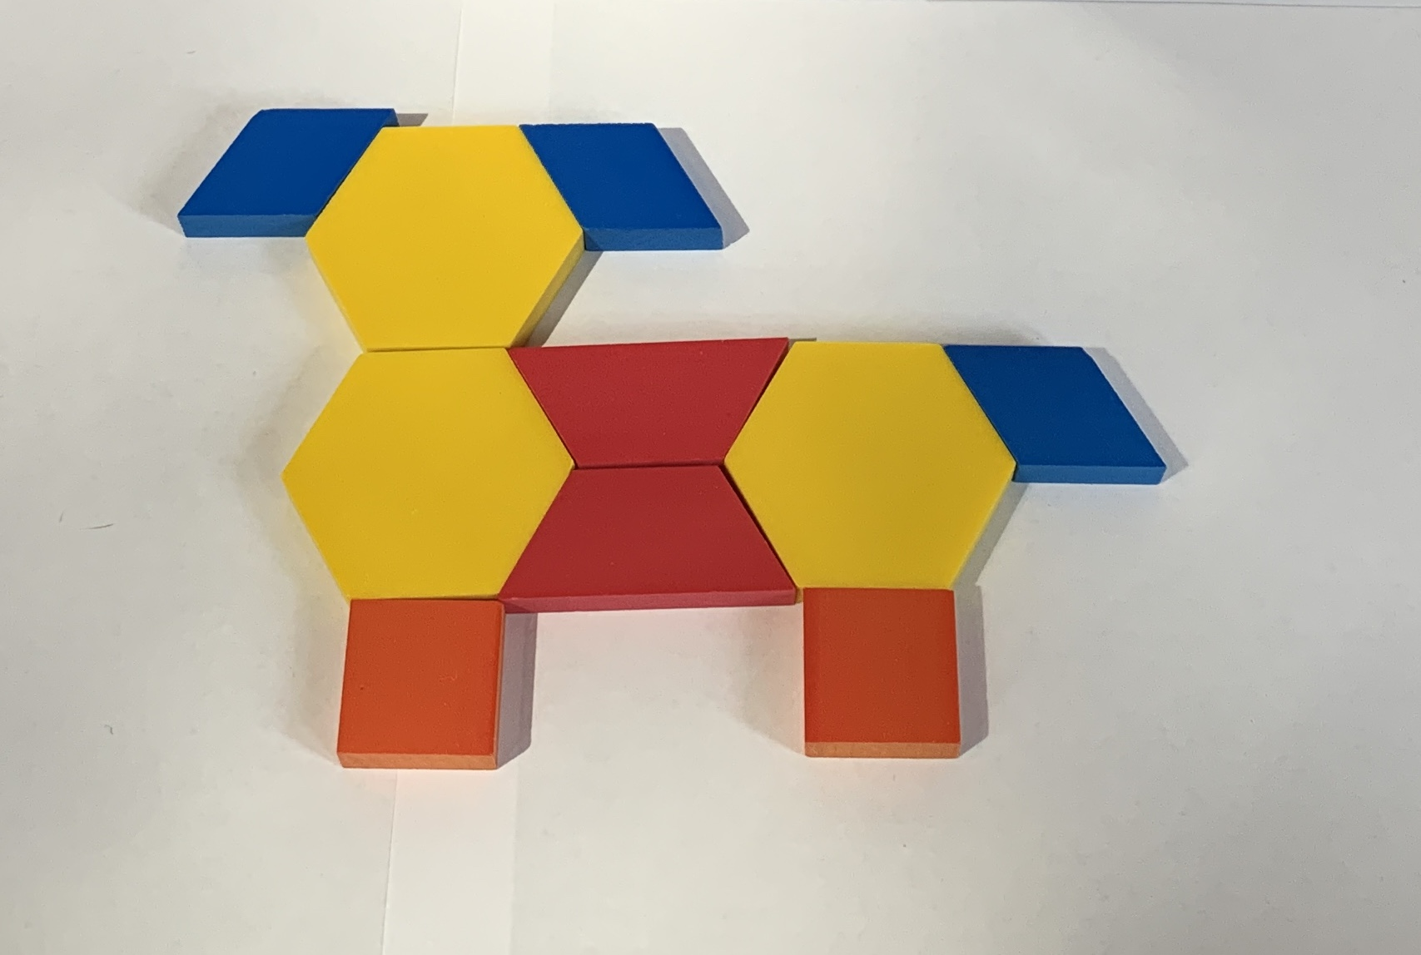
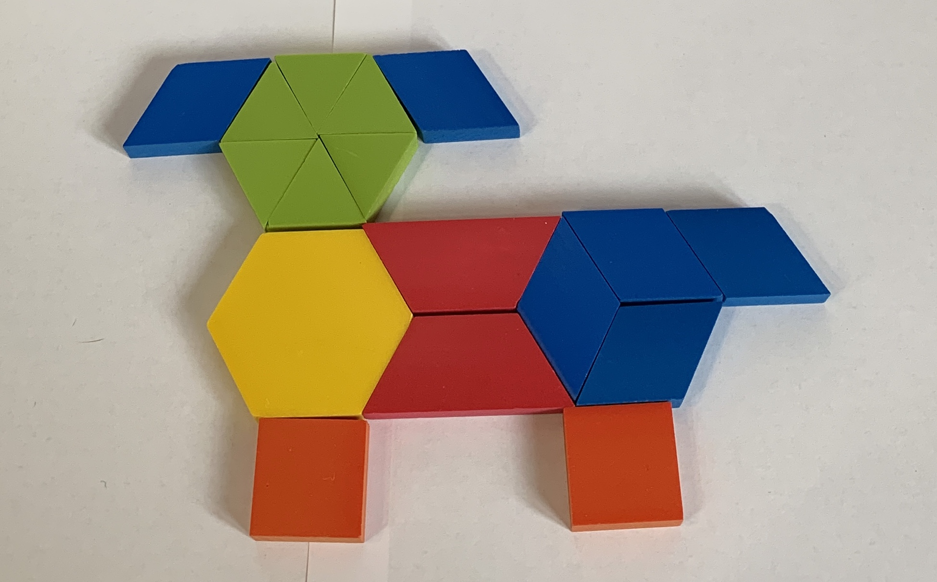

1 Build with Pattern Blocks

Student Task Statement

2 Shape Pictures

Student Task Statement
- Build something using the pattern blocks.
- Trace what you made and record how many pattern blocks you used.
- 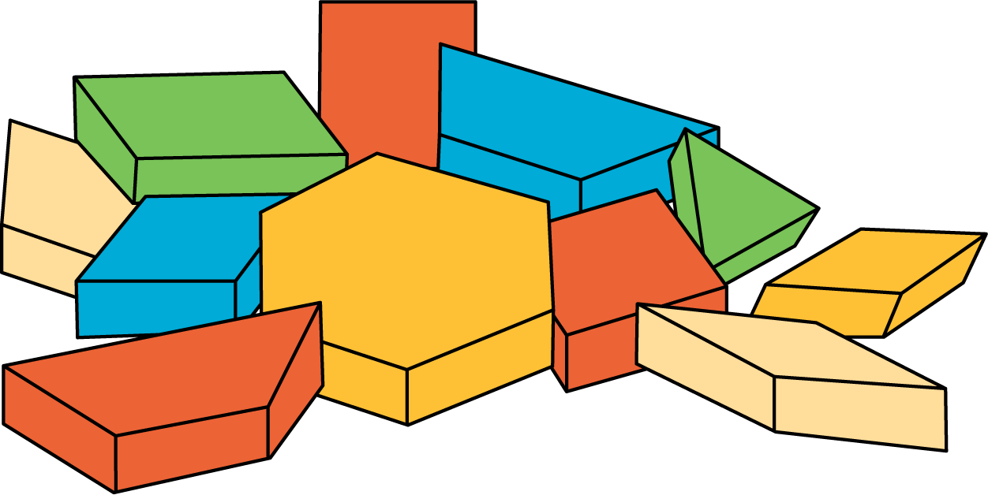
- Make the same object you just made, using different pattern blocks.
- Record how many pattern blocks you used.
If you have time: Build the same object again, using the most pattern blocks you can.
Record how many pattern blocks you used.

3 Introduce Picture Books, Find Shapes

Student Task Statement
© CC BY 2021 Illustrative Mathematics®

