Lesson 5: Simetría de figuras (parte 2)

Standards Alignments
Addressing | 4.G.A.1, 4.G.A.3, 4.NBT.B.5

Teacher-facing Learning Goals
- Identify figures with line symmetry and draw lines of symmetry on two-dimensional figures.

Student-facing Learning Goals
- Dibujemos algunas figuras que tienen líneas de simetría.

Lesson Purpose
The purpose of this lesson is for students to identify figures with line symmetry and to complete line-symmetric figures.
Previously, students learned to identify figures with line symmetry and drew lines of symmetry. In this lesson, students deepen their understanding of symmetry by reasoning about what the whole figure would look like when given half of a figure and a line of symmetry.
The work of this lesson helps students develop mental images of figures with lines of symmetry. Students also consider how to use what they know about drawing line segments, points, and angles to complete their drawings. They make strategic decisions about how to use available tools to complete the shapes or justify how they know their figures are symmetrical (MP5). Students may copy the figure to another piece of paper, and follow with folding, cutting, or tracing. They may also use rulers or protractors to measure distances and angles.

Access for:

Students with Disabilities
- Representation (Activity 1)

English Learners
- MLR8 (Activity 2)

Instructional Routines
Number Talk (Warm-up)

Materials to Gather
- Paper: Activity 2
- Patty paper: Activity 1, Activity 2, Activity 3
- Protractors: Activity 2, Activity 3
- Rulers or straightedges: Activity 1, Activity 2, Activity 3
- Scissors: Activity 2, Activity 3

Materials to Copy
- Two Symmetrical Figures (groups of 2): Activity 3

Required Preparation

Lesson Timeline
Warm-up | 10 min
Activity 1 | 15 min
Activity 2 | 20 min
Activity 3 | 10 min
Lesson Synthesis | 10 min
Cool-down | 5 min

Teacher Reflection Question
What connections did students make between the different strategies shared? What questions did you ask to help make the connections more visible?

Cool-down
(to be completed at the end of the lesson) 5min
Completémoslas

Standards Alignments
Addressing | 4.G.A.3

Student-facing Task Statement
La figura sombreada es la mitad de una figura completa que tiene como línea de simetría a la línea punteada.
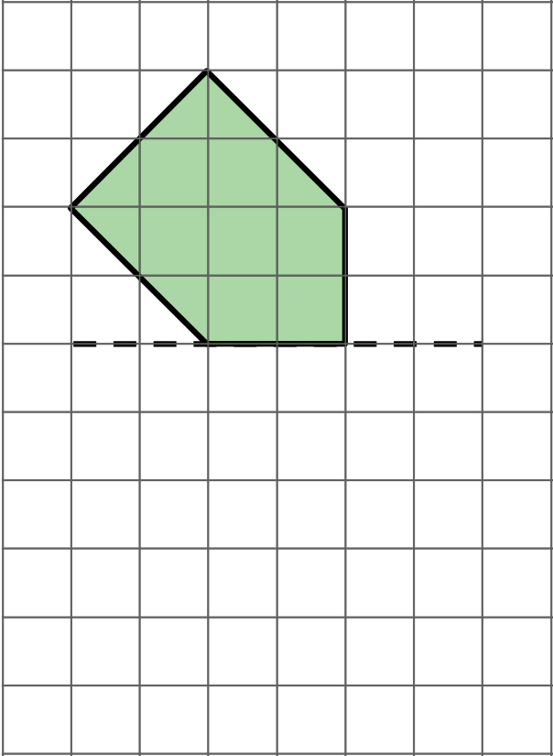
Este es el dibujo de Kiran para mostrar la figura completa.
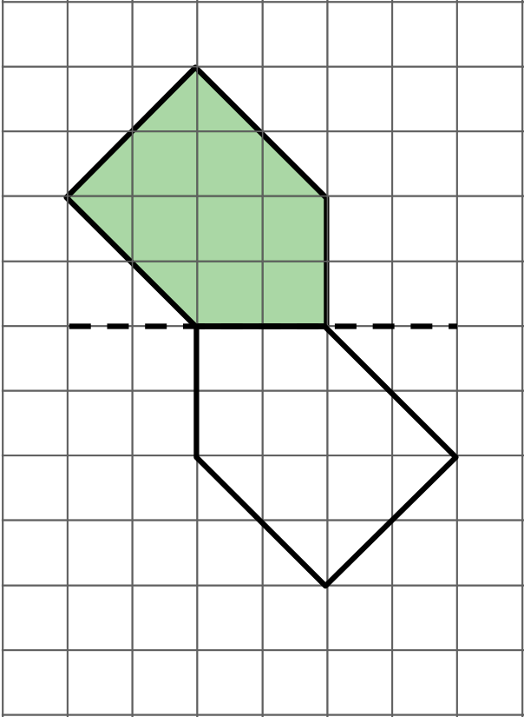
¿Estás de acuerdo con que el dibujo de Kiran muestra la figura completa correcta? Explica o muestra cómo razonaste. Si no estás de acuerdo, podrías mostrar un dibujo de la figura completa.

Student Responses
Disagree. Sample response: If Kiran's drawing is folded along the dashed line, the two halves don't match up exactly. The correct whole figure should look like this:
