Lesson 2: More or Fewer Pattern Blocks

Standards Alignments
Addressing | K.CC.A.1, K.CC.C, K.CC.C.6, K.CC.C.7, K.G.B.6

Teacher-facing Learning Goals
- Compare the number of objects in groups of up to 10 shapes.

Student-facing Learning Goals
- Let’s figure out if there are more triangle pattern blocks or trapezoid pattern blocks.

Lesson Purpose
The purpose of this lesson is for students to compare groups of up to 10 objects in the context of putting together pattern blocks.
In previous lessons, students put together and counted pattern blocks to fill in puzzles. Students have noticed that different combinations of pattern blocks can be used to create the same shape. Students use methods developed in previous units to compare the number of pattern blocks.

Access for:

Students with Disabilities
- Representation (Activity 2)

English Learners
- MLR8 (Activity 1)

Instructional Routines
Choral Count (Warm-up)

Materials to Gather
- Materials from previous centers: Activity 3
- Pattern blocks: Activity 1, Activity 2, Activity 3

Materials to Copy
- Quack Quack (groups of 1): Activity 1
- Make a Y (groups of 1): Activity 2
- Pattern Blocks Stage 6 Mat (groups of 2): Activity 3

Lesson Timeline
Warm-up | 10 min
Activity 1 | 10 min
Activity 2 | 15 min
Activity 3 | 15 min
Lesson Synthesis | 5 min
Cool-down | 5 min

Teacher Reflection Question
When do your students feel successful in math? How do you know?

Cool-down
(to be completed at the end of the lesson) 5min
Penguin Compare

Standards Alignments
Addressing | K.CC.C

Student-facing Task Statement
Circle the shape that is filled with more pattern blocks.
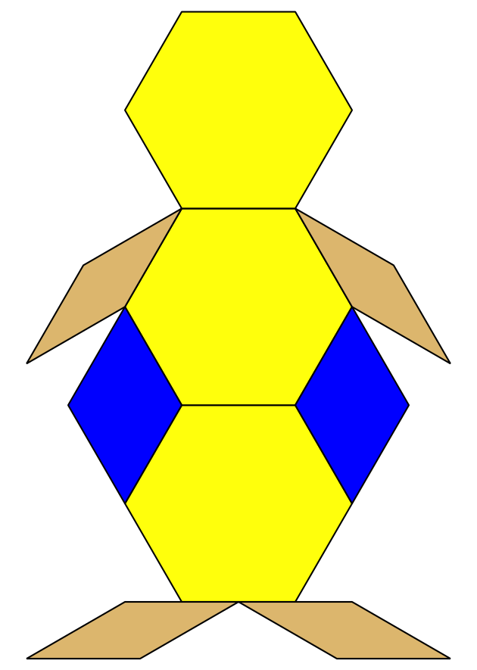
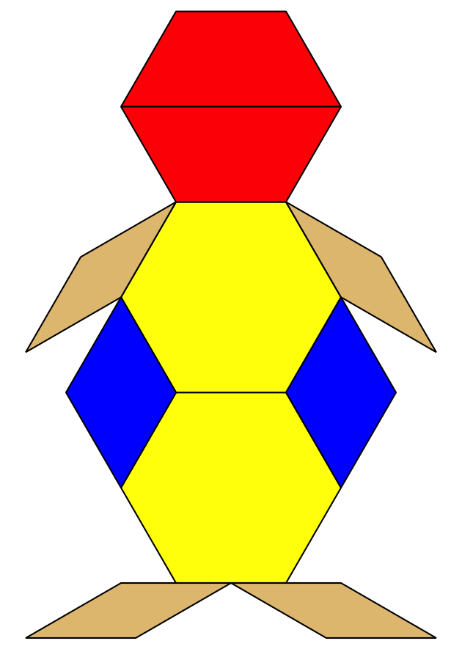

Student Responses
Students circle the penguin on the right.

