Lesson 10 Practice Problems
- To write $11x^{2}+17x−10$ in factored form, Diego first listed pairs of factors of -10.
- $(\underset{_}{​}+5)(\underset{_}{​}+\text{-}2)$
- $(\underset{_}{​}+2)(_{\underset{_}{​}}+\text{-}5)$
- $(\underset{_}{​}+10)(\underset{_}{​}+\text{-}1)$
- $(\underset{_}{​}+1)(\underset{_}{​}+\text{-}10)$
  - Use what Diego started to complete the rewriting.
  - How did you know you’ve found the right pair of expressions? What did you look for when trying out different possibilities?
- To rewrite $4x^{2}−12x−7$ in factored form, Jada listed some pairs of factors of $4x^{2}$:
- $(2x+\underset{_}{​})(2x+\underset{_}{​})$
- $(4x+\underset{_}{​})(1x+\underset{_}{​})$
- Use what Jada started to rewrite $4x^{2}−12x−7$ in factored form.
- Rewrite each quadratic expression in factored form. Then, use the zero product property to solve the equation.
  - $7x^{2}−22x+3=0$
  - $4x^{2}+x−5=0$
  - $9x^{2}−25=0$
- Han is solving the equation $5x^{2}+13x−6=0$.
- Here is his work:
- $\begin{matrix}5x^{2}+13x−6 & =0 \\ (5x−2)(x+3) & =0 \\ x=2 & \text{ or } x=\text{-}3\end{matrix}$
- Describe Han’s mistake. Then, find the correct solutions to the equation.
- A picture is 10 inches wide by 15 inches long. The area of the picture, including a frame that is $x$ inch thick, can be modeled by the function $A(x)=(2x+10)(2x+15)$.
  - Use function notation to write a statement that means: the area of the picture, including a frame that is 2 inches thick, is 266 square inches.
  - What is the total area if the picture has a frame that is 4 inches thick?
- (From Unit 7, Lesson 1.)
- To solve the equation $0=4x^{2}−28x+39$, Elena uses technology to graph the function $f(x)=4x^{2}−28x+39$. She finds that the graph crosses the $x$-axis at $(1.919,0)$ and $(5.081,0)$.
  - What is the name for the points where the graph of a function crosses the $x$-axis?
  - Use a calculator to compute $f(1.919)$ and $f(5.081)$.
  - Explain why 1.919 and 5.081 are approximate solutions to the equation $0=4x^{2}−28x+39$ and are not exact solutions.
- (From Unit 7, Lesson 2.)
- Which equation shows a next step in solving $9(x−1)^{2}=36$ that will lead to the correct solutions?
  - $9(x−1)=6 \text{ or } 9(x−1)=\text{-}6$
  - $3(x−1)=6$
  - $(x−1)^{2}=4$
  - $(9x−9)^{2}=36$
- (From Unit 7, Lesson 3.)
- Here is a description of the temperature at a certain location yesterday.
- “It started out cool in the morning, but then the temperature increased until noon. It stayed the same for a while, until it suddenly dropped quickly! It got colder than it was in the morning, and after that, it was cold for the rest of the day.”
Sketch a graph of the temperature as a function of time.
- 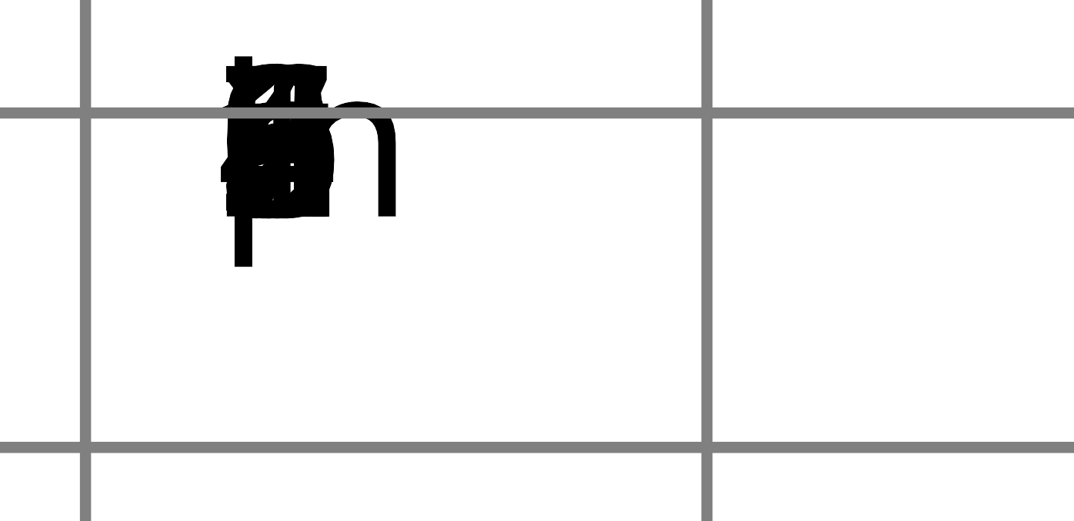
- (From Unit 4, Lesson 8.)
- Technology required. The number of people, $p$, who watch a weekly TV show is modeled by the equation $p=100,​000⋅(1.1)^{w}$, where $w$ is the number of weeks since the show first aired.
  - How many people watched the show the first time it aired? Explain how you know.
  - Use technology to graph the equation.
  - On which week does the show first get an audience of more than 500,000 people?
- (From Unit 5, Lesson 9.)
© CC BY 2019 by Illustrative Mathematics®

