Lesson 1 Practice Problems
- Here is a diagram of a straightedge and compass construction. $C$ is the center of one circle, and $B$ is the center of the other. Explain why the length of segment $BD$ is the same as the length of segment $AB$.

- 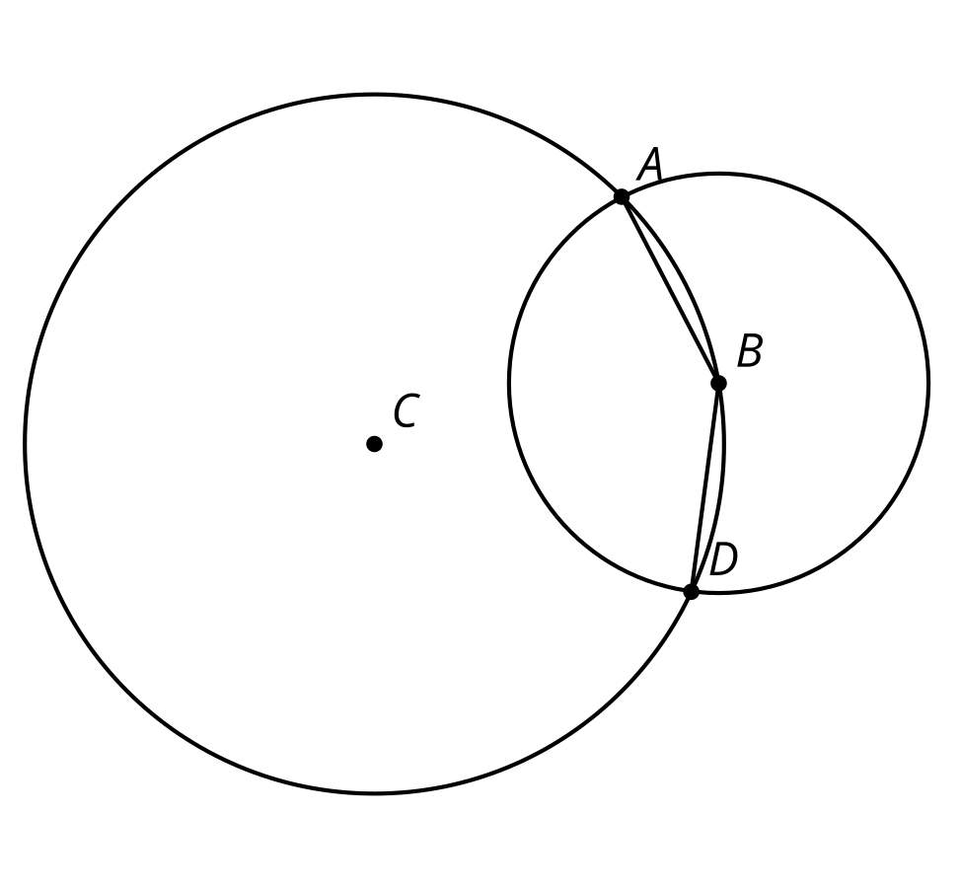

- Clare used a compass to make a circle with radius the same length as segment $AB$. She labeled the center $C$. Which statement is true?
- 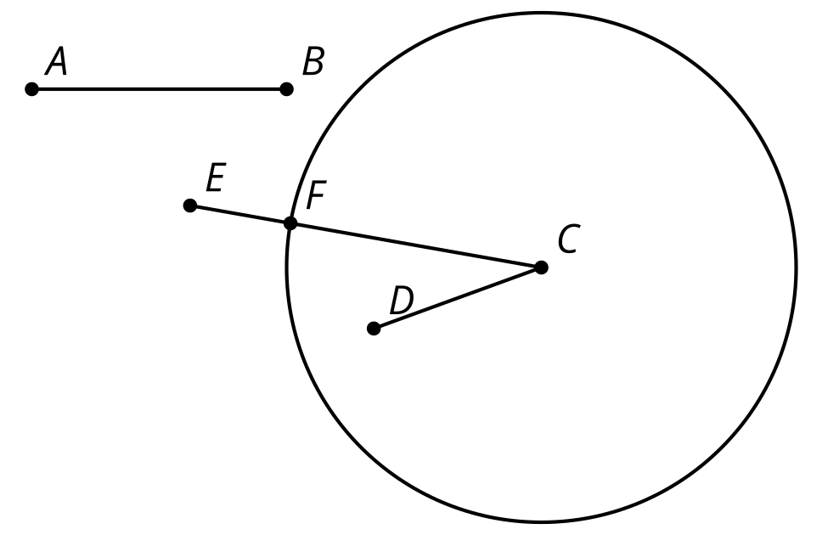
  - $AB>CD$
  - $AB=CD$
  - $AB>CE$
  - $AB=CE$
- The diagram was constructed with straightedge and compass tools. Points $A$, $B$, $C$, $D$, and $E$ are all on line segment $CD$. Name a line segment that is half the length of $CD$. Explain how you know.
- 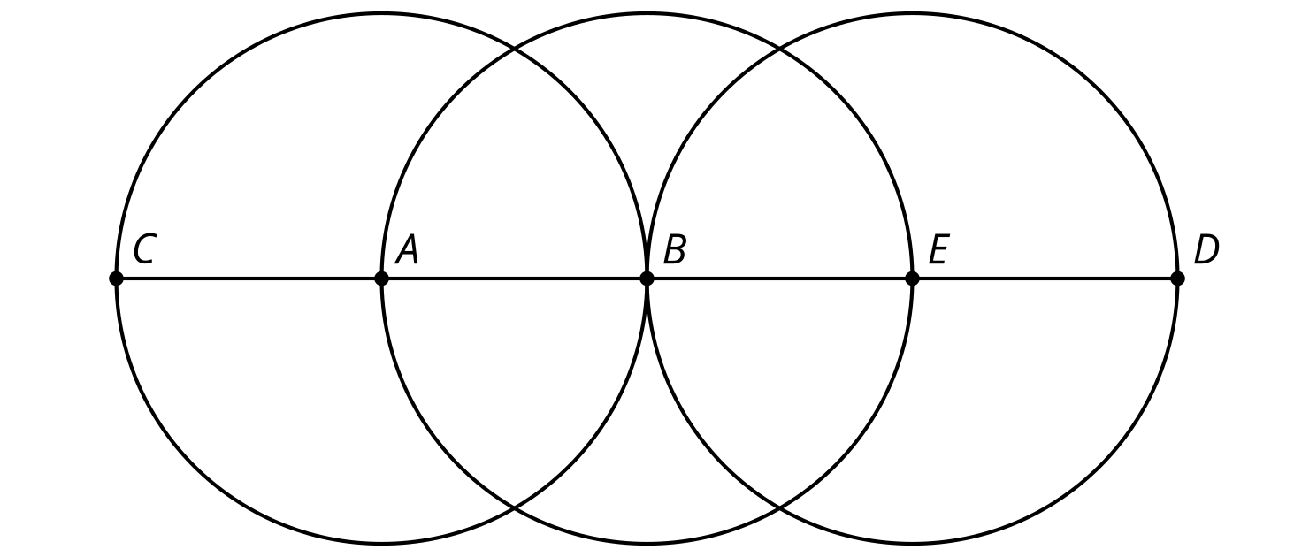
- This diagram was constructed with straightedge and compass tools. $A$ is the center of one circle, and $C$ is the center of the other.
- 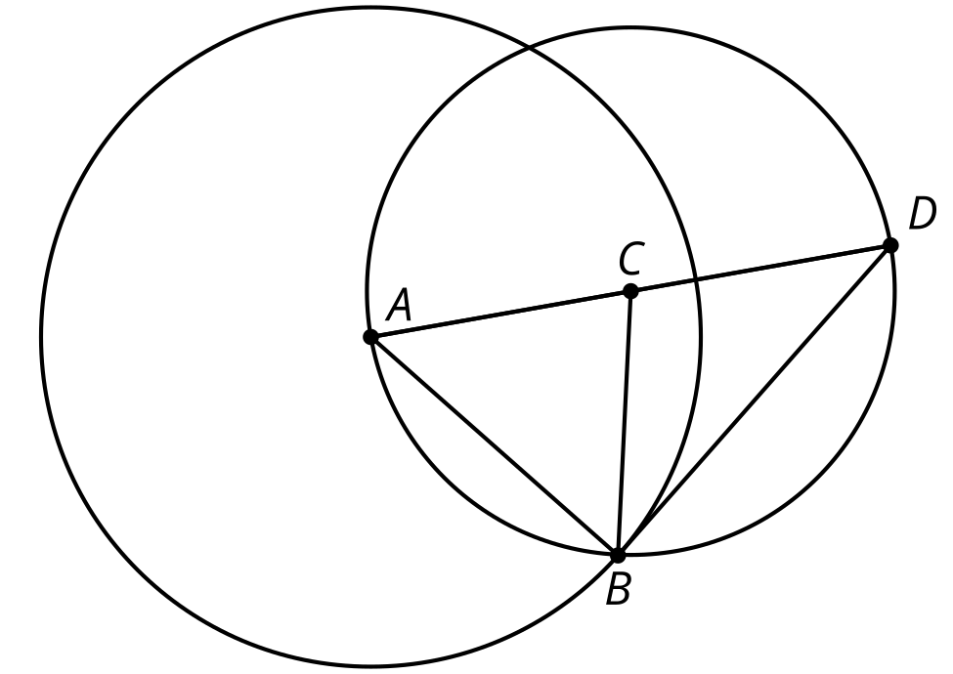
  - The 2 circles intersect at point $B$. Label the other intersection point $E$.
  - How does the length of segment $CE$ compare to the length of segment $AD$?
© CC BY 2019 by Illustrative Mathematics®

