Unit 2 Lesson 1: Story Problems and Expressions

WU Notice and Wonder: A Library (Warm up)

Student Task Statement
What do you notice?
What do you wonder?
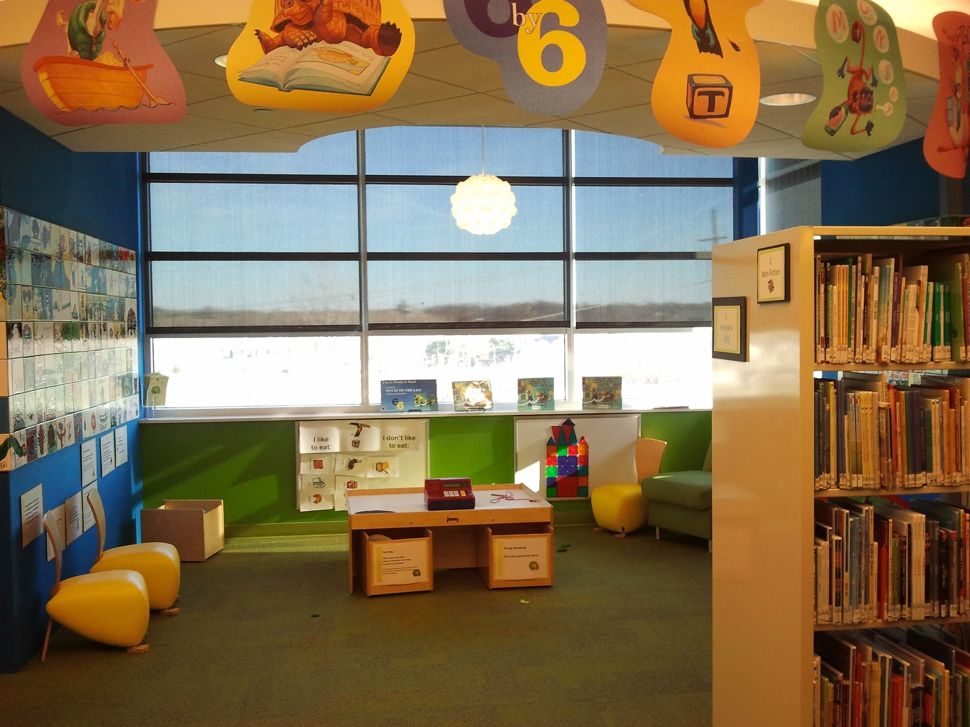

1 The Library

Student Task Statement
- Some kids were at the library.
Then some of the kids went home.
What do you notice?
What do you wonder?
- There were 9 kids at the library.
Then 2 of the kids went home.
How many kids are at the library now?
Show your thinking using drawings, numbers, or words.

2 Story Problems about the Library

Student Task Statement
- 5 books were on a shelf.
Clare put 2 more books on the shelf.
How many books are on the shelf now?
Show your thinking using drawings, numbers, or words.
- Expression: ________________________________
- 6 books were stacked up on the table.
4 of the books fell on the floor.
How many books are still on the table?
- Show your thinking using drawings, numbers, or words.
- Expression: ________________________________
- 6 kids were listening to a story.
4 more kids joined the group.
How many kids are listening to the story now?
Show your thinking using drawings, numbers, or words.
- Expression: ________________________________
- There were 5 computers turned on. The librarian turned 2 of the computers off.
How many computers are still on?
Show your thinking using drawings, numbers, or words.
- Expression: ________________________________
© CC BY 2021 Illustrative Mathematics®

