Teacher Presentation Materials

Unit 6 Lesson 1: Tape Diagrams and Equations

1 Which Diagram is Which? (Warm up)

Student Task Statement
- Here are two diagrams. One represents $2+5=7$. The other represents $5⋅2=10$. Which is which? Label the length of each diagram.
- 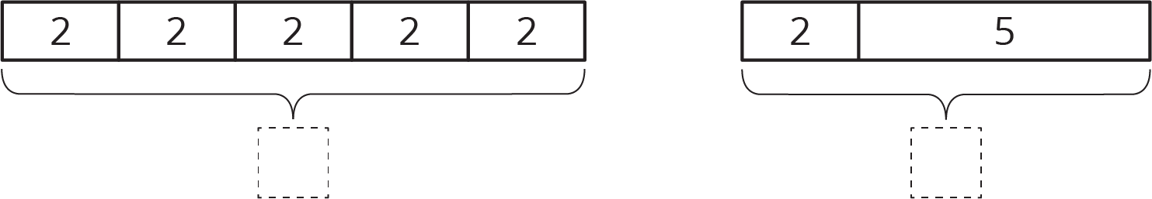
- Draw a diagram that represents each equation.
- $4+3=7$
- $4⋅3=12$

2 Match Equations and Tape Diagrams

Student Task Statement
Here are two tape diagrams. Match each equation to one of the tape diagrams.
- $4+x=12$
- $12÷4=x$
- $4⋅x=12$
- $12=4+x$
- $12−x=4$
- $12=4⋅x$
- $12−4=x$
- $x=12−4$
- $x+x+x+x=12$

3 Draw Diagrams for Equations

Student Task Statement
For each equation, draw a diagram and find the value of the unknown that makes the equation true.
- $18=3+x$
- $18=3⋅y$
© CC BY Open Up Resources. Adaptations CC BY IM.

