Unit 6 Lesson 6: More and Less than 1%

1 Number Talk: What Percentage? (Warm up)

Student Task Statement
Determine the percentage mentally.
10 is what percentage of 50?
5 is what percentage of 50?
1 is what percentage of 50?
17 is what percentage of 50?

Activity Synthesis
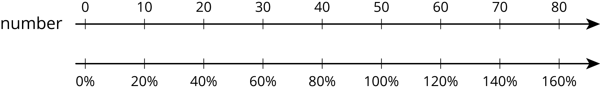

2 Waiting Tables

Student Task Statement
During one waiter’s shift, he delivered 13 appetizers, 17 entrées, and 10 desserts.
- What percentage of the dishes he delivered were:
  - desserts?
  - appetizers?
  - entrées?
- What do your percentages add up to?

Activity Synthesis
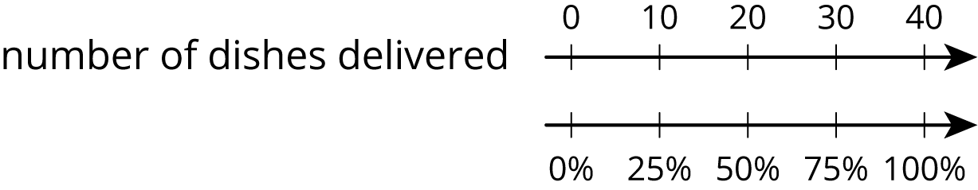

3 Fractions of a Percent

Student Task Statement
- Find each percentage of 60. What do you notice about your answers?
- 30% of 60
- 3% of 60
- 0.3% of 60
- 0.03% of 60
- 20% of 5,000 is 1,000 and 21% of 5,000 is 1,050. Find each percentage of 5,000 and be prepared to explain your reasoning. If you get stuck, consider using the double number line diagram.
  - 1% of 5,000
  - 0.1% of 5,000
  - 20.1% of 5,000
  - 20.4% of 5,000
- 15% of 80 is 12 and 16% of 80 is 12.8. Find each percentage of 80 and be prepared to explain your reasoning.
  - 15.1% of 80
  - 15.7% of 80

4 Population Growth (Optional)

Student Task Statement
- The population of City A was approximately 243,000 people, and it increased by 8% in one year. What was the new population?
- The population of city B was approximately 7,150,000, and it increased by 0.8% in one year. What was the new population?
© CC BY Open Up Resources. Adaptations CC BY IM.

