Lesson 14 Practice Problems
- Select all expressions that are perfect squares.
  - $9x^{2}+24x+16$
  - $2x^{2}+20x+100$
  - $(7−3x)^{2}$
  - $(5x+4)(5x−4)$
  - $(1−2x)(\text{-}2x+1)$
  - $4x^{2}+6x+\frac{9}{4}$
- Find the missing number that makes the expression a perfect square. Next, write the expression in factored form.
  - $49x^{2}−\underset{_}{​}x+16$
  - $36x^{2}+\underset{_}{​}x+4$
  - $4x^{2}−\underset{_}{​}x+25$
  - $9x^{2}+\underset{_}{​}x+9$
  - $121x^{2}+\underset{_}{​}x+9$
- Find the missing number that makes the expression a perfect square. Next, write the expression in factored form.
  - $9x^{2}+42x+\underset{_}{​}$
  - $49x^{2}−28x+\underset{_}{​}$
  - $25x^{2}+110x+\underset{_}{​}$
  - $64x^{2}−144x+\underset{_}{​}$
  - $4x^{2}+24x+\underset{_}{​}$
  - Find the value of $c$ to make the expression a perfect square. Then, write an equivalent expression in factored form.
- standard form $ax^{2}+bx+c$ | - factored form $(kx+m)^{2}$
  - $4x^{2}+4x$
  - $25x^{2}−30x$
  - Solve each equation by completing the square.
  - $4x^{2}+4x=3$
  - $25x^{2}−30x+8=0$
- For each function $f$, decide if the equation $f(x)=0$ has 0, 1, or 2 solutions. Explain how you know.

- A
- 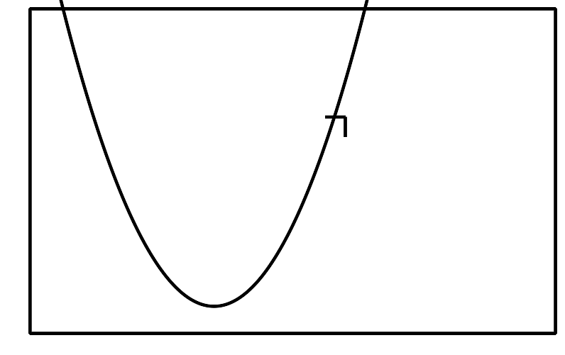

- B
- 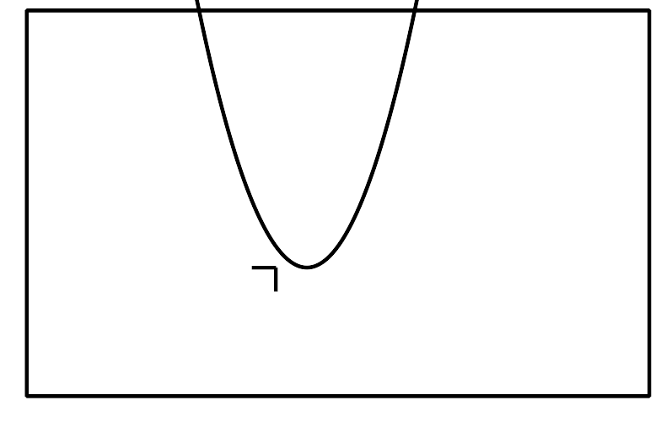

- C
- 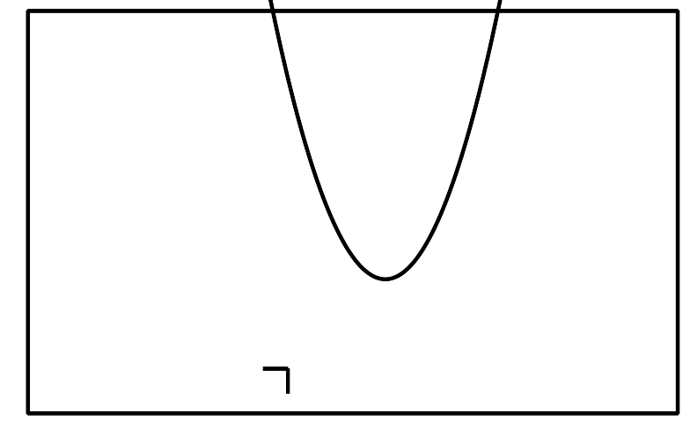

- D
- 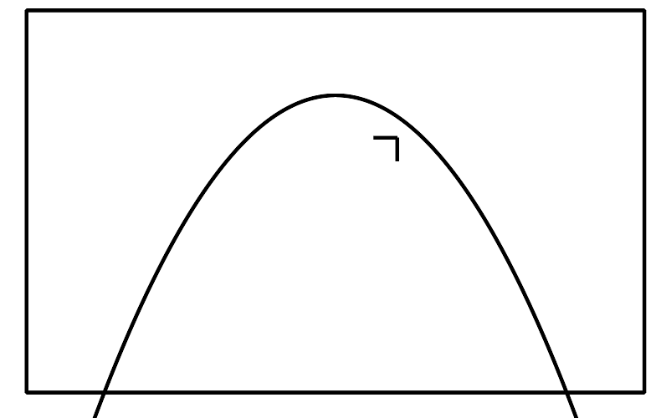

- E
- 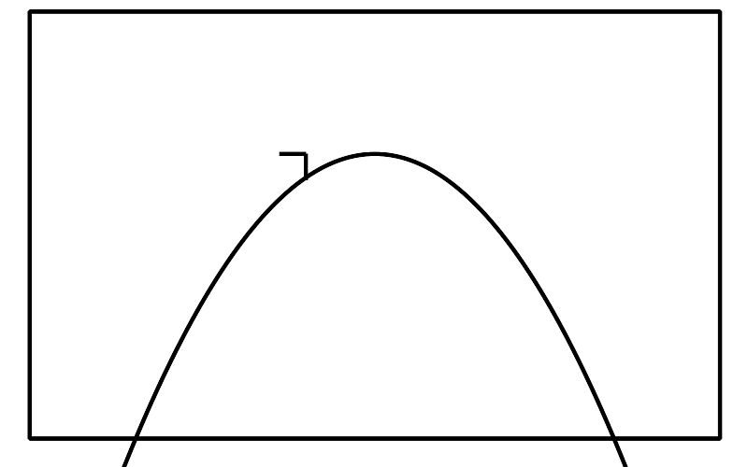

- F
- 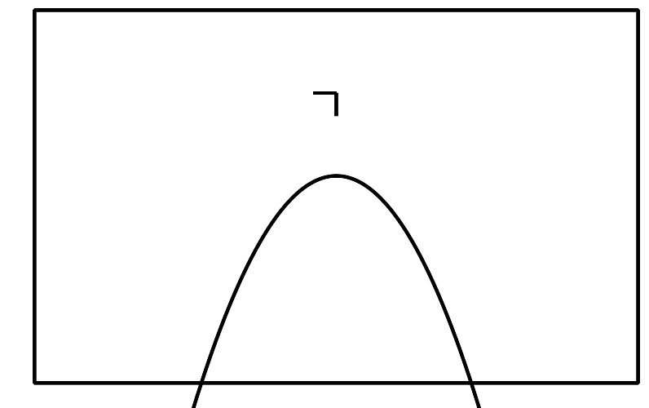
- (From Unit 7, Lesson 5.)
- Solve each equation.
- $p^{2}+10=7p$
- $x^{2}+11x+27=3$
- $(y+2)(y+6)=\text{-}3$

- (From Unit 7, Lesson 9.)
- Which function could represent the height in meters of an object thrown upwards from a height of 25 meters above the ground $t$ seconds after being launched?
  - $f(t)=\text{-}5t^{2}$
  - $f(t)=\text{-}5t^{2}+25$
  - $f(t)=\text{-}5t^{2}+25t+50$
  - $f(t)=\text{-}5t^{2}+50t+25$
- (From Unit 6, Lesson 6.)
- A group of children are guessing the number of pebbles in a glass jar. The guesses and the guessing errors are plotted on a coordinate plane.
  - Which guess is furthest away from the actual number?
  - How far is the furthest guess away from the actual number?
- (From Unit 4, Lesson 13.)
© CC BY 2019 by Illustrative Mathematics®

