Lesson 5 Practice Problems
- This diagram is a straightedge and compass construction of a line perpendicular to line $AB$ passing through point $C$. Explain why it was helpful to construct points $D$ and $A$ to be the same distance from $C$.
- 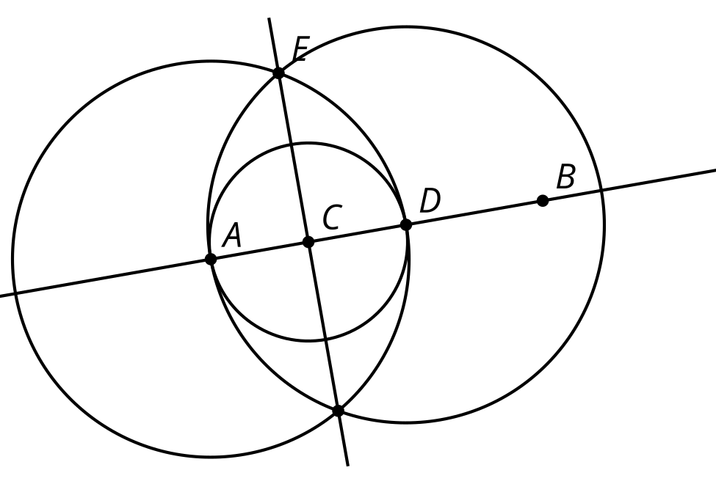
- This diagram is a straightedge and compass construction.
- Select all true statements.
- 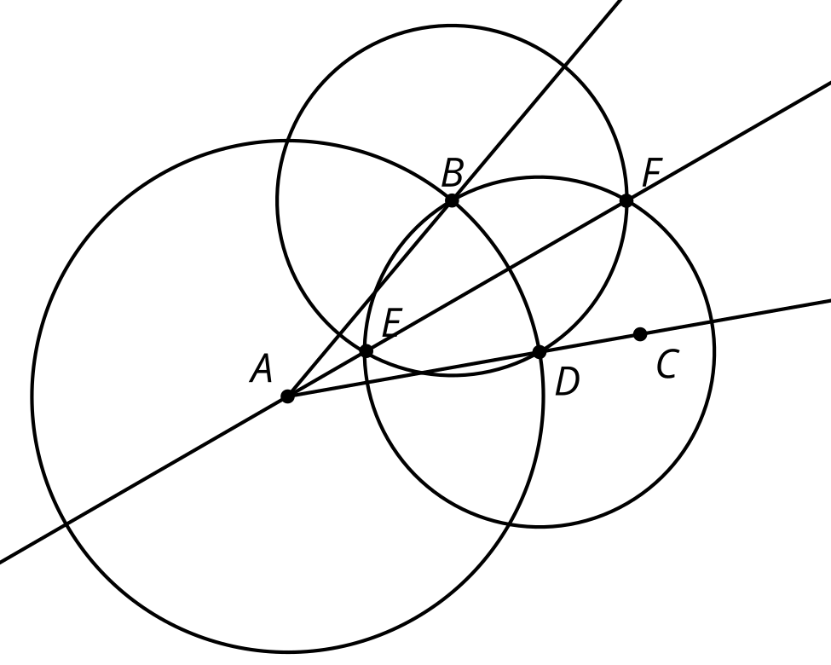
  - Line $EF$ is the bisector of angle $BAC$.
  - Line $EF$ is the perpendicular bisector of segment $BA$.
  - Line $EF$ is the perpendicular bisector of segment $AC$.
  - Line $EF$ is the perpendicular bisector of segment $BD$.
  - Line $EF$ is parallel to line $CD$.
- This diagram is a straightedge and compass construction. $A$ is the center of one circle, and $B$ is the center of the other. A rhombus is a quadrilateral with 4 congruent sides. Explain why quadrilateral $ACBD$ is a rhombus.
- 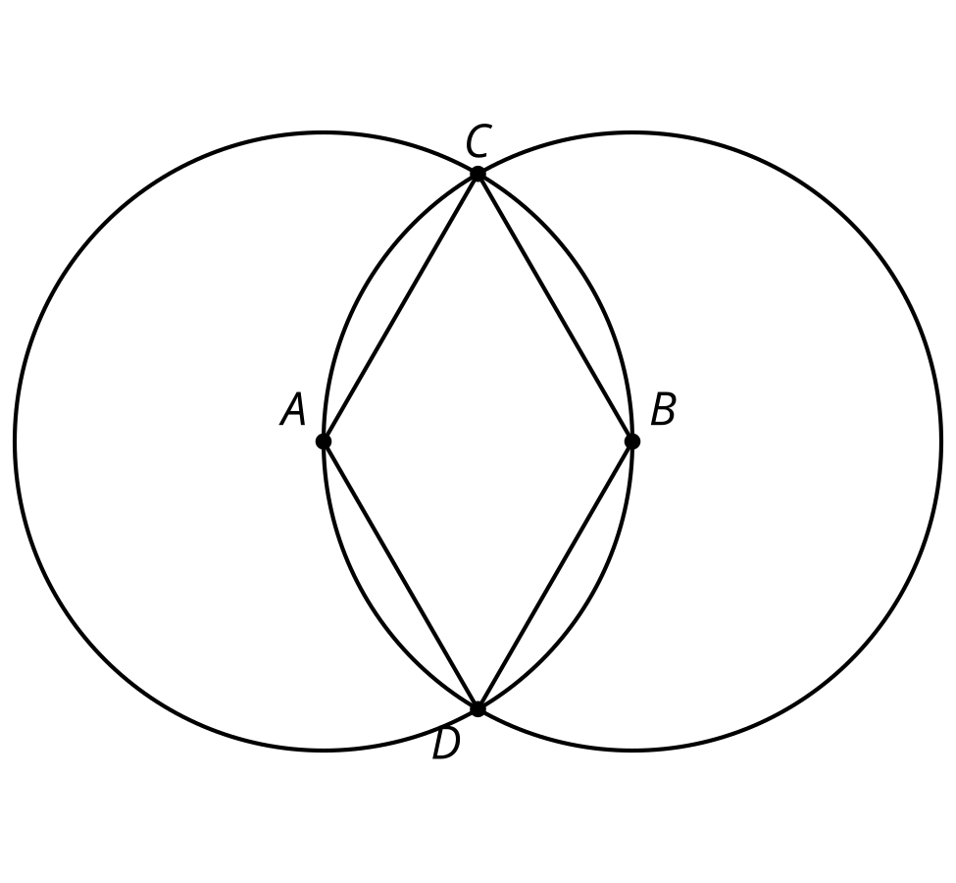
- (From Unit 1, Lesson 4.)
- $A$, $B$, and $C$ are the centers of the three circles. Which line segment is congruent to $HF$?
- 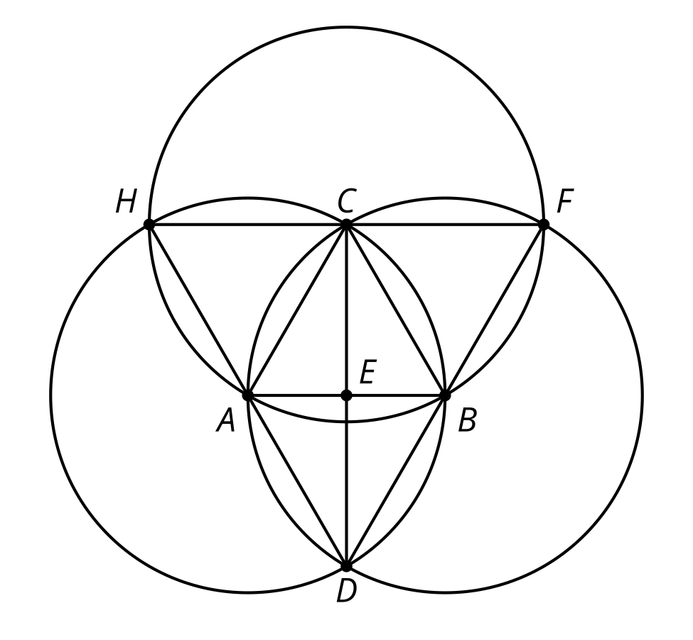
  - $AB$
  - $CD$
  - $DF$
  - $CB$
- (From Unit 1, Lesson 4.)
- In the construction, $A$ is the center of one circle, and $B$ is the center of the other. Explain why segment $EA$ is the same length as segment $BC$.
- 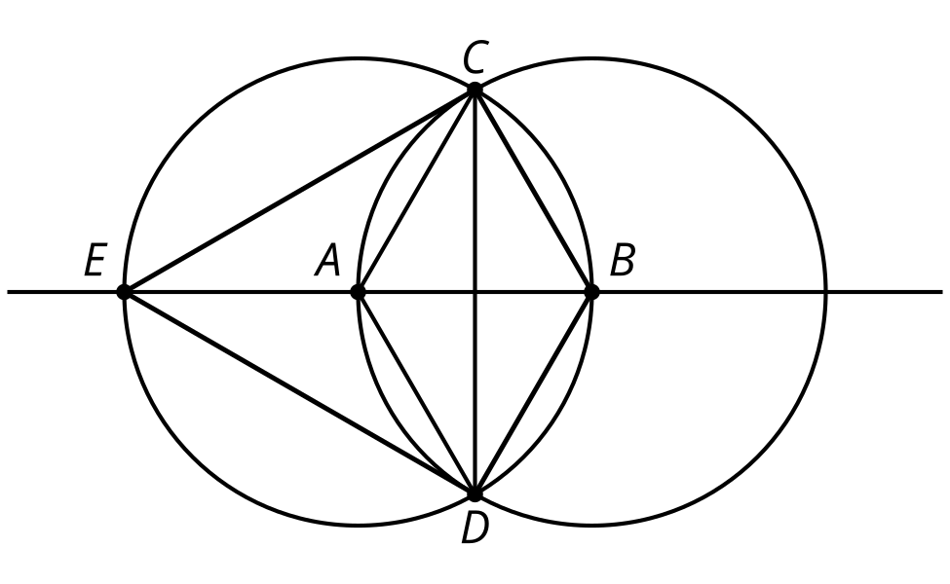
- (From Unit 1, Lesson 2.)

- $AB⊥CD$
- 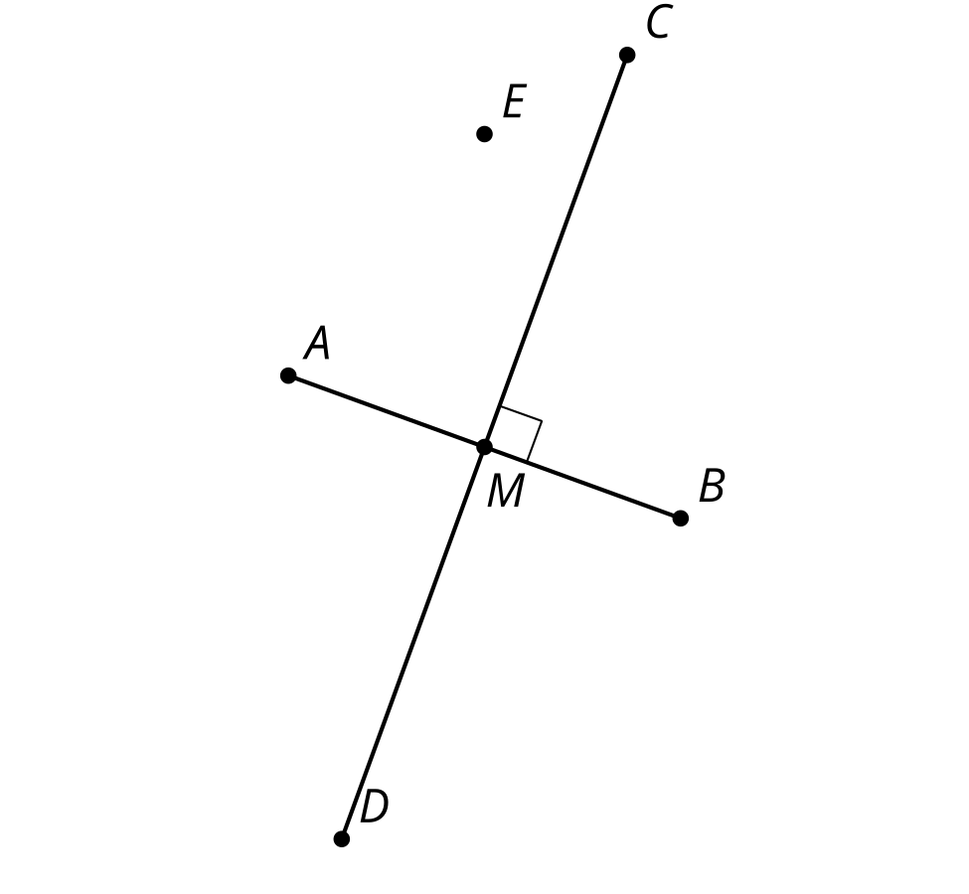
- In this diagram, line segment $CD$ is the perpendicular bisector of line segment $AB$. Assume the conjecture that the set of points equidistant from $A$ and $B$ is the perpendicular bisector of $AB$ is true. Is point $M$ closer to point $A$, closer to point $B$, or the same distance from both points? Explain how you know.
- (From Unit 1, Lesson 3.)
- A sheet of paper with points $A$ and $B$ is folded so that $A$ and $B$ match up with each other.
- 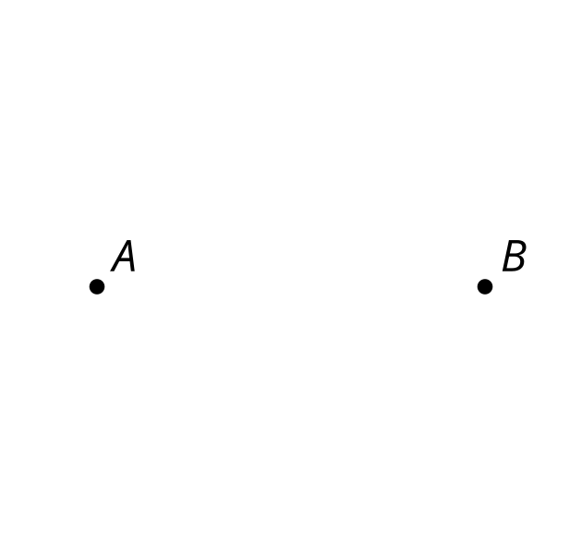
- Explain why the crease in the sheet of paper is the perpendicular bisector of segment $AB$. (Assume the conjecture that the set of points equidistant from $A$ and $B$ is the perpendicular bisector of segment $AB$ is true.)
- (From Unit 1, Lesson 3.)
- Here is a diagram of a straightedge and compass construction. $C$ is the center of one circle, and $B$ is the center of the other. Explain why the length of segment $CB$ is the same as the length of segment $CD$.
- 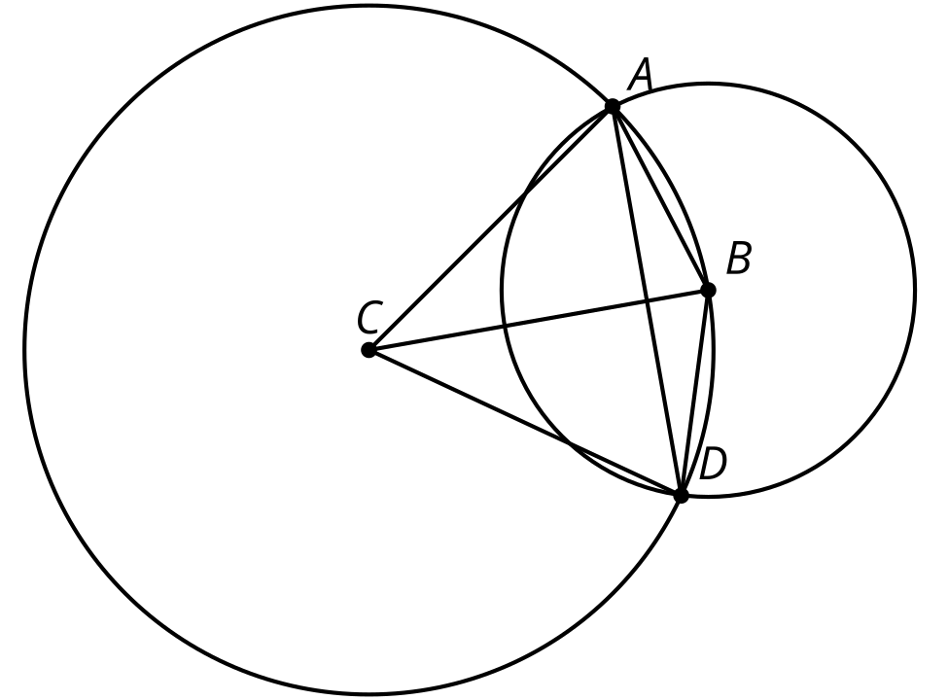
- (From Unit 1, Lesson 1.)
© CC BY 2019 by Illustrative Mathematics®

