Lesson 11: Approximating Pi
- Let’s approximate the value of pi.

11.1: More Sides
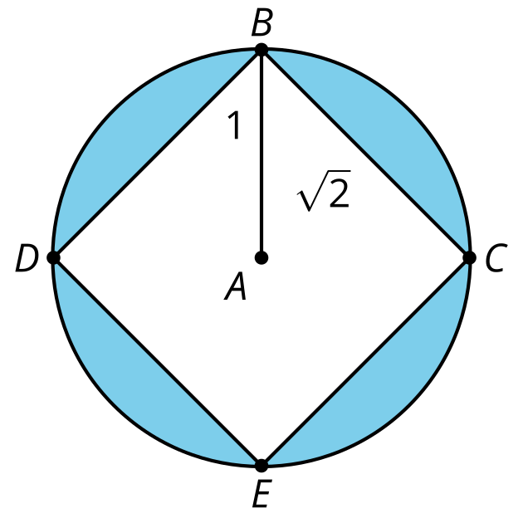
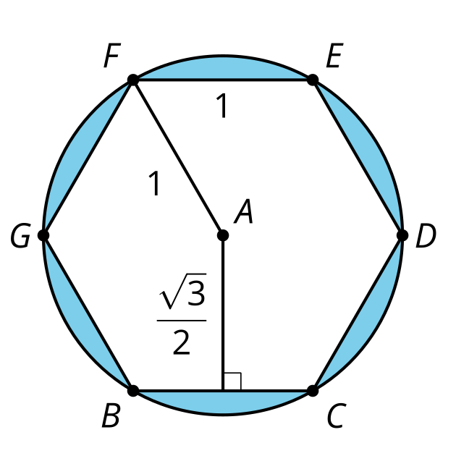
Calculate the area of the shaded regions.

11.2: N Sides
Here is one part of a regular $n$-sided polygon inscribed in a circle of radius 1.
Come up with a general formula for the perimeter of the polygon in terms of $n$. Explain or show your reasoning.
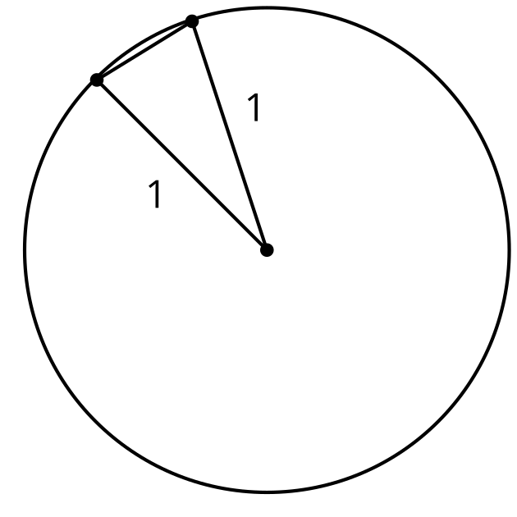

11.3: So Many Sides
Let's use the expression you came up with to approximate the value of $π$.
- How close is the approximation when $n=6$?
- How close is the approximation when $n=10$?
- How close is the approximation when $n=20$?
- How close is the approximation when $n=50$?
- What value of $n$ approximates the value of $π$ to the thousandths place?

Are you ready for more?
Describe how to find the area of a regular $n$-gon with side length $s$. Then write an expression that will give the area.

Lesson 11 Summary
It's easier to work with polygons than with circles because we can decompose polygons into simple shapes such as triangles. We can use polygons to figure out things about circles. For example, we know how to calculate the area of regular polygons inscribed in a circle of radius 1.
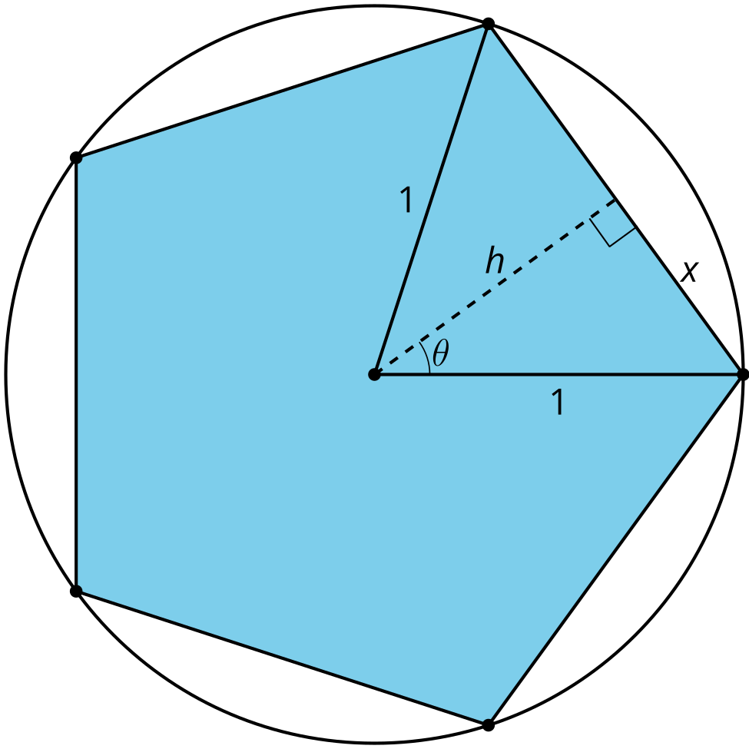
To find the area of this regular pentagon, let's find the area of one triangle and then multiply by 5. Drawing in the altitude creates a right triangle, so we can use trigonometry to calculate the lengths of both $x$ and $h$. To find $θ$ use the fact that a full rotation is ${360}^{∘}$ and that in an isosceles triangle the altitude is also an angle bisector. So $θ=360÷10$. $sin\left(36\right)=\frac{x}{1}$ so $x$ is about 0.59 units. $cos\left(36\right)=\frac{h}{1}$ so $h$ is about 0.81 units. The area of the isosceles triangle is about 0.48 square units and the area of the pentagon is 5 times that, or about 2.4 square units.
That's not very close to the area of the circle, but if we add more and more sides to the regular polygon, its area gets closer and closer to covering the entire circle.
© CC BY 2019 by Illustrative Mathematics®

