Unit 2 Lesson 5: Center Day 1

WU Notice and Wonder: Math Picture (Warm up)

Student Task Statement
What do you notice?
What do you wonder?

1 Introduce Math Stories, Add and Subtract

Student Task Statement

2 Centers: Choice Time

Student Task Statement
Choose a center.
Sort and Display
Math Stories
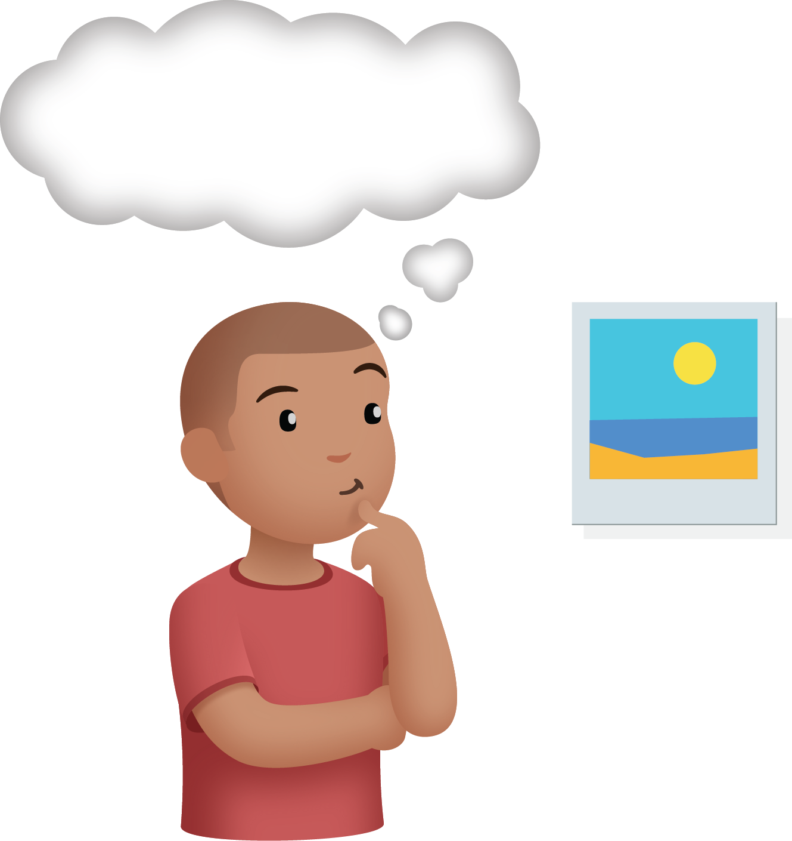
Find the Pair
© CC BY 2021 Illustrative Mathematics®

