Lesson 4: Center Day 1
- Let’s practice adding and subtracting.

Warm-up: Number Talk: Use Tens to Add
Find the value of each expression mentally.
- $9+6$
- $29+6$
- $39+7$
- $39+9$

4.2: Centers: Choice Time
Choose a center.
Target Numbers
Five in a Row
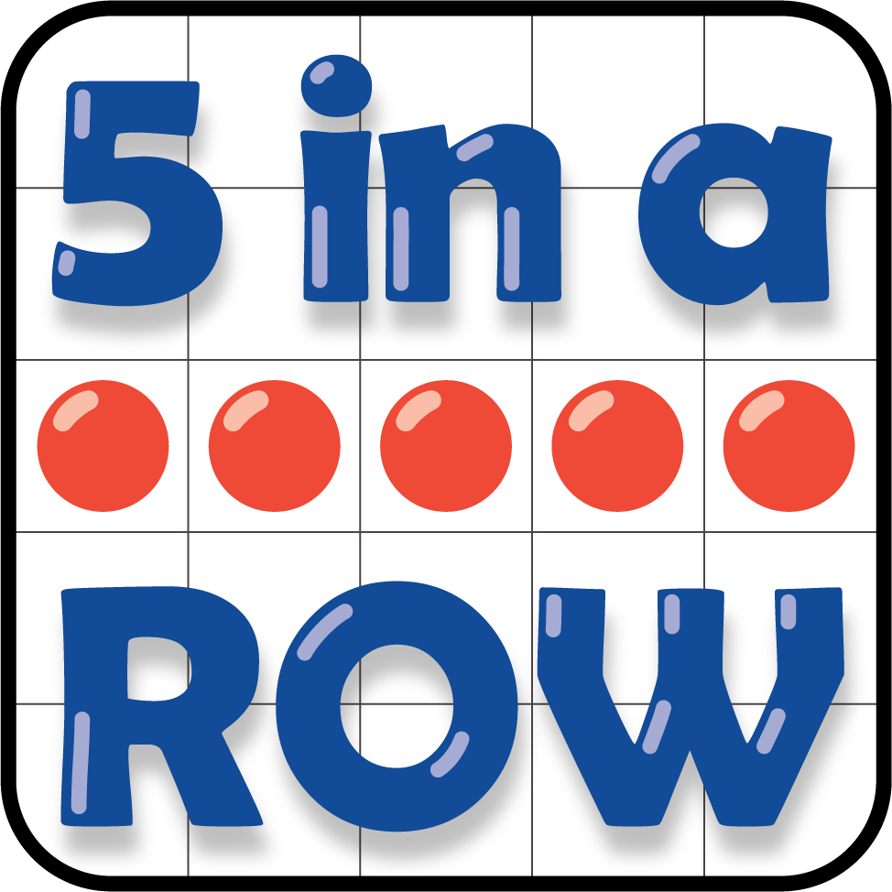
Get Your Numbers in Order
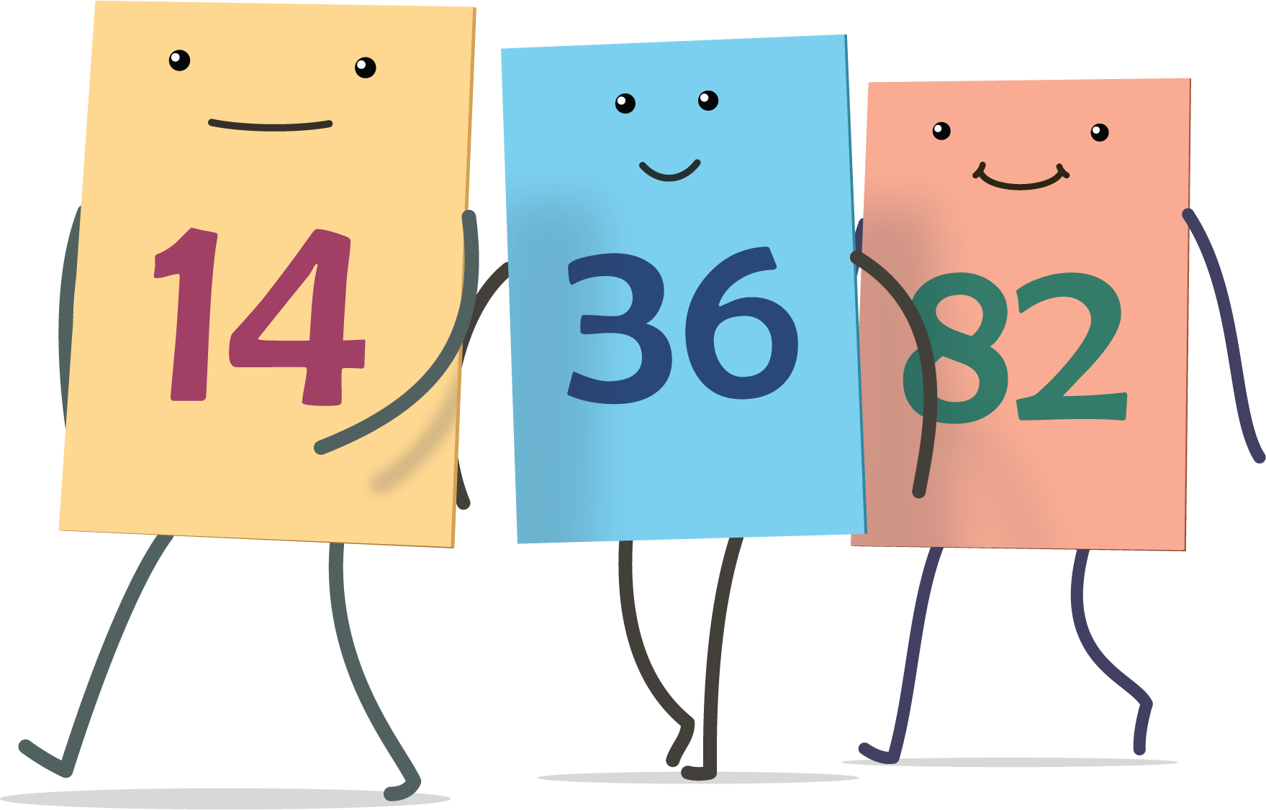
© CC BY 2021 Illustrative Mathematics®

