Unit 8 Lesson 1: Estimation Explorations with Fractions

WU Which One Doesn’t Belong: Fractions (Warm up)

Student Task Statement
Which one doesn’t belong?
A
B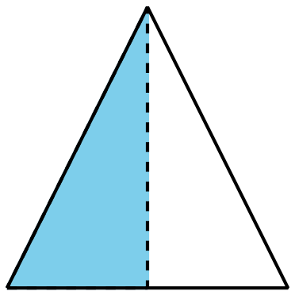
C
D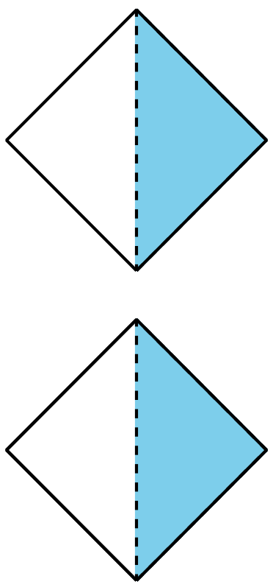

1 Estimation Exploration: Diagram

Student Task Statement
What fraction of the square is shaded?
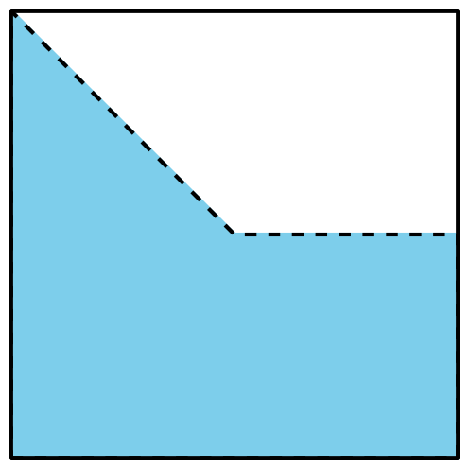
Record an estimate that is:
too low | about right | too high

2 Estimation Exploration: Fraction Strip

Student Task Statement
What fraction of the strip is shaded?
Record an estimate that is:
too low | about right | too high

3 Estimation Exploration: Number Line

Student Task Statement
What number does the point represent?
Record an estimate that is:
too low | about right | too high
© CC BY 2021 Illustrative Mathematics®

