Lesson 6: All Kinds of Attributes (Optional)

Standards Alignments
Addressing | 4.G.A.1, 4.G.A.2, 4.G.A.3

Teacher-facing Learning Goals
- Draw line symmetric figures and identify lines of symmetry.
- Identify two-dimensional figures using an understanding of parallelism and perpendicularity.

Student-facing Learning Goals
- Let’s use what we know about attributes of figures to create drawings.

Lesson Purpose
The purpose of this optional lesson is for students to use what they know about symmetry and parallel and perpendicular lines to complete or draw figures with those attributes on a grid.
This lesson is optional because it synthesizes all the sorting and classifying students have done up to this point. Grids are given here to encourage students to support students’ parallel lines, perpendicularity, and measurements and to support also thinking about attributes of figures. In upcoming lessons, students will use these lines of reasoning to solve problems about perimeter and angle measurements.
This lesson has a Student Section Summary.

Access for:

Students with Disabilities
- Action and Expression (Activity 1)

English Learners
- MLR2 (Activity 2)

Instructional Routines
How Many Do You See? (Warm-up)

Materials to Gather
- Straightedges: Activity 1

Lesson Timeline
Warm-up | 10 min
Activity 1 | 20 min
Activity 2 | 10 min
Lesson Synthesis | 10 min
Cool-down | 5 min

Teacher Reflection Question
How did you hear students use the vocabulary they have learned in previous lessons as they created and described shapes and figures in today's lesson? What can you do to encourage students to use geometric vocabulary in upcoming lessons and outside of math class?

Cool-down
(to be completed at the end of the lesson) 5min
Can You See It?

Standards Alignments
Addressing | 4.G.A.1, 4.G.A.3

Student-facing Task Statement
Here are diagrams that each show a pair of intersecting segments.
Add 1 or more segments to each diagram to make a figure that has:
1.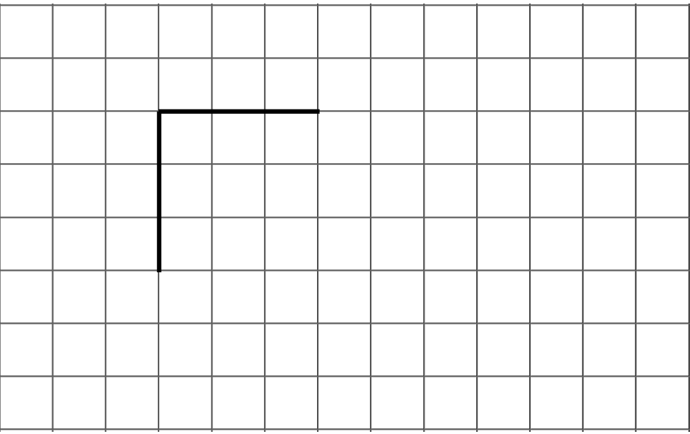
1 line of symmetry
2.
2 or more lines of symmetry
3.
no lines of symmetry

Student Responses
Sample responses:
1.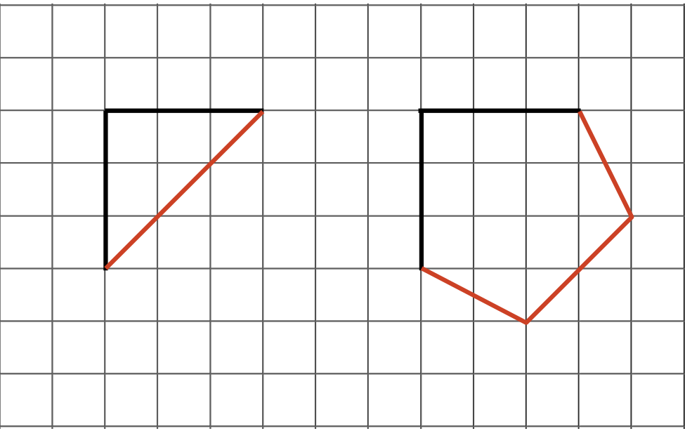
2.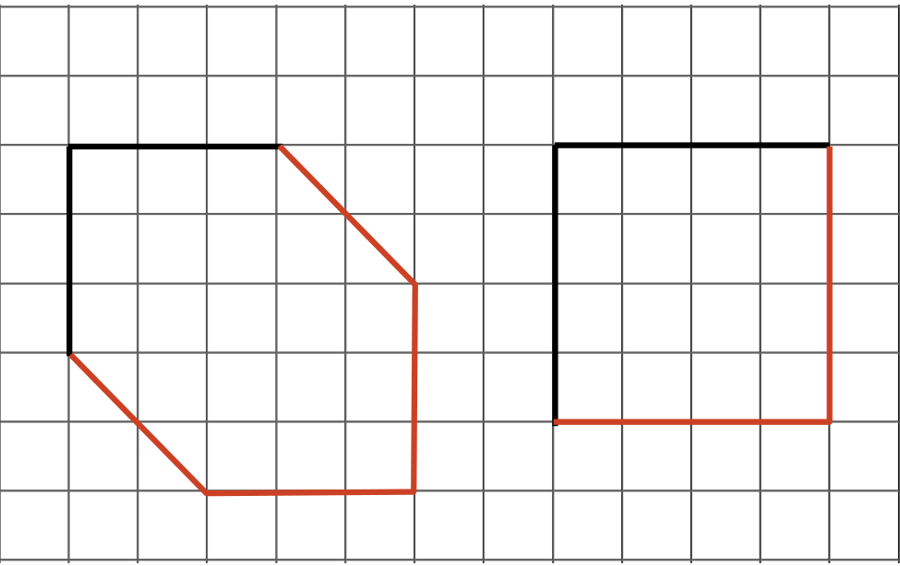
3.