Unit 6 Lesson 1 Cumulative Practice Problems
- Given the rule:
- 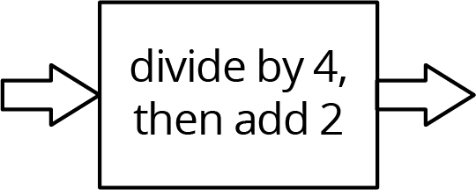
- Complete the table for the function rule for the following input values:
- input | - 0 | - 2 | - 4 | - 6 | - 8 | - 10
- output
- Here is an input-output rule:
- 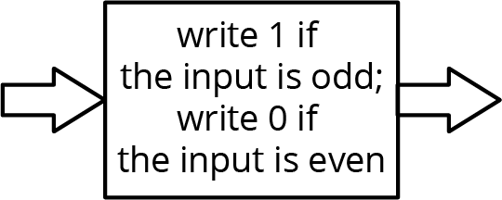
- Complete the table for the input-output rule:
- input | - -3 | - -2 | - -1 | - 0 | - 1 | - 2 | - 3
- output
- Andre’s school orders some new supplies for the chemistry lab. The online store shows a pack of 10 test tubes costs $4 less than a set of nested beakers. In order to fully equip the lab, the school orders 12 sets of beakers and 8 packs of test tubes.
  - Write an equation that shows the cost of a pack of test tubes, $t$, in terms of the cost of a set of beakers, $b$.
  - The school office receives a bill for the supplies in the amount of $348. Write an equation with $t$ and $b$ that describes this situation.
  - Since $t$ is in terms of $b$ from the first equation, this expression can be substituted into the second equation where $t$ appears. Write an equation that shows this substitution.
  - Solve the equation for $b$.
  - How much did the school pay for a set of beakers? For a pack of test tubes?
- (From Unit 5, Lesson 16.)
- Solve: $\left\{\begin{matrix}y=x−4 \\ y=6x−10\end{matrix}\right.$
- (From Unit 5, Lesson 15.)
- For what value of $x$ do the expressions $2x+3$ and $3x−6$ have the same value?
- (From Unit 4, Lesson 17.)
© CC BY Open Up Resources. Adaptations CC BY IM.

