Lesson 2 Practice Problems
- Which of the following is true?
  - $\text{sin}(A)=\frac{6}{10}$
  - $\text{cos}(A)=\frac{6}{10}$
  - $\text{sin}(B)=\frac{8}{10}$
  - $\text{cos}(B)=\frac{6}{10}$
- Here is triangle ABC:
  - Express the length of segment $AB$ using sine or cosine.
  - Express the length of segment $BC$ using sine or cosine.
- Triangle DEF is similar to triangle ABC.
  - What is the length of segment $DE$? What is the length of segment $EF$? Explain how you know.
  - Explain why the length of segment $DE$ is $\text{cos}(D)$ and the length of segment $EF$ is $\text{sin}(D)$.
- Here is a triangle.
- Find $\text{cos}(A)$, $\text{sin}(A)$, and $\text{tan}(A)$. Explain your reasoning.
- Sketch and label a right triangle $ABC$ with $\text{tan}(A)=2$.
- 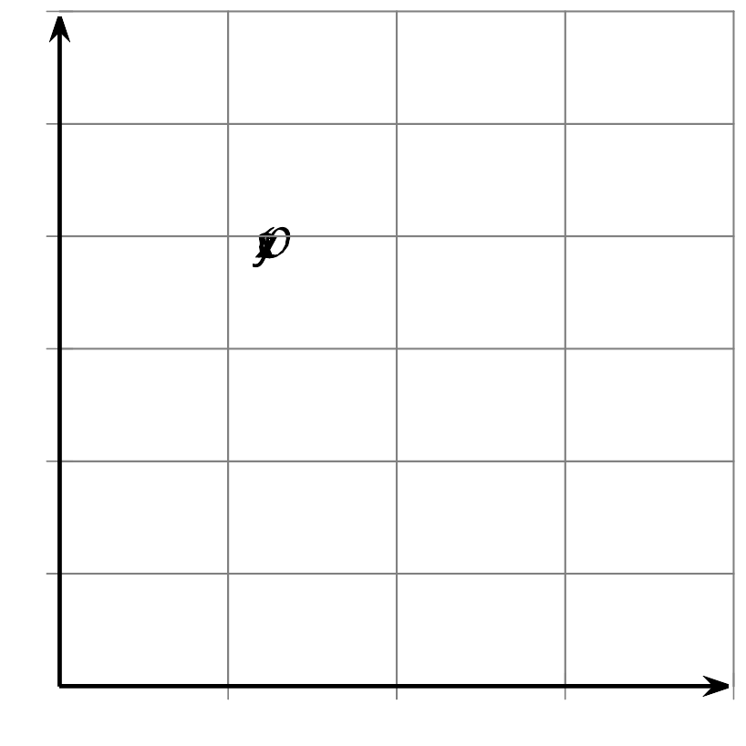
- The point $(1,4)$ lies on a circle with center $(0,0)$. Name at least one point in each quadrant that lies on the circle.
- (From Unit 6, Lesson 1.)
© CC BY 2019 by Illustrative Mathematics®

