Lesson 12: Estimating a Population Mean
- Let’s estimate population means using sample data.

12.1: Rolling Distribution
In the next activity, you will roll a standard number cube 35 times.
- Draw a dot plot that shows the distribution of values you might expect for the rolls. Explain your reasoning.
- 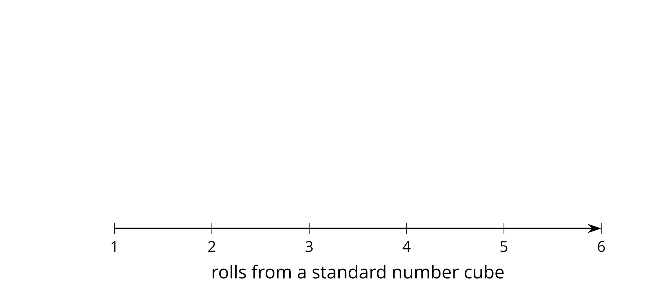
- If you rolled the number cube one million times and found the mean of all the values, what do you expect for the mean? Explain your reasoning.

12.2: Rolling for Means
Roll your number cube 35 times, recording the values as you do so.
- Every 5 values, find the mean.
- rolls | - 1 through 5 | - 6 through 10 | - 11 through 15 | - 16 through 20 | - 21 through 25 | - 26 through 30 | - 31 through 35
- mean
- Share your means with your group and create a dot plot of all the means from your group.
- 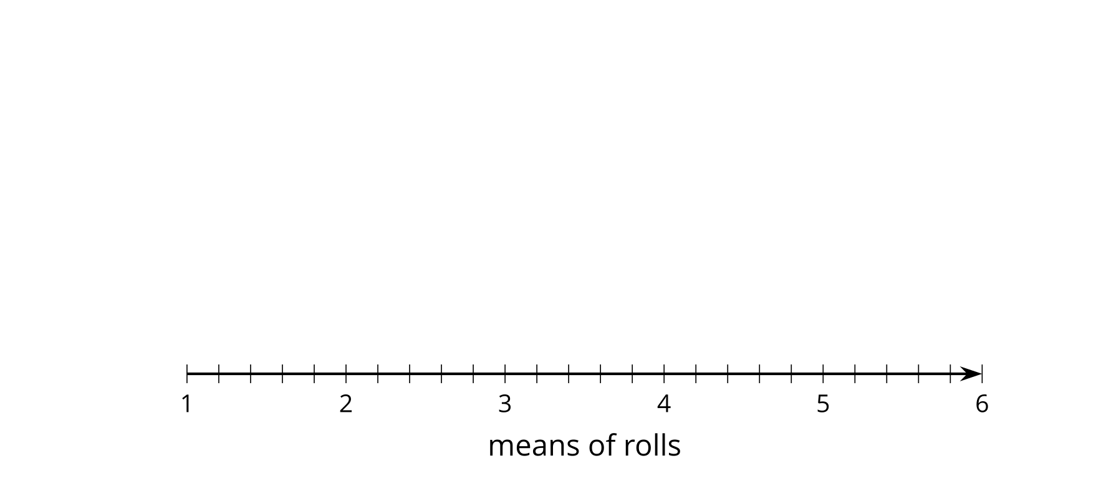
- What do you notice about the shape of the distribution of means?
- Using the dot plot of means, what do you think is a good estimate for the mean of all 140 rolls from your group? How does this value compare to your estimate from the warm-up?

12.3: Margin of Error for Means
As with the means of sample proportions, the means of sample means are usually within 2 standard deviations of the population mean when there is a large sample size or when the population distribution is approximately normal. For each situation:
- Use the sample means to estimate the mean of the population.
- Find the standard deviation of the sample means.
- Use the standard deviation of the sample means to estimate the margin of error.
- 10 samples of 25 gas stations are selected at random and the price of regular gasoline is recorded for each gas station. The sample means are shown for the 10 samples.
- $2.38 | - $2.42 | - $2.64 | - $2.35 | - $2.65 | - $2.47 | - $2.67 | - $2.59
- $2.63 | - $2.41

- The mean number of claimed UFO sightings are shown for 13 samples of 5 randomly selected months.
- 400.2 | - 427.4 | - 892.2 | - 640.6 | - 713.4 | - 614 | - 725.8 | - 477.2
- 460 | - 445.2 | - 476.8 | - 336.6 | - 536.4

- A company producing baseballs selects 10 baseballs at random 9 times a day and measures the diameter in centimeters. The mean of each of the 9 samples of 10 baseballs is shown.
- 7.5 | - 7.6 | - 7.2 | - 7.4 | - 7.2 | - 7.3 | - 7.5 | - 6.9
- 7.5

- A publisher takes 15 random samples of 10 people to determine the number of minutes they spend reading a newspaper. The sample mean is displayed for each of the samples.
- 11.1 | - 9.2 | - 8.1 | - 10.5 | - 10 | - 9.7 | - 7.7 | - 11.8
- 11.1 | - 7.6 | - 6.3 | - 9.4 | - 10.4 | - 8.7 | - 10.2

Are you ready for more?
Place slips of paper numbered with the integers from 1 to 99 in a paper bag.
- Draw a sample of 10 and record its mean.
- What is the mean absolute deviation of the 10 numbers from their mean?
- Use 50, the actual mean of all of the numbers in the bag, in the calculation of the mean absolute deviation of the 10 numbers you drew. How close is this value to the actual MAD of the sample?

Lesson 12 Summary
Similar to estimating proportions for populations, we can estimate a population mean based on the mean of several random samples. Using the data from the samples, find the mean of the sample means and the standard deviation of the sample means. The population is very likely to be within 2 sample standard deviations of the mean of the sample means.
For example, a digital clock maker wants to know how well its clocks keep time. They select several random samples of 40 clocks and compare them to an atomic clock to see how many seconds are lost or gained in a day. From each sample, they calculate a sample mean, the mean of the differences between the time, in seconds, on the atomic clock and each digital clock in a given sample.
The mean difference of the sample means is 0.095 seconds (0.095 seconds ahead of the atomic clock time), and the standard deviation of the sample means is 2.791 seconds. The company should expect that the mean difference between the clock time and the actual time for all the clocks it makes is somewhere between -5.487 seconds ($0.095−2⋅2.791$) and 5.677 seconds ($0.095+2⋅2.791$).
© CC BY 2019 by Illustrative Mathematics®

