Lesson 8: Sine and Cosine in the Same Right Triangle
- Let’s connect cosine and sine.

8.1: Which One Doesn’t Belong: Four Triangles
Which one doesn’t belong?

A
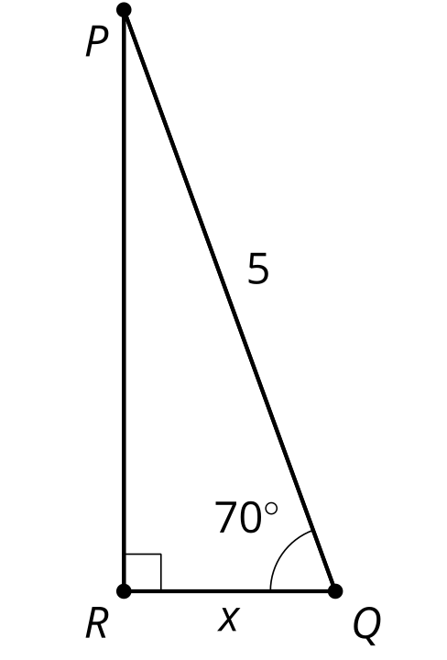

B
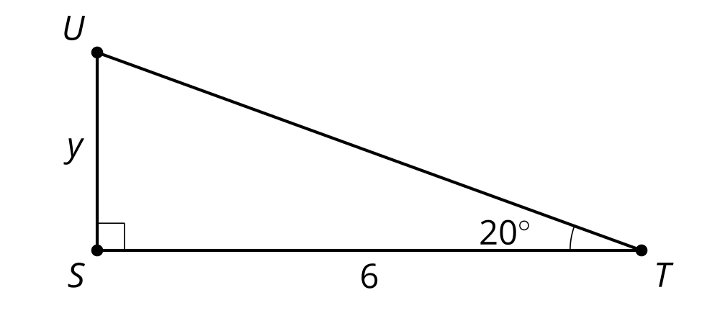

C
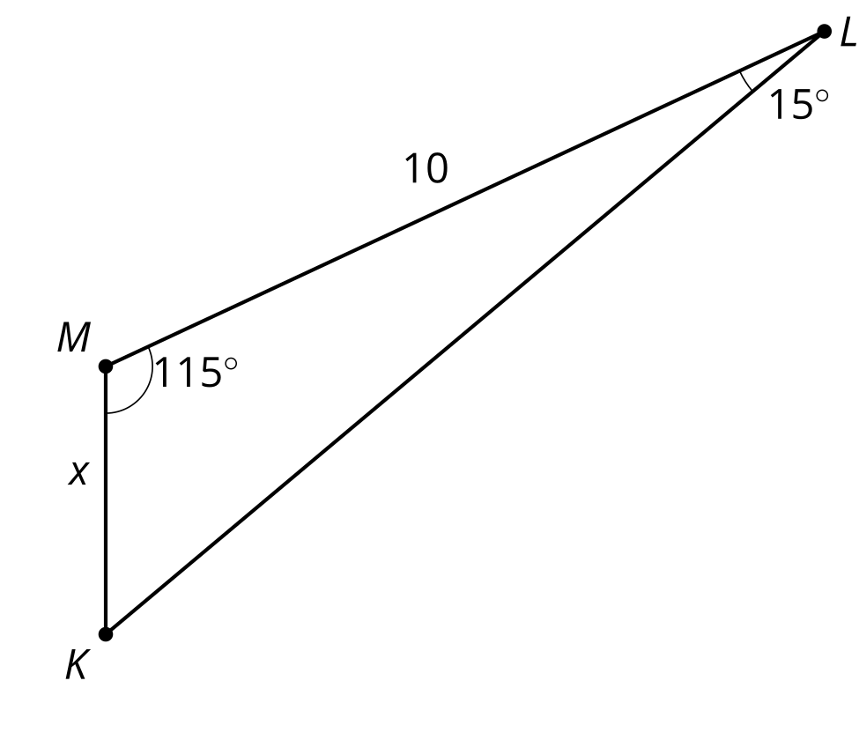

D
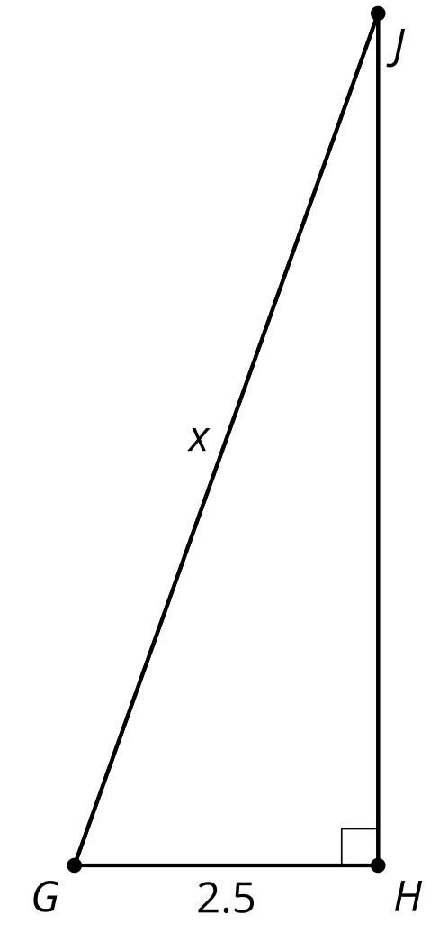

8.2: Twin Triangles
Your teacher will assign you to either Column A or Column B. Find the value of the variable for the problems in your column.
Column A:
Column B:

A1
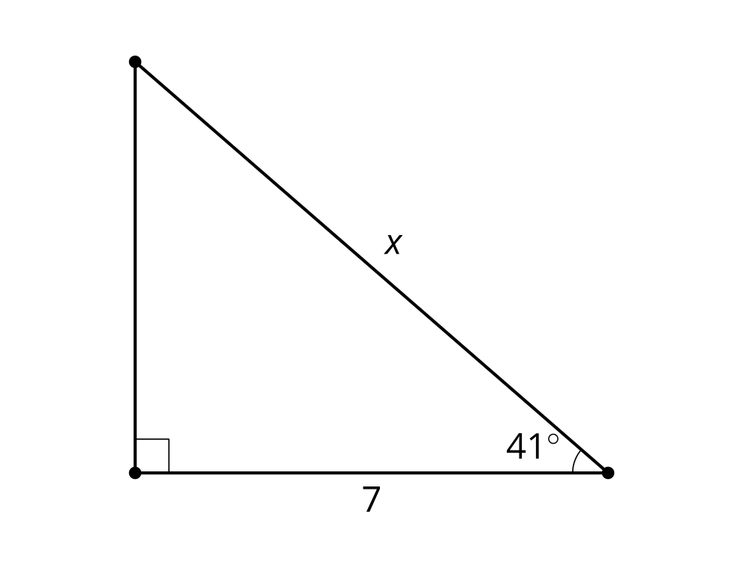

B1
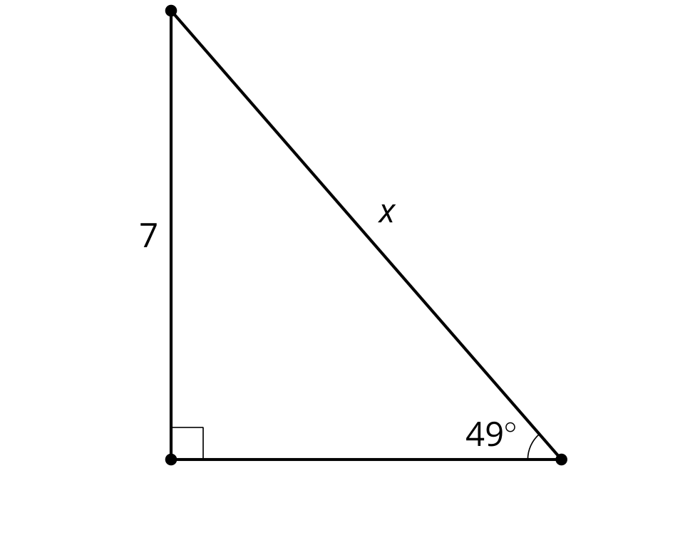

A2
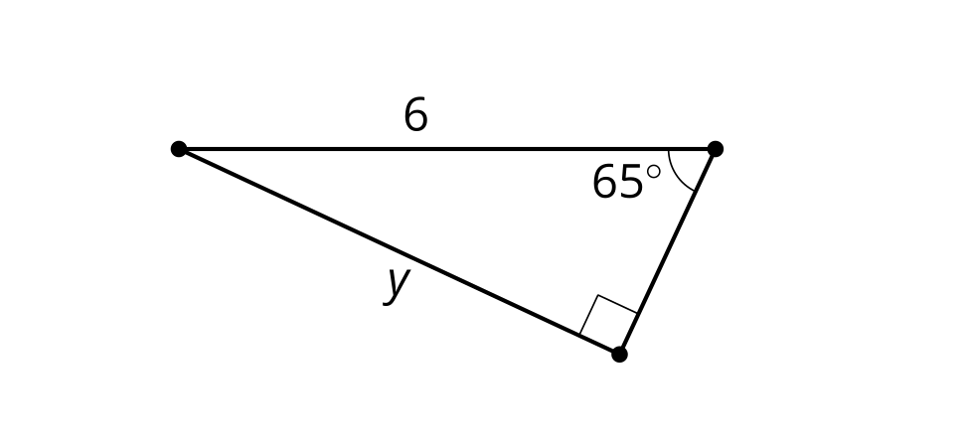

B2
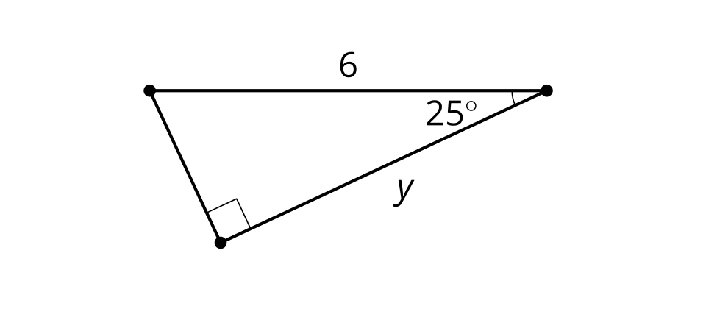

A3
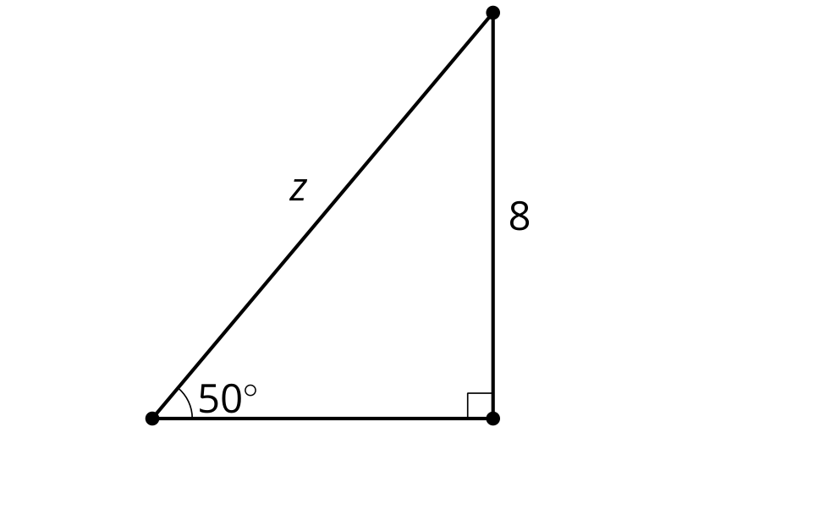

B3
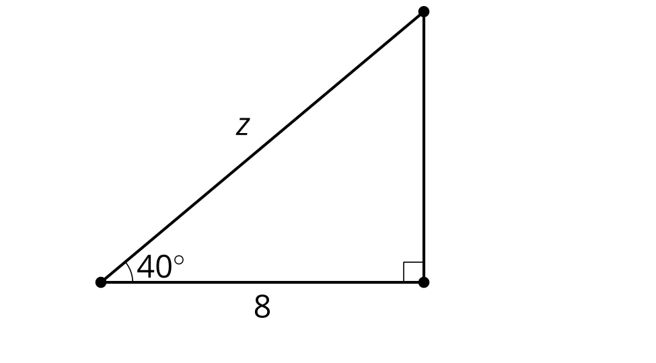
Compare your solutions with your group's solutions. Why did you get the same answers to different problems?

8.3: Explain the Co-nnection
- Draw a diagram that will help you explain why $sin\left(θ\right)=cos\left(90−θ\right)$.
- Explain why $sin\left(θ\right)=cos\left(90−θ\right)$.
Discuss your thinking with your group. If you disagree, work to reach an agreement.
Create a visual display that includes:
- A clearly-labeled diagram.
- An explanation using precise language.

Are you ready for more?
- Make a conjecture about the relationship between $tan\left(θ\right)$ and $tan\left(90−θ\right)$.
- Prove your conjecture.

Lesson 8 Summary
In previous lessons, we recalled that any right triangle with acute angles of 25 and 65 degrees was similar to any other right triangle with these same acute angles. Revisiting these triangles, we notice that the sine of 25 degrees is equal to the cosine of 65 degrees, and the cosine of 25 degrees is equal to the sine of 65 degrees.
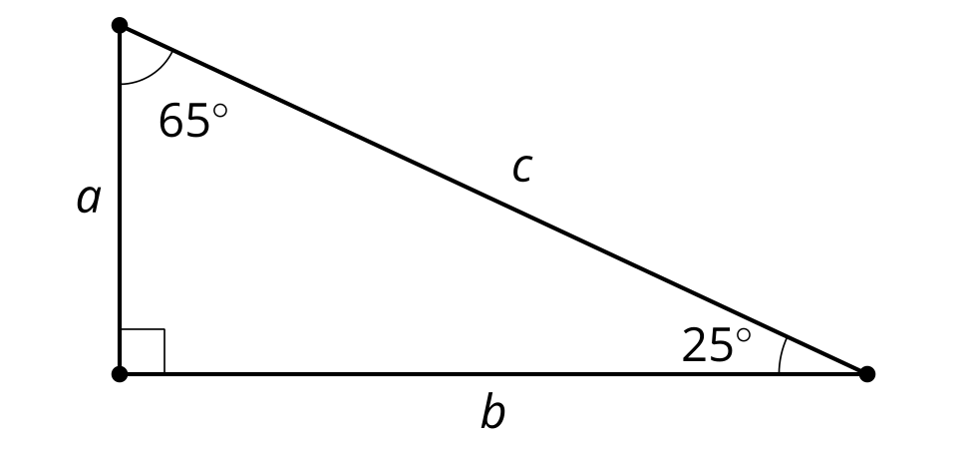
angle | cosine of angle = adjacent leg $÷$ hypotenuse | sine of angle = opposite leg $÷$ hypotenuse
${25}^{∘}$ | 0.906 | 0.423
${65}^{∘}$ | 0.423 | 0.906
Looking at a general right triangle, the angles can be written as 90, $θ$, and $90−θ$. Mathematicians often use Greek letters to represent angles. For instance, $θ$ is a Greek letter we use frequently in trigonometry.
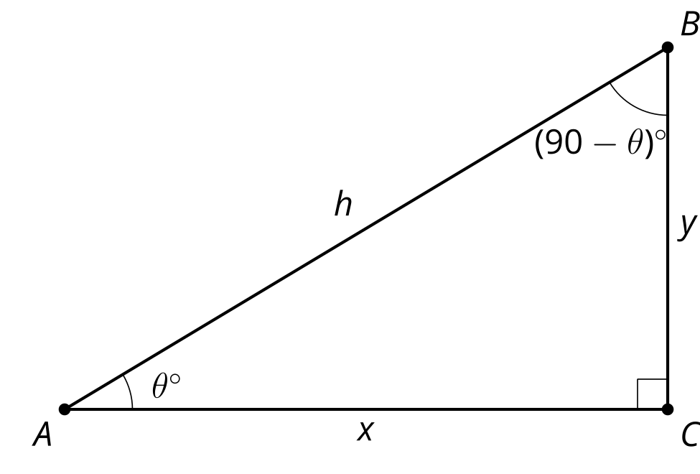
 | cosine of angle | sine of angle
angle | adjacent leg $÷$ hypotenuse | opposite leg $÷$ hypotenuse
$θ^{∘}$ | $\frac{x}{h}$ | $\frac{y}{h}$
${\left(90−θ\right)}^{∘}$ | $\frac{y}{h}$ | $\frac{x}{h}$
© CC BY 2019 by Illustrative Mathematics®

