Unit 2 Lesson 15: Multiply More Fractions

WU Number Talk: Multiply Mixed Numbers (Warm up)

Student Task Statement
Find the value of each expression mentally.
- $6×\frac{3}{8}$
- $6×2\frac{3}{8}$
- $7×\frac{9}{10}$
- $7×3\frac{9}{10}$

1 Multiply Your Way

Student Task Statement
Write numbers from the list in the blank spaces so the situations make sense. Each number will be used only one time. Be prepared to explain your thinking.
4 | 5 | $5\frac{1}{2}$ | 3 | $5\frac{3}{4}$ | 2

- The area of the rug is $16\frac{1}{2}$ square feet. The length of the rug is ___________ feet.
- The width of the rug is ___________ feet.
- The puzzle is $2\frac{1}{2}$ feet wide. It is _______ feet long. It has an area of _________ square feet.
- The area of the whiteboard is 23 square feet. The length of the whiteboard is
- _________ feet. The width of the whiteboard is ________ feet.
Share your solutions with your partner. Explain what choices you made and why.

2 Equivalent Expressions

Student Task Statement
Each diagram represents a way to calculate $4×5\frac{2}{3}$. Each expression is equivalent to $4×5\frac{2}{3}$. Match the diagrams and expressions. Show or explain your reasoning.
A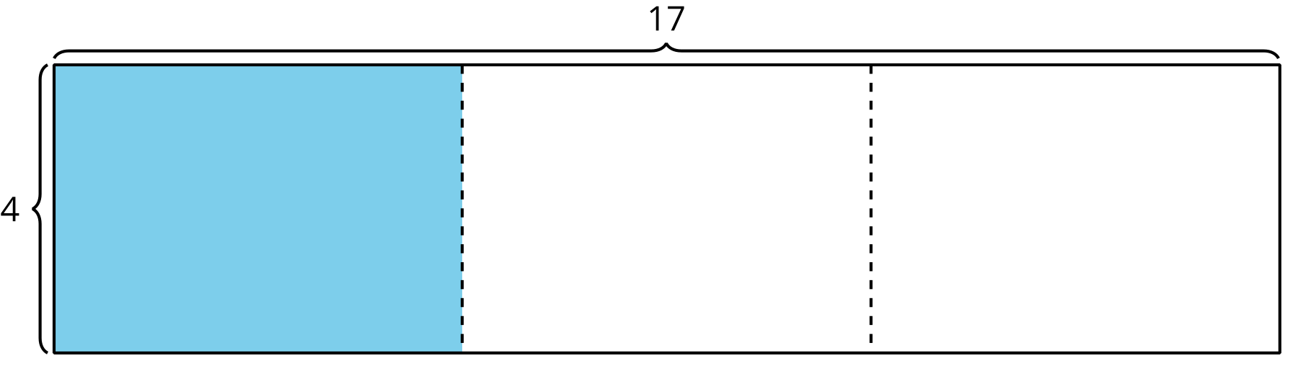
B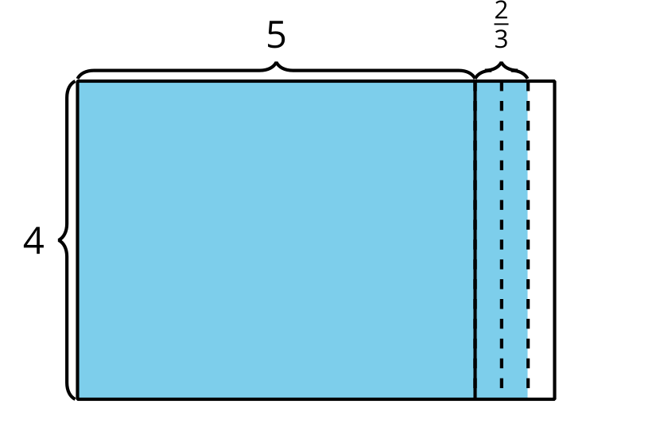
1. $\left(4×5\right)+\left(4×\frac{2}{3}\right)$
C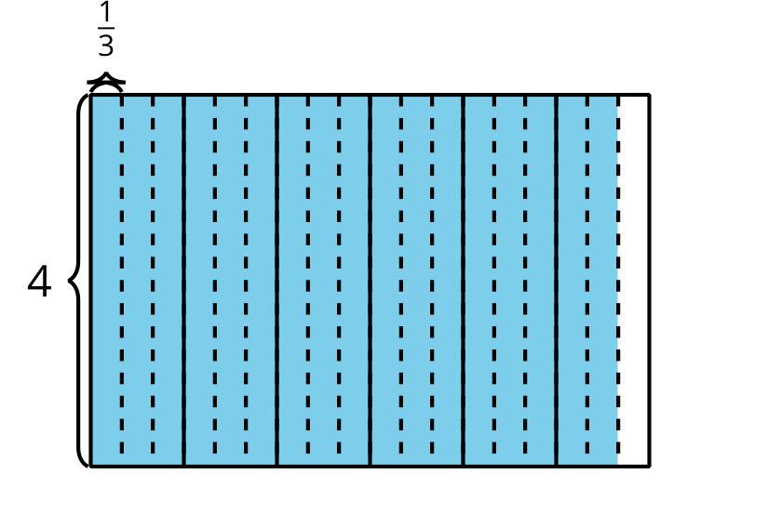
2. $\left(4×6\right)−\left(4×\frac{1}{3}\right)$

3. $4×\frac{17}{3}$
D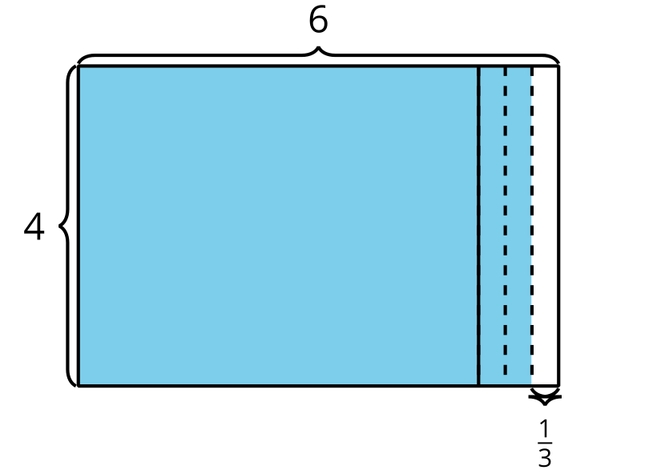

4. $\left(4×17\right)÷3$
Choose your favorite diagram and expression to find the value of $4×5\frac{2}{3}$. Explain why it is your favorite.
© CC BY 2021 Illustrative Mathematics®

