Unit 7 Lesson 9: Equal Pieces

WU Which One Doesn’t Belong: Pieces of Shapes (Warm up)

Student Task Statement
Which one doesn’t belong?
A
B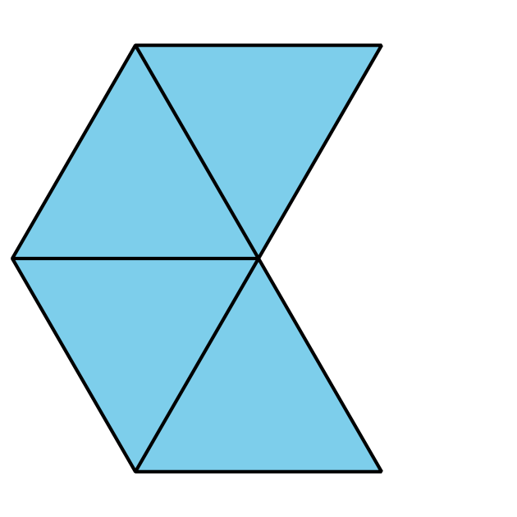
C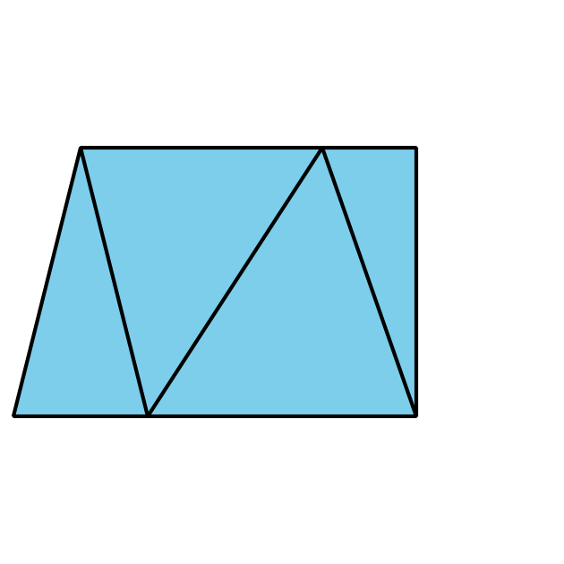
D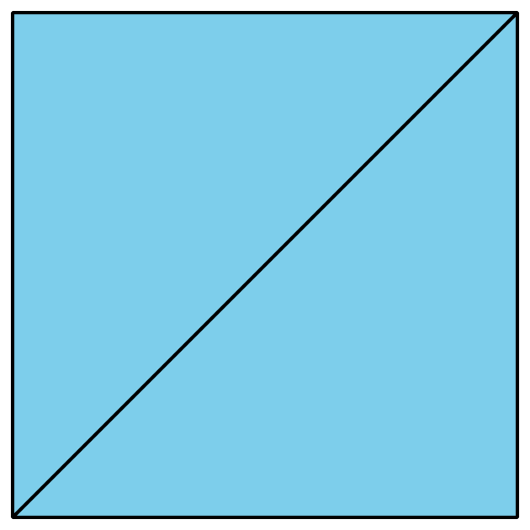

1 Build a Circle

Student Task Statement
Synthesis:
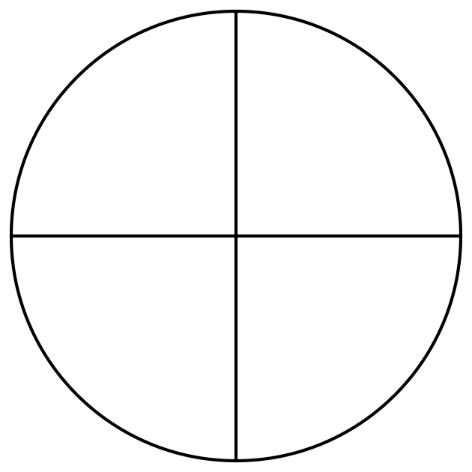
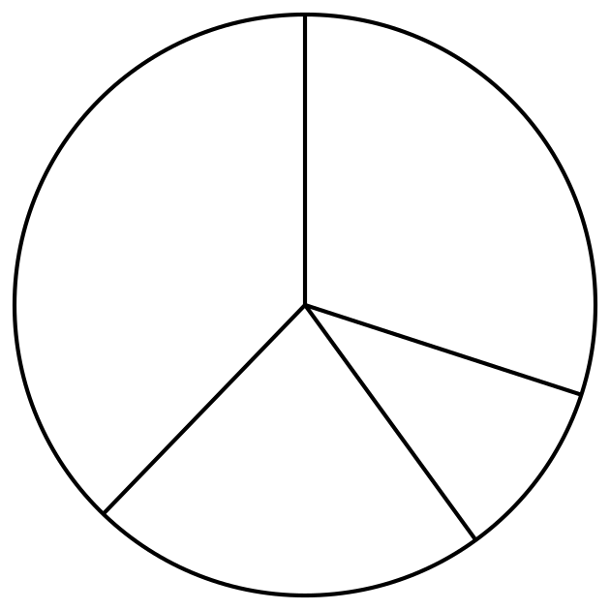
Which of these shows equal pieces that make a circle?

2 Fold into Equal Pieces

Student Task Statement
- Cut out one circle and one square.
- Fold each shape so that there are 2 equal pieces.
- Be ready to explain how you know your shape has 2 equal pieces.
- Cut out one circle and one square.
- Fold each shape so that there are 4 equal pieces.
- Be ready to explain how you know your shape has 4 equal pieces.
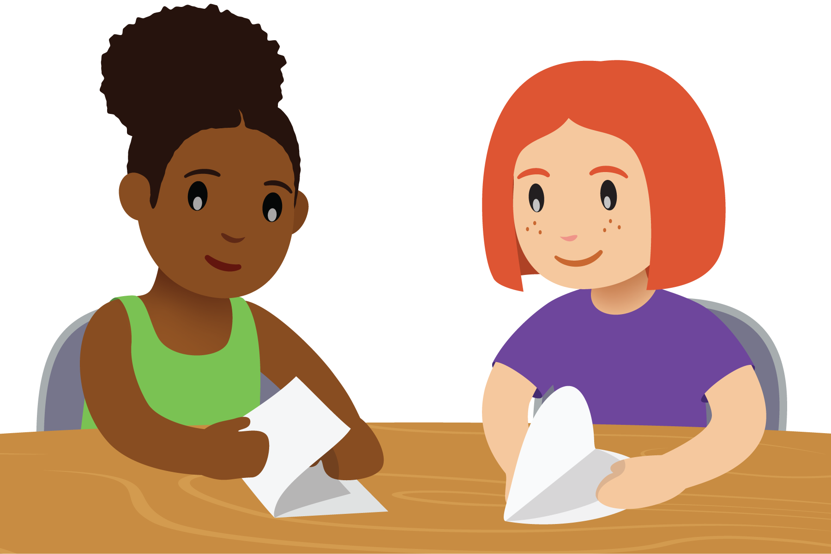

3 Halves or Fourths

Student Task Statement
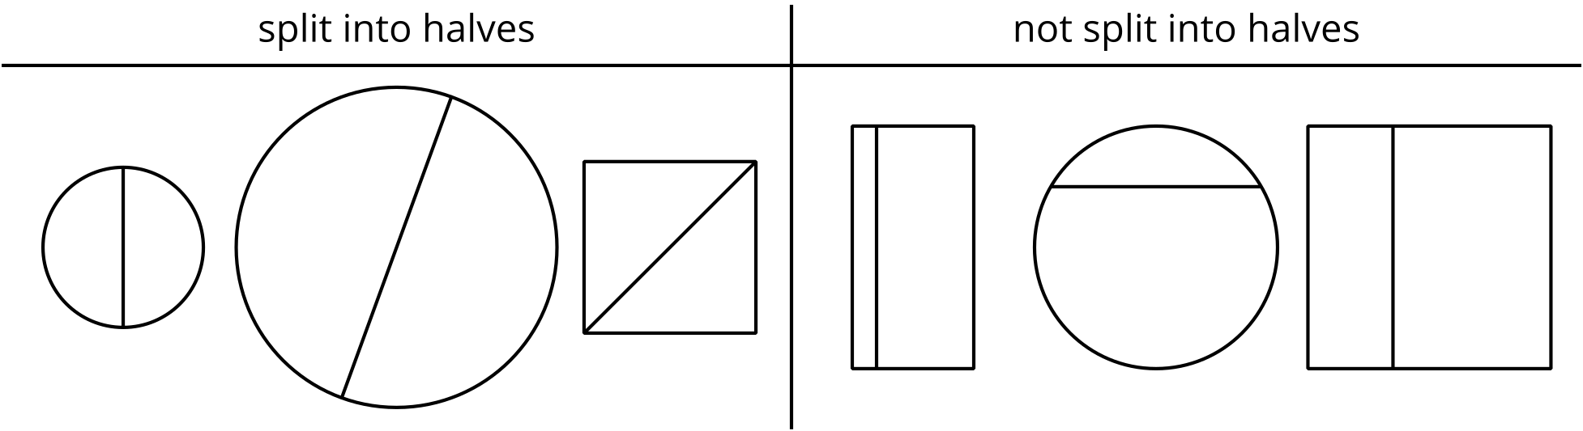
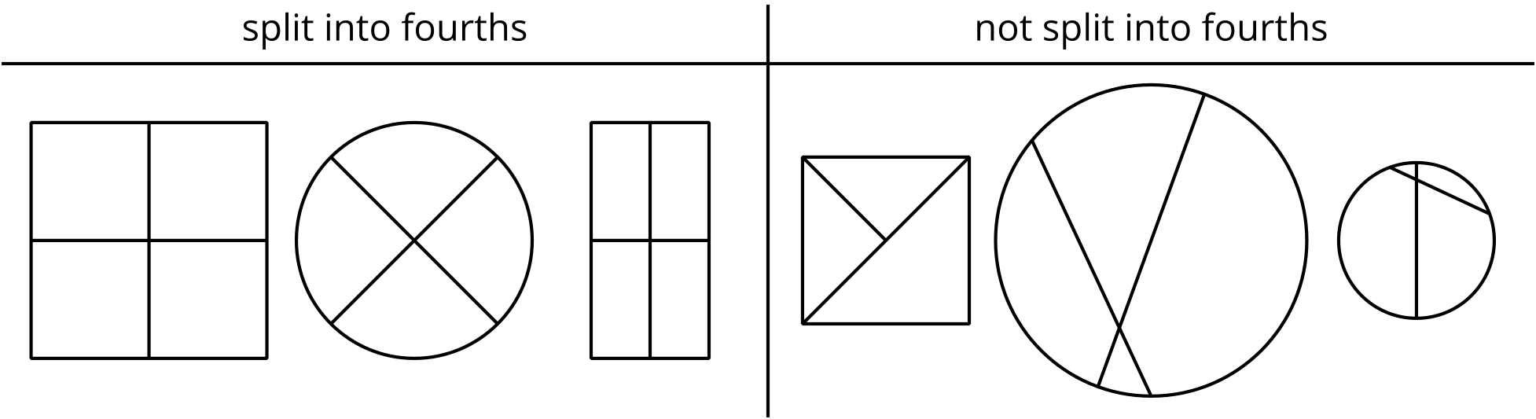

- Split each shape into halves.
- Split each shape into fourths.
- Split each shape into fourths.
- Split each shape into halves.
- Split each shape into halves.
- Split each shape into fourths.
© CC BY 2021 Illustrative Mathematics®

