Unit 2 Lesson 10: Meet Slope

1 Equal Quotients (Warm up)

Student Task Statement
Write some numbers that are equal to $15÷12$.

2 Similar Triangles on the Same Line

Student Task Statement
- The figure shows three right triangles, each with its longest side on the same line. Your teacher will assign you two triangles. Explain why the two triangles are similar.
- 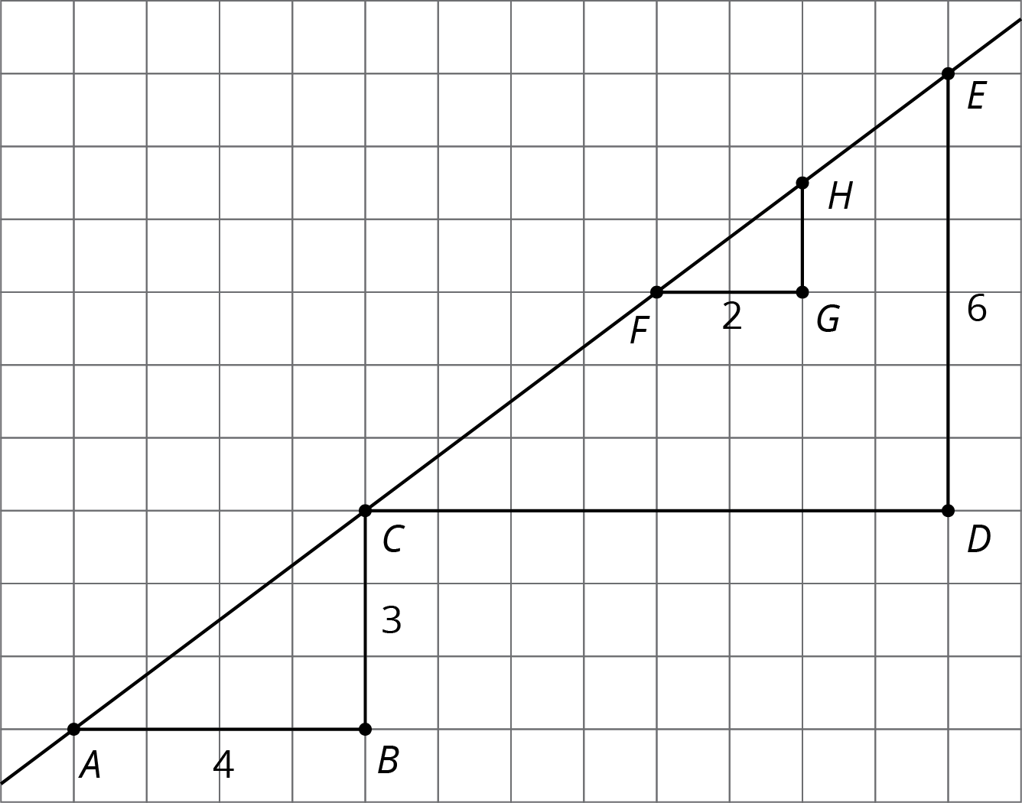
- Complete the table.
- triangle | - length of  vertical side | - length of  horizontal side | - (vertical side) $÷$ (horizontal side)
- $ABC$
- $CDE$
- $FGH$

Activity Synthesis
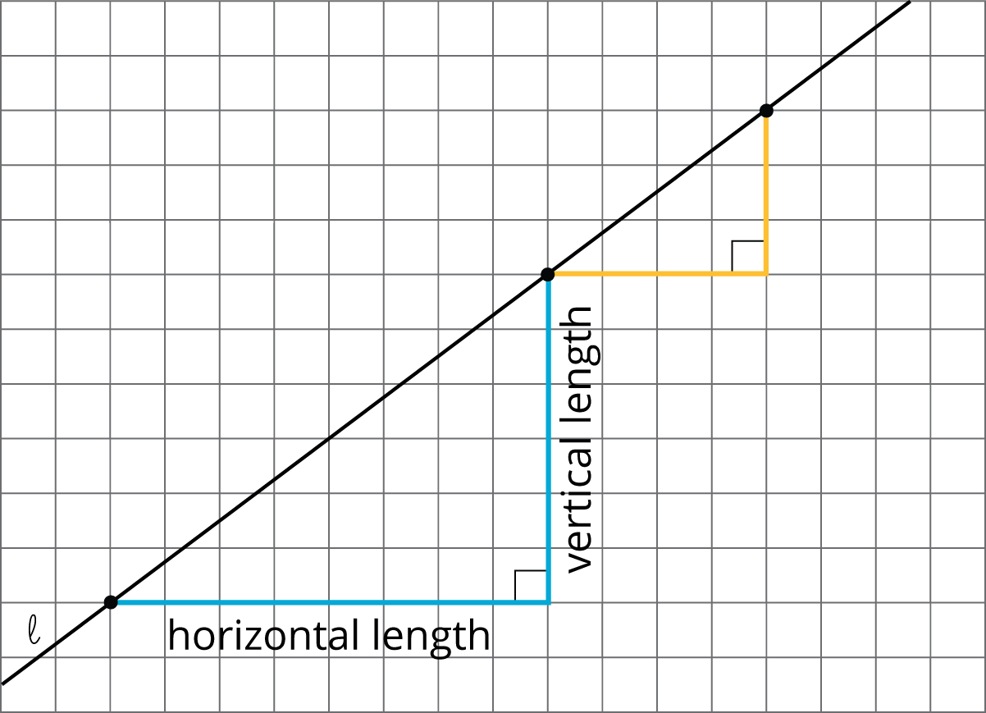

3 Multiple Lines with the Same Slope

Student Task Statement
- Draw two lines with slope 3. What do you notice about the two lines?
- Draw two lines with slope $\frac{1}{2}$. What do you notice about the two lines?

4 Different Slopes of Different Lines (Optional)

Student Task Statement
Here are several lines.
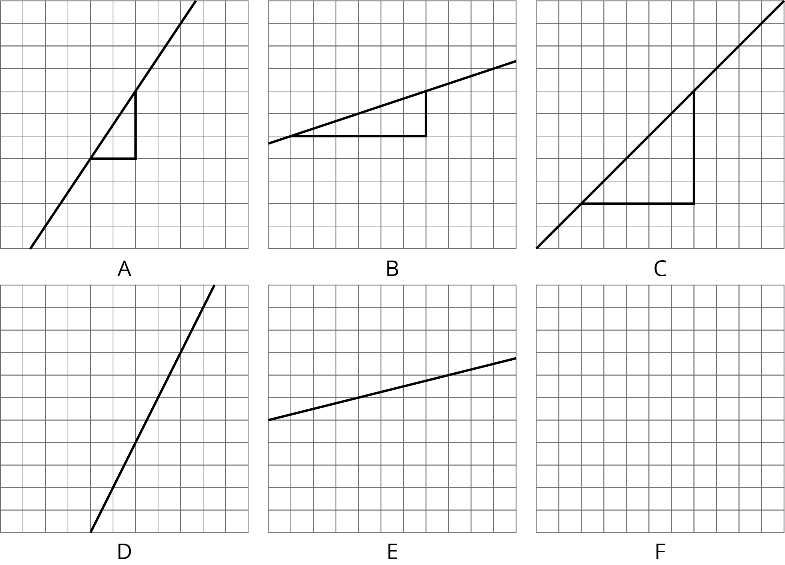
- Match each line shown with a slope from this list: $\frac{1}{3}$, 2, 1, 0.25, $\frac{3}{2}$, $\frac{1}{2}$.
- One of the given slopes does not have a line to match. Draw a line with this slope on the empty grid (F).

Images for Activity Synthesis
© CC BY Open Up Resources. Adaptations CC BY IM.

