Lesson 9: Using Trigonometric Ratios to Find Angles
- Let’s work backwards to find angles in right triangles.

9.1: Once More with the Table
A triangle with side lengths 3, 4, and 5 is a right triangle by the converse of the Pythagorean Theorem. What are the measures of the acute angles?

9.2: From Ratios to Angles
Find all missing side and angle measures.
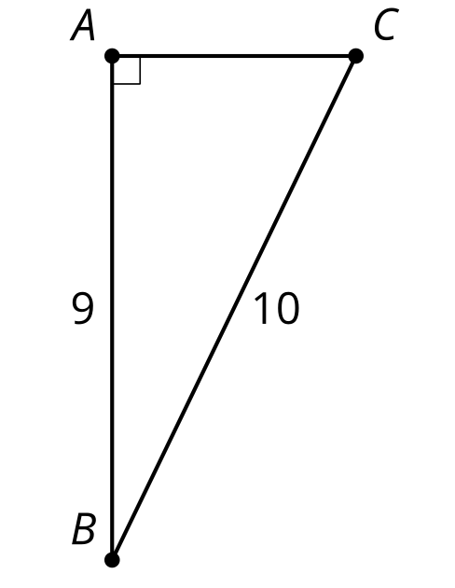
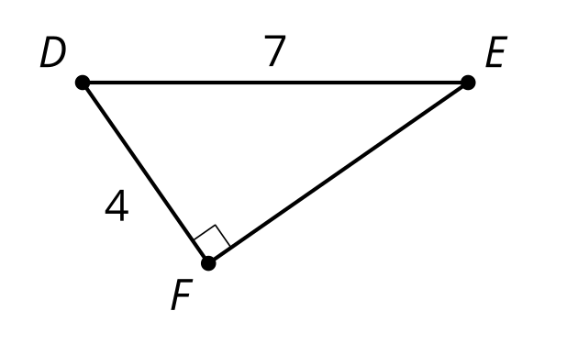
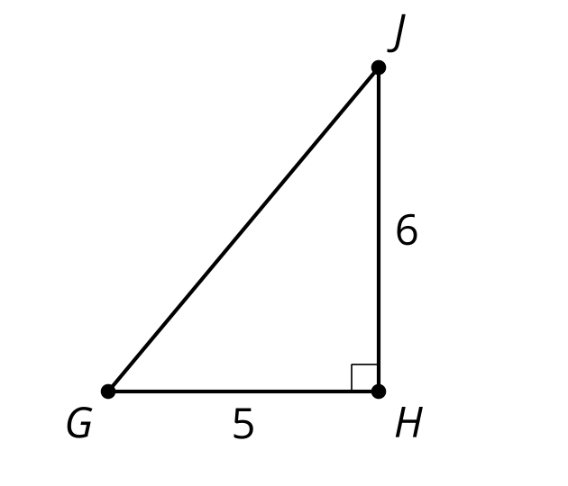

9.3: Leaning Ladders
A good rule of thumb for a safe angle to use when leaning a ladder is the angle formed by your body when you stand on the ground and hold your arms out parallel to the ground.
- What are the angles in the triangle formed by your body and the ladder?
- What are the angles in the triangle formed by the ladder, the ground, and the railing? Explain or show your reasoning.
- You have a 13 foot long ladder and need to climb to a 12 foot tall roof.
  - If you put the top of the ladder at the top of the wall, what angle is formed between the ladder and the ground?
  - Is it possible to adjust the ladder to a safe angle? If so, give someone instructions to do so. If not, explain why not.
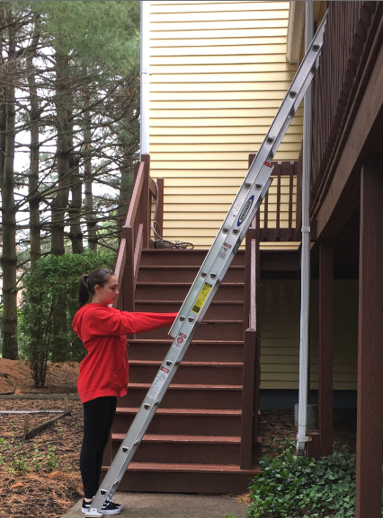

Are you ready for more?
People have various proportions to their body. Suppose that someone’s height to arm ratio is $5:1$.
- What are the angles in the triangle formed by their body and the ladder?
- How far off is this from the $4:1$ safe angle?
- What could this person do to make the ladder closer to the safe ladder angle?

Lesson 9 Summary
Using trigonometric ratios and a calculator, the missing sides and angles of right triangles can be found.
Using the right triangle table we can estimate angle measures as in previous lessons. However, with a calculator, we can find angles more precisely.
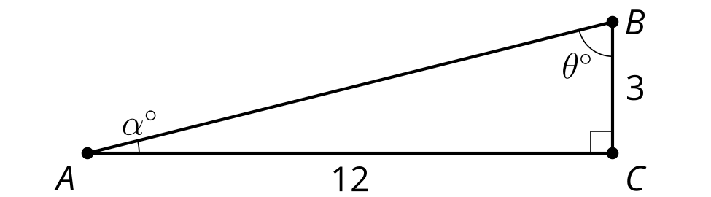
The side opposite angle $A$ is 3 units long, and the side adjacent to $A$ is 12 units long. So to find angle $A$, we write an equation using tangent: $tan\left(α\right)=\frac{3}{12}$. To find the measure of angle $A$ we ask the calculator, “What angle has a tangent of $\frac{3}{12}$?” To ask that, we use arctangent by writing $arctan\left(\frac{3}{12}\right)$. If we know the cosine, we use arccosine to look up the angle, and if we know the sine, we use arcsine. So $α=arctan\left(\frac{3}{12}\right)$, which means angle $A$ measures about 14 degrees.
Angle $B$ can be calculated using another trigonometric equation or the Triangle Angle Sum Theorem. Let's use arctangent again. We know $tan\left(θ\right)=\frac{12}{3}$, so $θ=arctan\left(\frac{12}{3}\right)$, which is about 76 degrees. This matches the answer we get with the Triangle Angle Sum Theorem: $180−90−14=76$.
© CC BY 2019 by Illustrative Mathematics®

