Unit 5 Lesson 17: Volume and Density

1 A Kilogram by Any Other Name (Warm up)

Student Task Statement
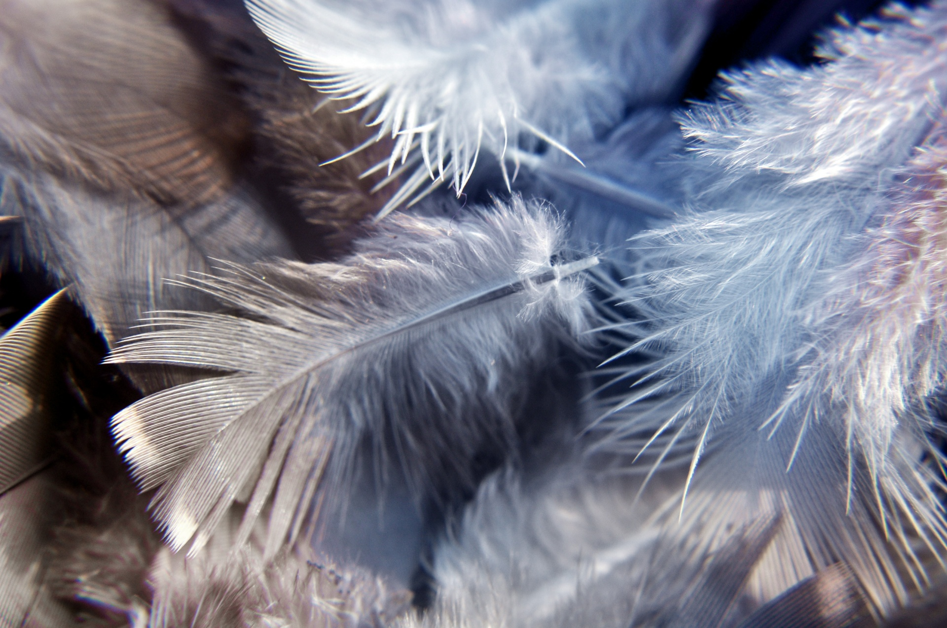
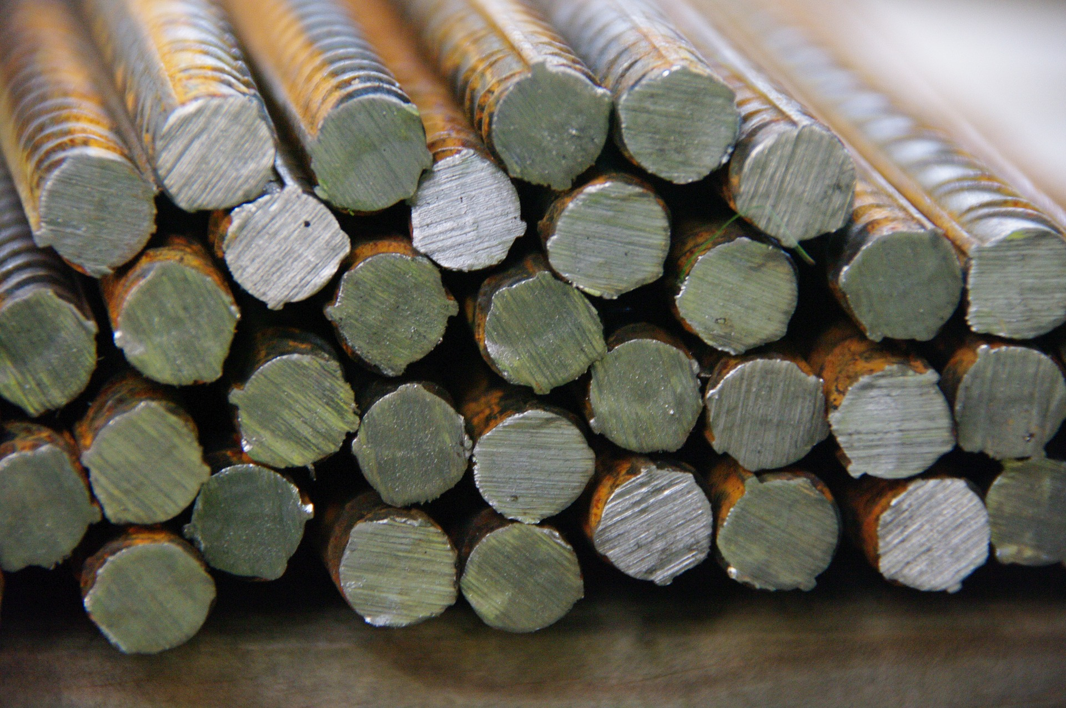
Which has more mass, a thousand kilograms of feathers or a thousand kilograms of steel? Explain your reasoning.

Activity Synthesis

density: 1 gram per cm³
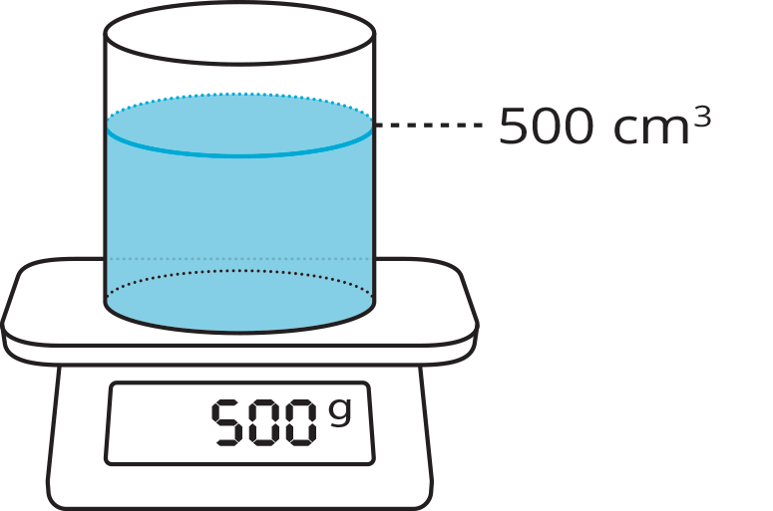

2 Light as a Feather

Student Task Statement
The feathers in a pillow have a total mass of 59 grams. The pillow is in the shape of a rectangular prism measuring 51 cm by 66 cm by 7 cm.
A steel anchor is shaped like a square pyramid. Each side of the base measures 20 cm, and its height is 28 cm. The anchor’s mass is 30 kg.
- What’s the density of feathers in kilograms per cubic meter?
- What’s the density of steel in kilograms per cubic meter?
- What’s the volume of 1,000 kg of feathers in cubic meters?
- What’s the volume of 1,000 kg of steel in cubic meters?

3 A Fishy Situation

Student Task Statement
An aquarium manager drew a blueprint for a cylindrical fish tank. The tank has a vertical tube in the middle in which visitors can stand and view the fish.
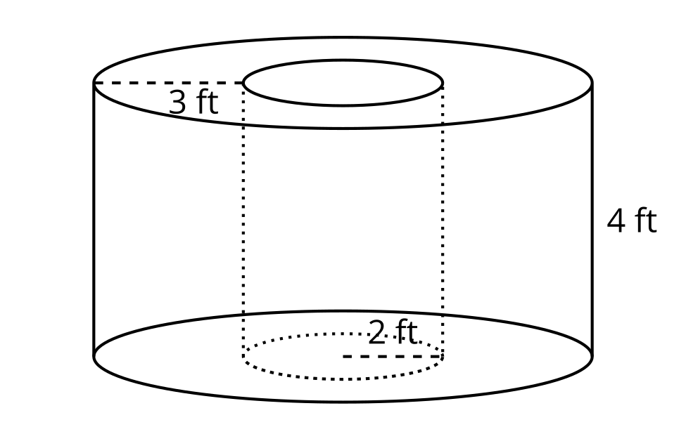
The best average density for the species of fish that will go in the tank is 16 fish per 100 gallons of water. This provides enough room for the fish to swim while making sure that there are plenty of fish for people to see.
The aquarium has 275 fish available to put in the tank. Is this the right number of fish for the tank? If not, how many fish should be added or removed? Explain your reasoning.
© CC BY 2019 by Illustrative Mathematics®

