Unit 2 Lesson 16: Estimate Products

WU Notice and Wonder: Garden Size (Warm up)

Student Task Statement
What do you notice? What do you wonder?
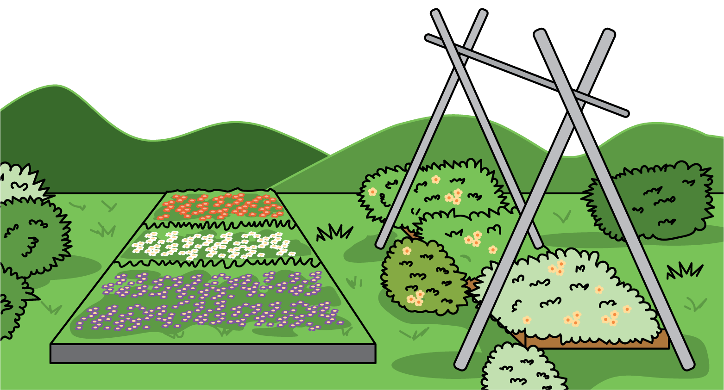

1 Priya’s Garden

Images for Launch

Student Task Statement
Priya has enough materials to build a garden that is 36 square feet.
Choose all the side lengths that are reasonable for her garden. Be prepared to explain your thinking to your partner.
- 9 feet by $4\frac{2}{3}$ feet
- 9 feet by $3\frac{8}{9}$ feet
- 12 feet by $2\frac{11}{12}$ feet
- 9 feet by $2\frac{2}{3}$ feet

2 Too High, Too Low, Just About Right

Student Task Statement
- Write a whole number product that is slightly less than, slightly greater than, or about equal to the value of $7×12\frac{8}{9}$.
  - slightly less:
  - slightly greater:
  - just right:
- Write a whole number product that is slightly less than, slightly greater than, or about equal to the value of $9×4\frac{2}{29}$.
  - slightly less:
  - slightly greater:
  - just right:
- Without calculating, use the numbers 2, 3, 5, 6, and 7, to complete the expression with a value close to 20.
_× _aaaiaaaiaaaiaaai
- Explain how you know your expression represents a value close to 20.
© CC BY 2021 Illustrative Mathematics®

