Lesson 12: Equivalent Fractions on a Number Line

Standards Alignments
Addressing | 3.NF.A.3.a, 3.NF.A.3.b
Building Towards | 3.NF.A.3

Teacher-facing Learning Goals
- Identify and generate equivalent fractions.
- Understand two fractions as equivalent if they are at the same point on a number line.

Student-facing Learning Goals
- Let’s find fractions at the same location.

Lesson Purpose
The purpose of this lesson is for students to use the number line to determine whether fractions are equivalent.
In previous lessons, students learned that two fractions are equivalent if they are the same size. In this lesson, students work with situations that involve lengths to build their understanding that fractions at the same location on a number line are equivalent. Number lines are provided to ensure that if students choose to use two number lines to demonstrate equivalence, they work with the same length interval for 1 unit.

Access for:

Students with Disabilities
- Engagement (Activity 2)

English Learners
- MLR8 (Activity 1)

Instructional Routines
Notice and Wonder (Warm-up)

Materials to Gather
- Number cubes: Activity 3

Lesson Timeline
Warm-up | 10 min
Activity 1 | 10 min
Activity 2 | 10 min
Activity 3 | 15 min
Lesson Synthesis | 10 min
Cool-down | 5 min

Teacher Reflection Question
In this lesson, students use number lines to show that fractions are equivalent. How did their previous work with diagrams and fraction strips prepare them to do this?

Cool-down
(to be completed at the end of the lesson) 5min
Equivalence on the Number Line

Standards Alignments
Addressing | 3.NF.A.3.a

Student-facing Task Statement
Use the number line(s) to decide whether $\frac{3}{4}$ and $\frac{6}{8}$ are equivalent. Explain your reasoning.

Student Responses
$\frac{3}{4}$ and $\frac{6}{8}$ are equivalent because they are at the same point on the number line. Sample responses:
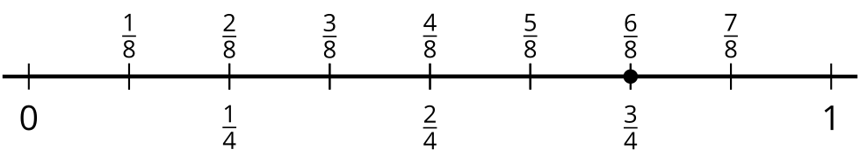
or
