Lesson 2: Compare the Length of Objects Indirectly
- Let’s compare 2 objects using a third object.

Warm-up: Number Talk: Add within 100
Find the value of each expression mentally.
- $35+20$
- $35+25$
- $30+45$
- $37+45$

2.1: Which is Longer? Which is Shorter?
Find 2 objects that are longer and 2 objects that are shorter than the unsharpened pencil.
Write a sentence that compares each object to the pencil.
Example: The bulletin board is longer than the pencil.

2.2: Measure Your Desk
Compare the length of the side of your desk and the length of one of the legs of your desk using the string.
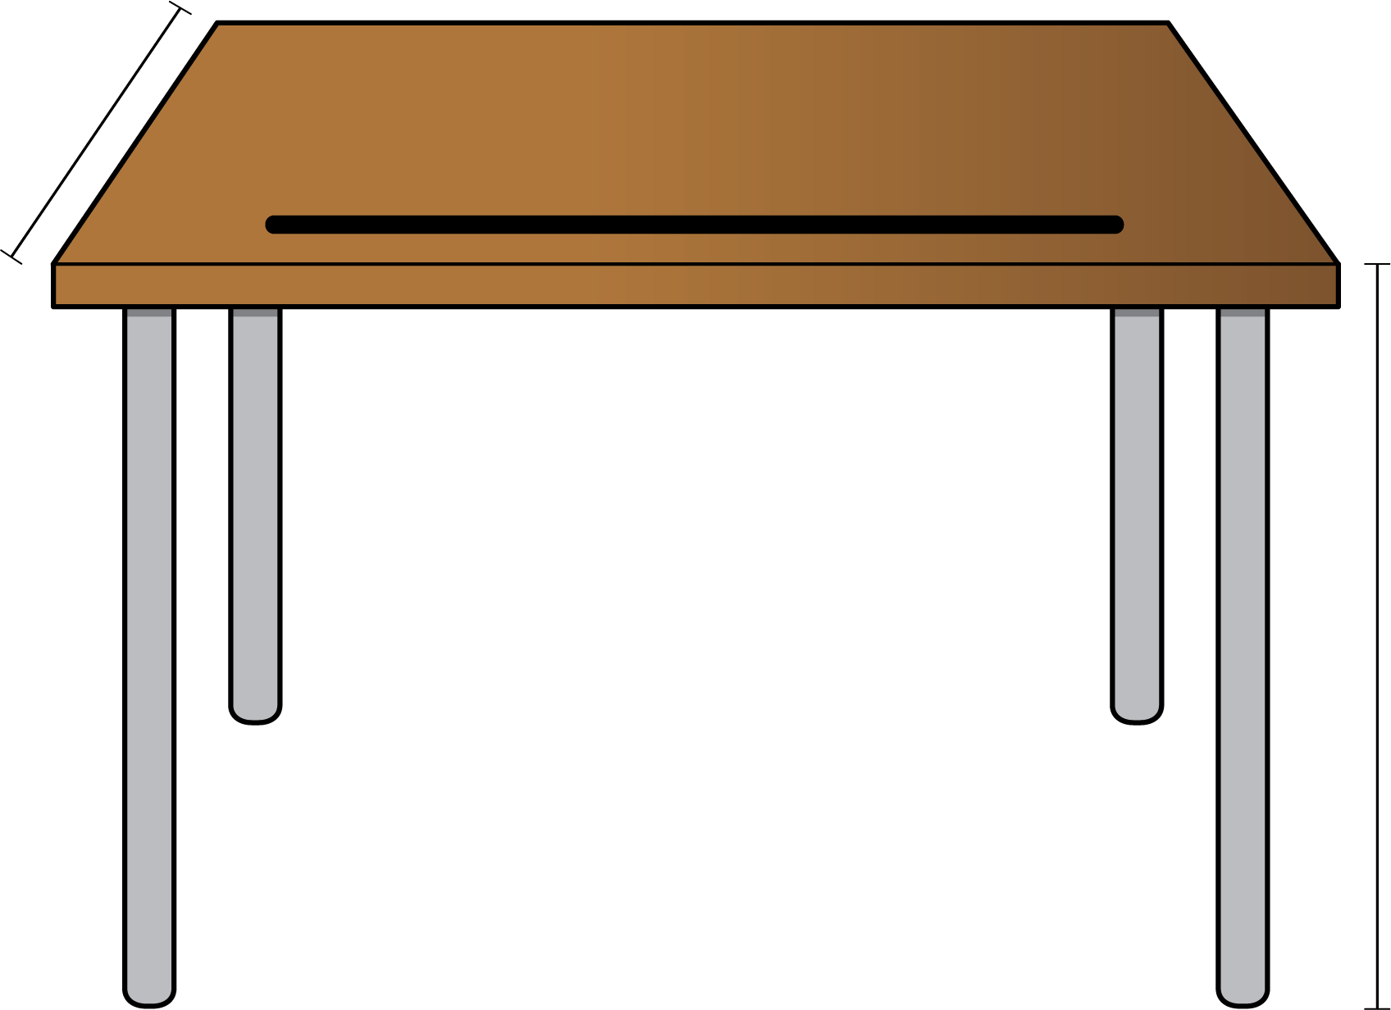
Use a drawing or words to explain how you know which is longer.
© CC BY 2021 Illustrative Mathematics®

