Lesson 4: Symmetry in Figures (Part 1)

Standards Alignments
Addressing | 4.G.A.2, 4.G.A.3

Teacher-facing Learning Goals
- Describe lines of symmetry for two-dimensional figures and identify figures with line symmetry.

Student-facing Learning Goals
- Let’s describe symmetry in two-dimensional figures.

Lesson Purpose
The purpose of this lesson is to introduce the concept of line symmetry and for students to identify lines of symmetry in two-dimensional figures.
This lesson introduces students to symmetry as an attribute of two-dimensional figures. Students relate lines of symmetry to the lines of folding that create two identical halves: if a figure is folded along or mirrored across such a line, the two halves would overlap and match exactly. The idea of folding along or mirroring across a line is essential here, as there are some figures that could be decomposed into two identical halves but have no line symmetry.
After reasoning about the meaning of lines of symmetry from examples and non-examples, students work to identify figures that have line symmetry and draw lines of symmetry.

Access for:

Students with Disabilities
- Representation (Activity 1)

English Learners
- MLR8 (Activity 2)

Instructional Routines
MLR1 Stronger and Clearer Each Time (Activity 1), Notice and Wonder (Warm-up)

Materials to Gather
- Materials from a previous lesson: Activity 2
- Patty paper: Activity 1, Activity 2, Activity 3
- Protractors: Activity 1, Activity 2
- Rulers or straightedges: Activity 1, Activity 3
- Rulers: Activity 2
- Scissors: Activity 1

Materials to Copy
- Perfect Matches (groups of 6): Activity 1
- Shape Cards Grade 4 (groups of 2): Activity 2

Lesson Timeline
Warm-up | 10 min
Activity 1 | 20 min
Activity 2 | 15 min
Activity 3 | 10 min
Lesson Synthesis | 10 min
Cool-down | 5 min

Teacher Reflection Question
What ideas do students have about symmetry? How will you leverage those ideas in the next lesson?

Cool-down
(to be completed at the end of the lesson) 5min
One Line or More than One?

Standards Alignments
Addressing | 4.G.A.3

Student-facing Task Statement
Which figures have more than one line of symmetry? Explain or show your reasoning.
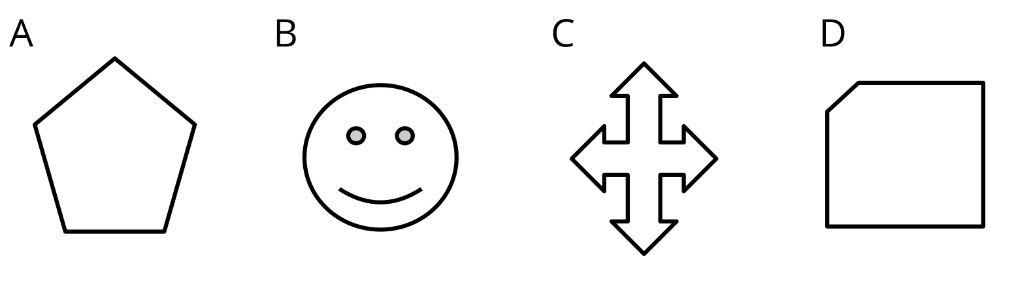

Student Responses
C is the only one with more than one line of symmetry. All the others have only one line of symmetry.
