Lesson 15 Practice Problems
- The $x$-axis of each graph has the diameter of a circle in meters. Label the $y$-axis on each graph with the appropriate measurement of a circle:
radius (m), circumference (m), or area (m²).
- 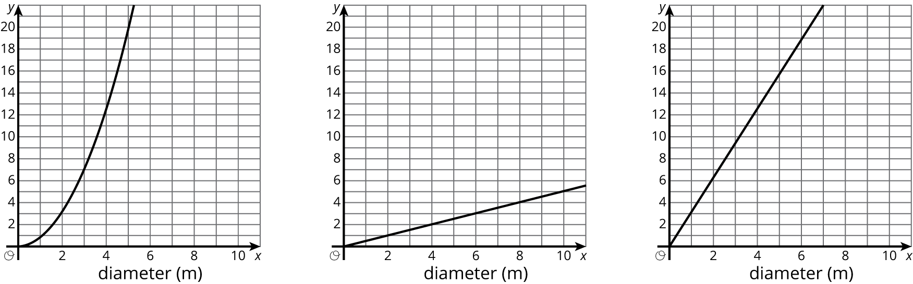
- A circle’s circumference is approximately 76 cm. Estimate the radius, diameter, and area of the circle.
- Jada paints a circular table that has a diameter of 37 inches. What is the area of the table?
- Point $A$ is the center of the circle, and the length of $CD$ is 15 centimeters. Find the circumference of this circle.
- 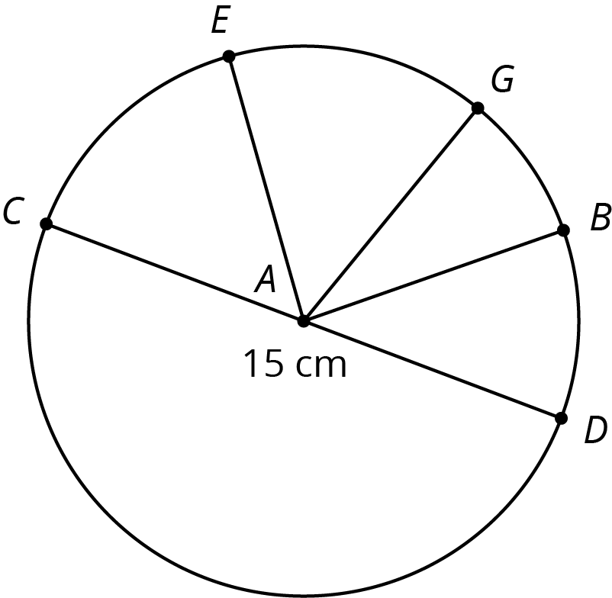
- (From Unit 5, Lesson 12.)
- The Carousel on the National Mall has 4 rings of horses. Kiran is riding on the inner ring, which has a radius of 9 feet. Mai is riding on the outer ring, which is 8 feet farther out from the center than the inner ring is.
  - In one rotation of the carousel, how much farther does Mai travel than Kiran?
  - One rotation of the carousel takes 12 seconds. How much faster does Mai travel than Kiran?
- (From Unit 5, Lesson 13.)
© CC BY Open Up Resources. Adaptations CC BY IM.

