Unit 6 Lesson 8: Percentage Situations

1 Tax, Tip, and Discount (Warm up)

Student Task Statement
What percentage of the car price is the tax?
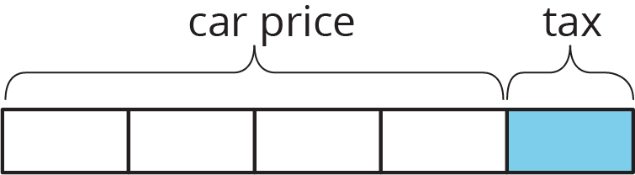
What percentage of the food cost is the tip?
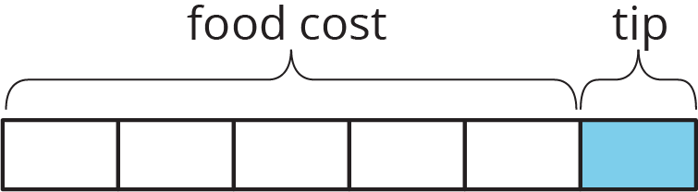
What percentage of the shirt cost is the discount?
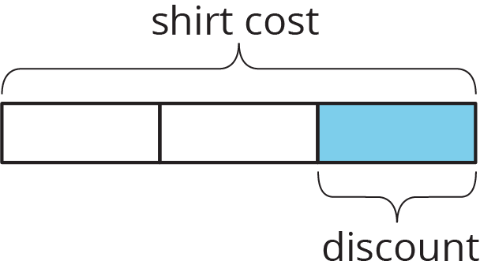

2 A Car Dealership

Student Task Statement
A car dealership pays a wholesale price of $12,000 to purchase a vehicle.
- The car dealership wants to make a 32% profit.
  - By how much will they mark up the price of the vehicle?
  - After the markup, what is the retail price of the vehicle?
- During a special sales event, the dealership offers a 10% discount off of the retail price. After the discount, how much will a customer pay for this vehicle?

3 Commission at a Gym

Student Task Statement
- For each gym membership sold, the gym keeps $42 and the employee who sold it gets $8. What is the commission the employee earned as a percentage of the total cost of the gym membership?
- If an employee sells a family pass for $135, what is the amount of the commission they get to keep?

4 Info Gap: Sporting Goods

Student Task Statement
Your teacher will give you either a problem card or a data card. Do not show or read your card to your partner.
If your teacher gives you the problem card:
- Silently read your card and think about what information you need to be able to answer the question.
- Ask your partner for the specific information that you need.
- Explain how you are using the information to solve the problem.
- Continue to ask questions until you have enough information to solve the problem.
- Share the problem card and solve the problem independently.
- Read the data card and discuss your reasoning.
If your teacher gives you the data card:
- Silently read your card.
- Ask your partner “What specific information do you need?” and wait for them to ask for information.
- If your partner asks for information that is not on the card, do not do the calculations for them. Tell them you don’t have that information.
- Before sharing the information, ask “Why do you need that information?” Listen to your partner’s reasoning and ask clarifying questions.
- Read the problem card and solve the problem independently.
- Share the data card and discuss your reasoning.
Pause here so your teacher can review your work. Ask your teacher for a new set of cards and repeat the activity, trading roles with your partner.

5 Card Sort: Percentage Situations (Optional)

Student Task Statement
Your teacher will give you a set of cards. Take turns with your partner matching a situation with a descriptor. For each match, explain your reasoning to your partner. If you disagree, work to reach an agreement.
© CC BY Open Up Resources. Adaptations CC BY IM.

