Lesson 3: Compongamos números de tres dígitos

Standards Alignments
Addressing | 2.NBT.A.1, 2.NBT.A.1.a, 2.NBT.A.1.b, 2.NBT.A.2, 2.NBT.B.5

Teacher-facing Learning Goals
- Compose three-digit numbers using place value understanding.

Student-facing Learning Goals
- Compongamos números de tres dígitos.

Lesson Purpose
The purpose of this lesson is for students to use base-ten representations to build an understanding of the digits in three-digit numbers.
In previous units, students used base-ten blocks and diagrams to compose and decompose tens when adding and subtracting by place. In previous lessons, students learned that a hundred is a unit that is made up of 10 tens and used base-ten blocks to show composing a hundred with 10 tens.
In this lesson, students represent three-digit numbers that include an amount of hundreds, tens, and ones. In the first activity, students take inventory of the units represented by a collection of base-ten blocks. They use their understanding of the units of hundred and ten to determine how to represent the total value with the fewest number of blocks possible. In the second activity, students use base-ten diagrams to represent values using the fewest number of each unit possible and connect these representations to the meaning of each digit in a three-digit numeral. In both activities, look for the different ways students represent and record the value of their blocks for reference in the activity syntheses and in future lessons.

Access for:

Students with Disabilities
- Engagement (Activity 2)

Instructional Routines
MLR7 Compare and Connect (Activity 1), Number Talk (Warm-up)

Materials to Gather
- Base-ten blocks: Activity 1, Activity 2
- Tools for creating a visual display: Activity 1

Lesson Timeline
Warm-up | 10 min
Activity 1 | 20 min
Activity 2 | 15 min
Lesson Synthesis | 10 min
Cool-down | 5 min

Teacher Reflection Question
In grade 1, students developed an understanding of the digits in a two-digit number. How did the work of this lesson reinforce that understanding? How did it build on that understanding?

Cool-down
(to be completed at the end of the lesson) 5min
¿Cuántos bloques?

Standards Alignments
Addressing | 2.NBT.A.1.a

Student-facing Task Statement
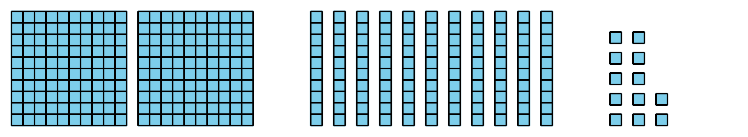
¿Cuántos de cada uno?
- Hay ____________ centenas.
- Hay ____________ decenas.
- Hay ____________ unidades.
- Dibuja un diagrama en base diez para representar el mismo valor total, pero usa el menor número posible de bloques.

Student Responses
- There are 2 hundreds.
- There are 11 tens.
- There are 12 ones.
- Students draw 3 hundreds, 2 tens, and 2 ones.

