Lesson 1: Varias veces

Standards Alignments
Building Towards | 4.OA.A.1, 4.OA.A.2

Teacher-facing Learning Goals
- Represent multiplicative comparison situations using objects and drawings.

Student-facing Learning Goals
- Representemos situaciones en las que hay “varias veces” una cantidad.

Lesson Purpose
The purpose of this lesson is for students to interpret and represent multiplicative comparison situations using objects and diagrams.
In previous grades, students learned how to represent additive comparison situations using discrete diagrams, tape diagrams, and addition and subtraction equations that use symbols to represent an unknown quantity. They used these representations to find differences.
In this lesson, students interpret the language of “times as many” in multiplicative comparison situations and connect this language to representations. They learn to recognize the difference between $n$ times as many and $n$ more. As they create representations using discrete diagrams in which each piece represents one item, students have opportunities to examine any errors in the representations they create and make necessary revisions. Although students may write equations to represent multiplicative comparisons, it is not required here, as they will have an opportunity to explore equations in depth in future lessons.

Access for:

Students with Disabilities
- Action and Expression (Activity 3)

English Learners
- MLR8 (Activity 2)

Instructional Routines
Notice and Wonder (Warm-up)

Materials to Gather
- Connecting cubes: Activity 1, Activity 2, Activity 3
- Number cubes: Activity 3

Materials to Copy
- Times as Many Recording Mat, Spanish (groups of 1): Activity 3

Lesson Timeline
Warm-up | 10 min
Activity 1 | 10 min
Activity 2 | 20 min
Activity 3 | 15 min
Lesson Synthesis | 10 min
Cool-down | 5 min

Teacher Reflection Question
In this lesson, students had access to connecting cubes to represent “twice as many” and “times as many.” How did students use the cubes to reason about or explain multiplicative comparison? If students did not use the cubes, how did they explain their reasoning?

Cool-down
(to be completed at the end of the lesson) 5min
Tres veces la cantidad de cubos

Standards Alignments
Building Towards | 4.OA.A.1, 4.OA.A.2

Student-facing Task Statement
En esta imagen se muestran unos cubos encajables.
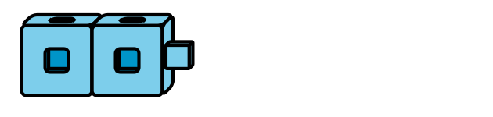
¿Cuál de las siguientes imágenes muestra 3 veces la cantidad de cubos que hay en la imagen de arriba? Explica tu razonamiento.
A
B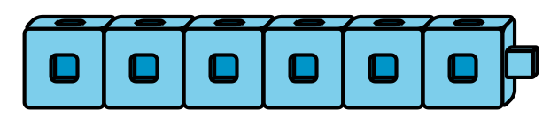
C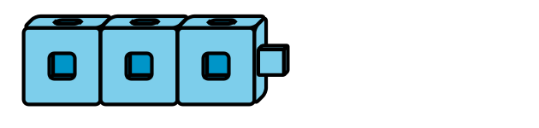

Student Responses
B has 6 cubes, which is 3 times as many as 2.

