Unit 7 Lesson 18: Applying the Quadratic Formula (Part 2)

1 Bits and Pieces (Warm up)

Student Task Statement
Evaluate each expression for $a=9$, $b=\text{-}5$, and $c=\text{-}2$
- $\text{-}b$
- $b^{2}$
- $b^{2}−4ac$
- $\text{-}b±\sqrt{a}$

2 Using the Formula with Care

Student Task Statement
Here are four equations, followed by attempts to solve them using the quadratic formula. Each attempt contains at least one error.
- Solve 1–2 equations by using the quadratic formula.
- Then, find and describe the error(s) in the worked solutions of the same equations as the ones you solved.
Equation 1: $2x^{2}+3=8x$
Equation 2: $x^{2}+3x=10$
Equation 3: $9x^{2}−2x−1=0$
Equation 4: $x^{2}−10x+23=0$
Here are the worked solutions with errors:
Equation 1: $2x^{2}+3=8x$
$a=2, b=\text{-}8, c=3$
$\begin{matrix}x & =\frac{\text{-}b±\sqrt{b^{2}−4ac}}{2a} & & \\ x & =\frac{\text{-}(\text{-}8)±\sqrt{(\text{-}8)^{2}−4(2)(3)}}{2(2)} & & \\ x & =\frac{8±\sqrt{64−24}}{4} & & \\ x & =\frac{8±\sqrt{40}}{4} & & \\ x & =2±\sqrt{10} & & \end{matrix}$
Equation 2: $x^{2}+3x=10$
$a=1, b=3, c=10$
$\begin{matrix}x & =\frac{\text{-}b±\sqrt{b^{2}−4ac}}{2a} \\ x & =\frac{\text{-}3±\sqrt{3^{2}−4(1)(10)}}{2(1)} \\ x & =\frac{\text{-}3±\sqrt{9−40}}{2} \\ x & =\frac{\text{-}3±\sqrt{\text{-}31}}{2} \\ & \text{No solutions}\end{matrix}$
Equation 3: $9x^{2}−2x−1=0$
$a=9, b=\text{-}2, c=\text{-}1$
$\begin{matrix}x & =\frac{\text{-}b±\sqrt{b^{2}−4ac}}{2a} \\ x & =\frac{2±\sqrt{(\text{-}2)^{2}−4(9)(\text{-}1)}}{2} \\ x & =\frac{2±\sqrt{4+36}}{2} \\ x & =\frac{2±\sqrt{40}}{2}\end{matrix}$
Equation 4: $x^{2}−10x+23=0$
$a=1, b=\text{-}10, c=23$
$\begin{matrix}x & =\frac{\text{-}b±\sqrt{b^{2}−4ac}}{2a} \\ x & =\frac{\text{-}10±\sqrt{(\text{-}10)^{2}−4(1)(23)}}{2} \\ x & =\frac{\text{-}10±\sqrt{\text{-}100−92}}{2} \\ x & =\frac{\text{-}10±\sqrt{\text{-}192}}{2} \\ & \text{No solutions}\end{matrix}$

3 Sure About That?

Student Task Statement
- The equation $h(t)=2+30t−5t^{2}$ represents the height, as a function of time, of a pumpkin that was catapulted up in the air. Height is measured in meters and time is measured in seconds.
  - The pumpkin reached a maximum height of 47 meters. How many seconds after launch did that happen? Show your reasoning.
  - Suppose someone was unconvinced by your solution. Find another way (besides the steps you already took) to show your solution is correct.
- The equation $r(p)=80p−p^{2}$ models the revenue a band expects to collect as a function of the price of one concert ticket. Ticket prices and revenues are in dollars.
- A band member says that a ticket price of either $15.50 or $74.50 would generate approximately $1,000 in revenue. Do you agree? Show your reasoning.

Activity Synthesis
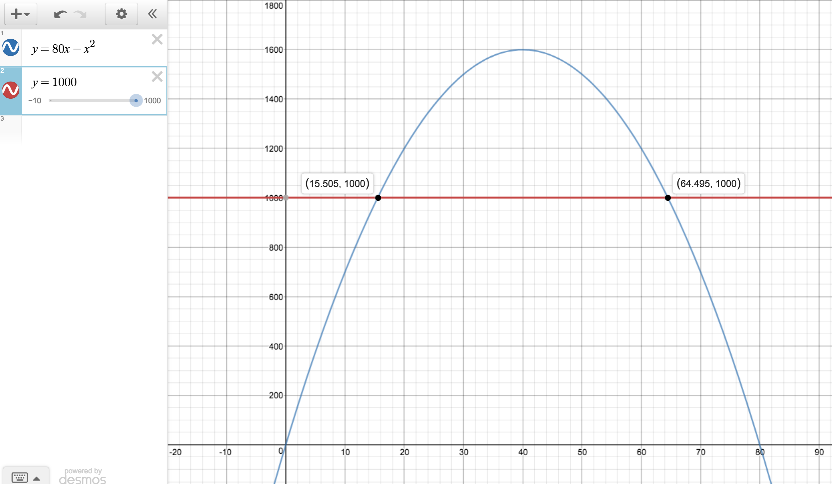
© CC BY 2019 by Illustrative Mathematics®

