Lesson 10: Solving Problems with Trigonometry
- Let’s solve problems about right triangles.

10.1: Notice and Wonder: Practicing Perimeter
What do you notice? What do you wonder?
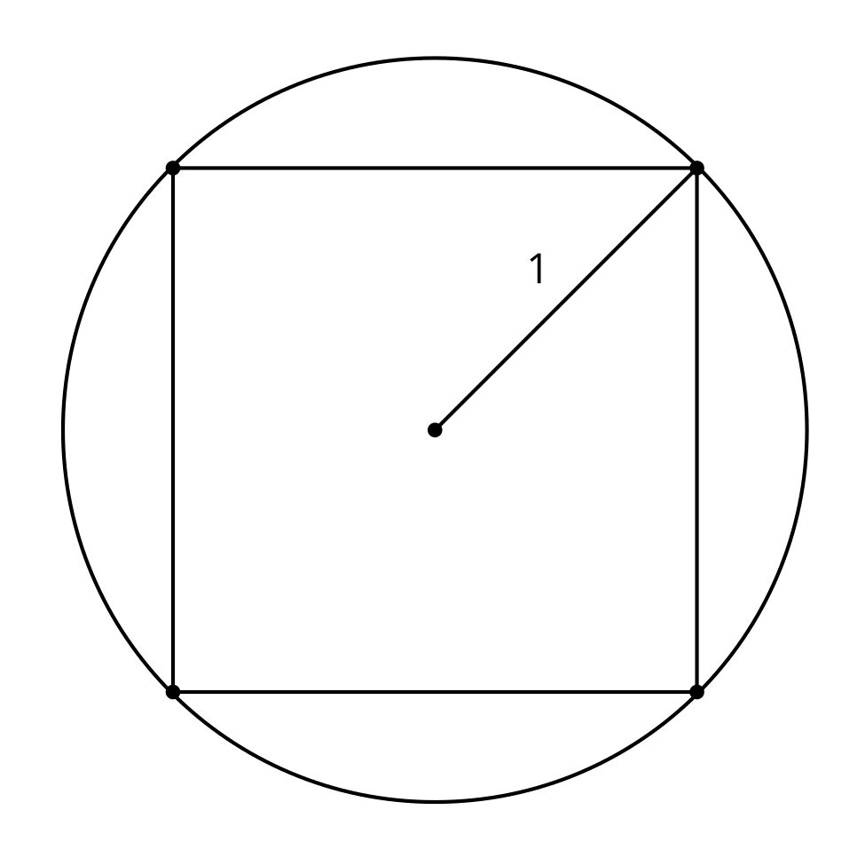
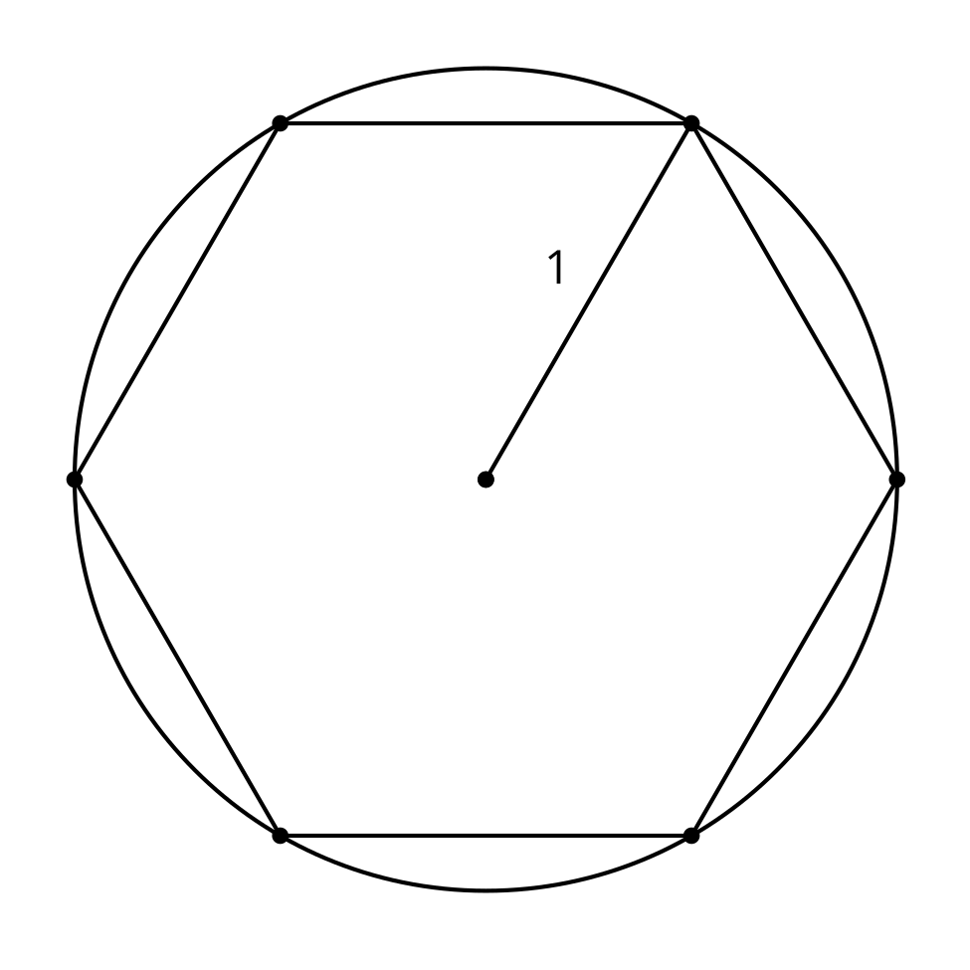
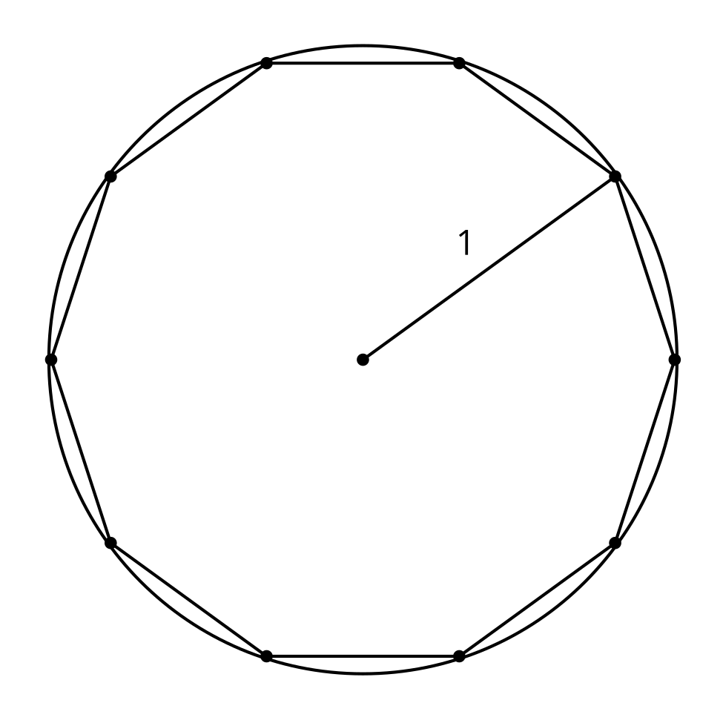

10.2: Growing Regular Polygons
- Here is a square inscribed in a circle with radius 1 meter. What is the perimeter of the square? Explain or show your reasoning.
- 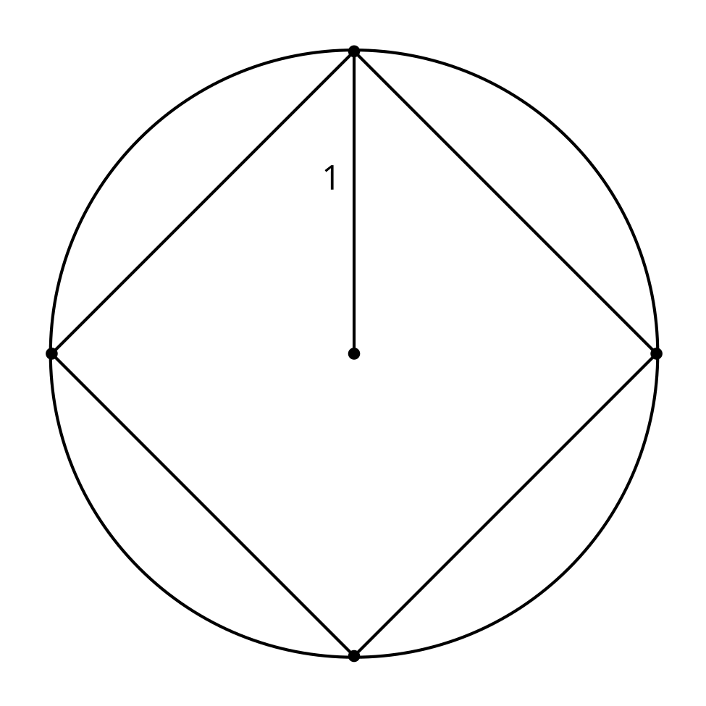
- What is the perimeter of a regular pentagon inscribed in a circle with radius 1 meter? Explain or show your reasoning.
- What is the perimeter of a regular decagon inscribed in a circle with radius 1 meter? Explain or show your reasoning.
- What is happening to the perimeter as the number of sides increases?

Are you ready for more?
Here is a diagram of a square inscribed in a circle and another circle inscribed in the same square.
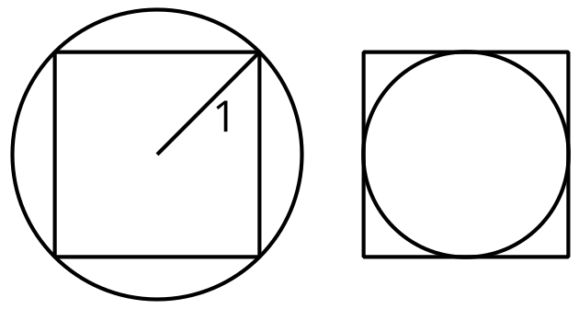
- How much shorter is the perimeter of the small circle than the perimeter of the large circle?
- If the square was replaced with a regular polygon with more sides, would your previous answer be larger, smaller, or the same? Explain or show your reasoning.

10.3: Gentle Descent
An airplane travels 150 miles horizontally during a decrease of 35,000 feet vertically.
- What is the angle of descent?
- How long is the plane's path?

Lesson 10 Summary
We know how to calculate the missing sides and angles of right triangles using trigonometric ratios and the Pythagorean Theorem. We can use the same strategies to solve some problems with other shapes. For example: Given a regular hexagon with side length 10 units, find its area.
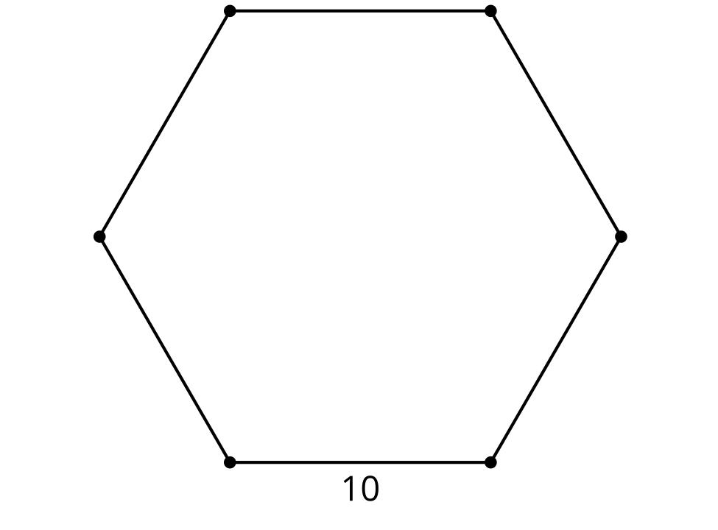
Decompose the hexagon into 6 isosceles triangles. The angle at the center is ${360}^{∘}÷6={60}^{∘}$. That means we created 6 equilateral triangles because the base angles of isosceles triangles are congruent.
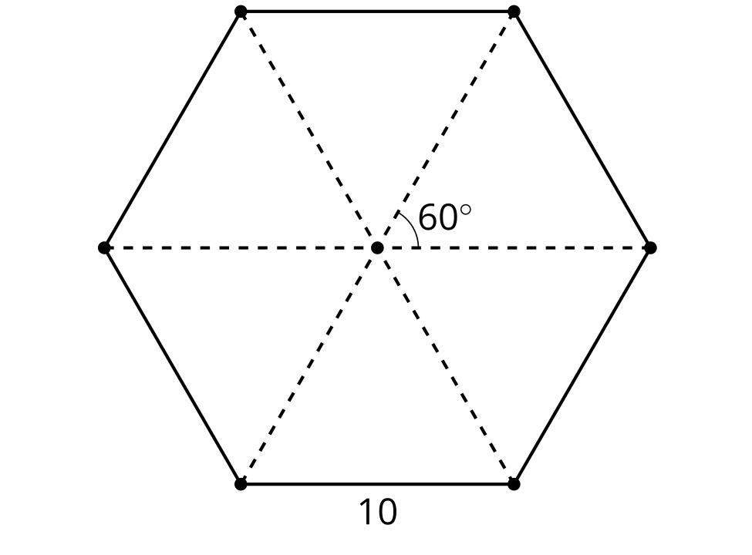
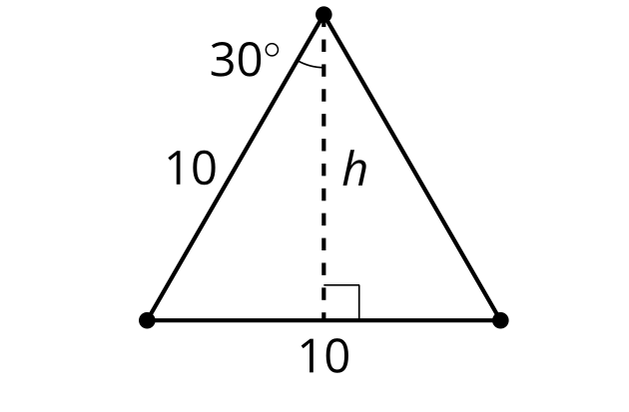
To find the area of the hexagon, we can find the area of each triangle. Drawing in the altitude to find the height of the triangle creates a right triangle, so we can use trigonometry. In an isosceles (and an equilateral) triangle the altitude is also the angle bisector, so the angle is 30 degrees. That means $cos\left(30\right)=\frac{h}{10}$ so $h$ is about 8.7 units. The area of one triangle is $\frac{1}{2}\left(10\right)\left(8.7\right)$, or 43.5 square units. So the area of the hexagon is 6 times that, or about 259.8 square units.
© CC BY 2019 by Illustrative Mathematics®

