Unit 2 Lesson 1: Let’s Make a Box

1 Which One Doesn’t Belong: Boxes (Warm up)

Student Task Statement
Which one doesn’t belong?
A.
length: 4 cm
width: 8 cm
height: 10 cm
B.
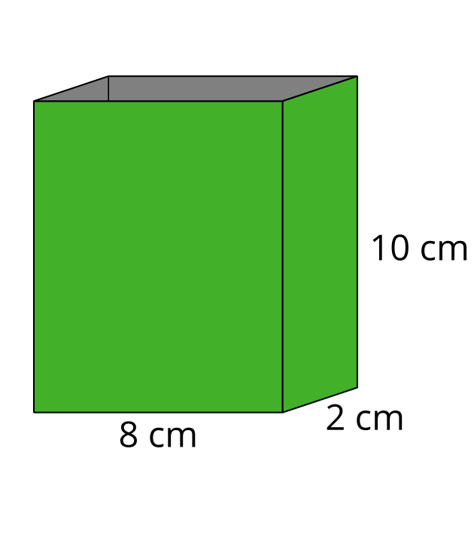
C.
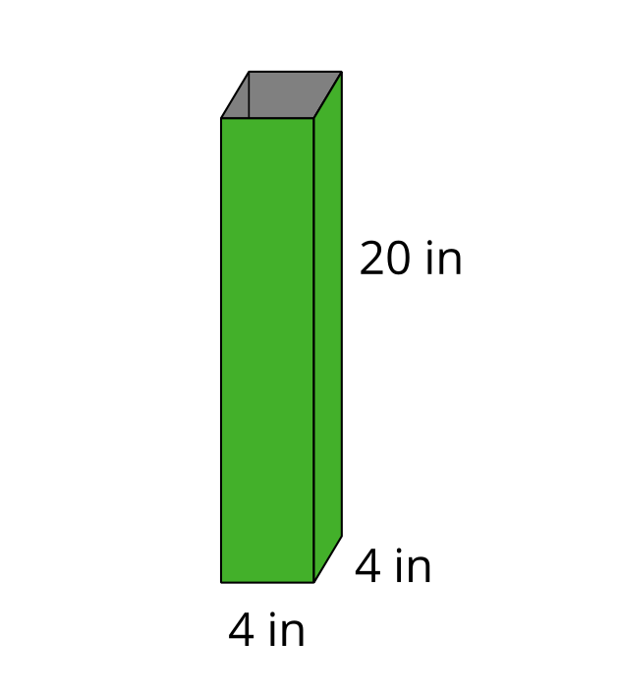
D.
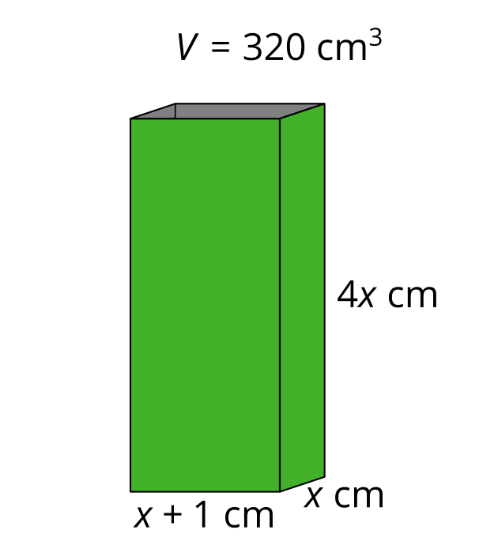

2 Building Boxes

Images for Launch
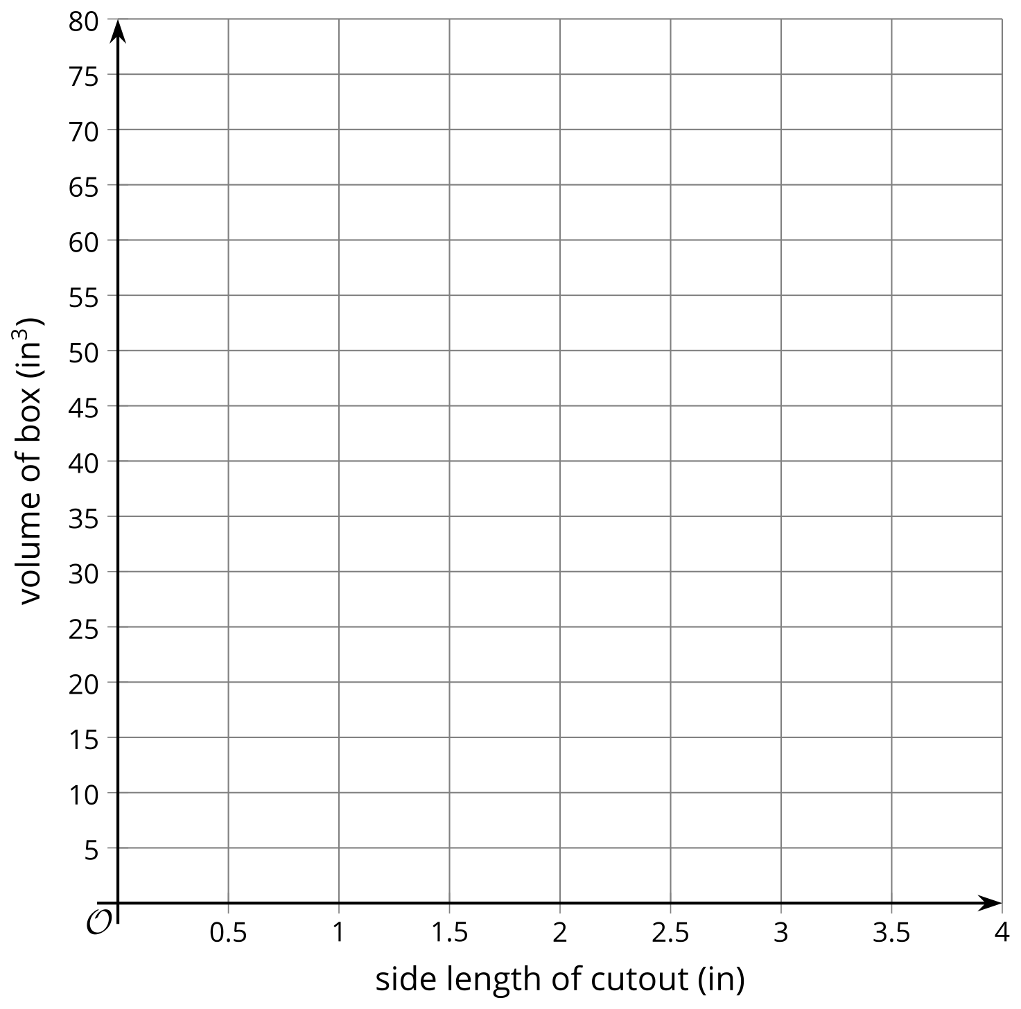

Student Task Statement
Your teacher will give you some supplies.
- Construct an open-top box from a sheet of paper by cutting out a square from each corner and then folding up the sides.
- Calculate the volume of your box, and complete the table with your information.
side length of square cutout (in) | length (in) | width (in) | height (in) | volume of box (in³)
1

3 Building the Biggest Box

Student Task Statement
- The volume $V\left(x\right)$ in cubic inches of the open-top box is a function of the side length $x$ in inches of the square cutouts. Make a plan to figure out how to construct the box with the largest volume.
- Pause here so your teacher can review your plan.
- Write an expression for $V\left(x\right)$.
- Use graphing technology to create a graph representing $V\left(x\right)$. Approximate the value of $x$ that would allow you to construct an open-top box with the largest volume possible from one piece of paper.
© CC BY 2019 by Illustrative Mathematics®

