Lesson 1 Practice Problems
- A rectangular schoolyard is to be fenced in using the wall of the school for one side and 150 meters of fencing for the other three sides. The area $A(x)$ in square meters of the schoolyard is a function of the length $x$ in meters of each of the sides perpendicular to the school wall.
  - Write an expression for $A(x)$.
  - What is the area of the schoolyard when $x=40$?
  - What is a reasonable domain for $A$ in this context?
- Noah finds an expression for $V(x)$ that gives the volume of an open-top box in cubic inches in terms of the length $x$ in inches of the cutout squares used to make it. This is the graph Noah gets if he allows $x$ to take on any value between -1 and 5.
- 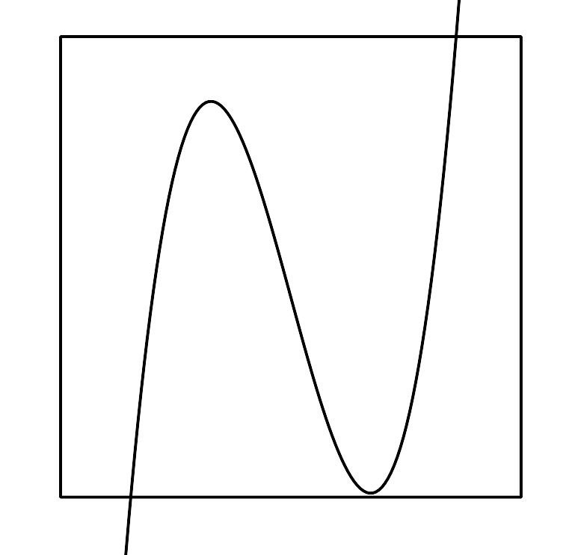
  - What would be a more appropriate domain for Noah to use instead?
  - What is the approximate maximum volume for his box?
- Mai wants to make an open-top box by cutting out corners of a square piece of cardboard and folding up the sides. The cardboard is 10 centimeters by 10 centimeters. The volume $V(x)$ in cubic centimeters of the open-top box is a function of the side length $x$ in centimeters of the square cutouts.
  - Write an expression for $V(x)$.
  - What is the volume of the box when $x=3$?
- The area of a pond covered by algae is $\frac{1}{4}$ of a square meter on day 1 and it doubles each day. Complete the table.
- day | - 1 | - 2 | - 3 | - 4 | - 5 | - 6
- area of algae
in square meters
- (From Unit 1, Lesson 2.)
- Here is a table showing values of sequence $p$. Define $p$ recursively using function notation.
- $n$ | - $p(n)$
- 1 | - 5,000
- 2 | - 500
- 3 | - 50
- 4 | - 5
- 5 | - 0.5
- (From Unit 1, Lesson 6.)
- The table shows two sloth populations growing over time.
- time  (years since 1990) | - population 1  (thousands) | - population 2  (thousands)
- 0 | - 90.0 | - 39
- 1 | - 76.5 | - 37
- 2 | - 65.0 | - 35
- 3 | - 55.3 | - 33
- 4 | - 47.0 | - 31
- 5
- 6
- 7
- 8
  - Describe a pattern in how each population changed from one year to the next.
  - These patterns continued for many years. Based on this information, fill in the extra rows in the table.
  - On the same axes, draw graphs of the two populations over time.
  - Does Population 2 ever equal Population 1? If so, when? Explain or show your reasoning.
- (From Unit 1, Lesson 10.)
© CC BY 2019 by Illustrative Mathematics®

