Unit 7 Lesson 11: A Bigger Piece

WU Choral Count: 10 More, 10 Less (Warm up)

Student Task Statement

1 Which is Bigger?

Student Task Statement

  - Each partner cuts out their circle.
  - Decide who will cut into halves and who will cut into fourths.
  - Fold your circle into halves or fourths then cut it.
  - Compare your pieces with your partner.
  - What do you notice?
  - Be ready to explain your thinking in a way that others will understand.

  - Repeat with your squares.
  - Compare your pieces with your partner.
  - What do you notice?
  - Be ready to explain your thinking in a way that others will understand.
- Write 2 things you notice about your pieces.

2 Priya and Han Share Roti

Student Task Statement
Priya and Han are sharing roti.
- Priya says, “I want half of the roti because halves are bigger than fourths.”
- Han says, “I want a fourth of the roti because fourths are bigger than halves because 4 is bigger than 2.”
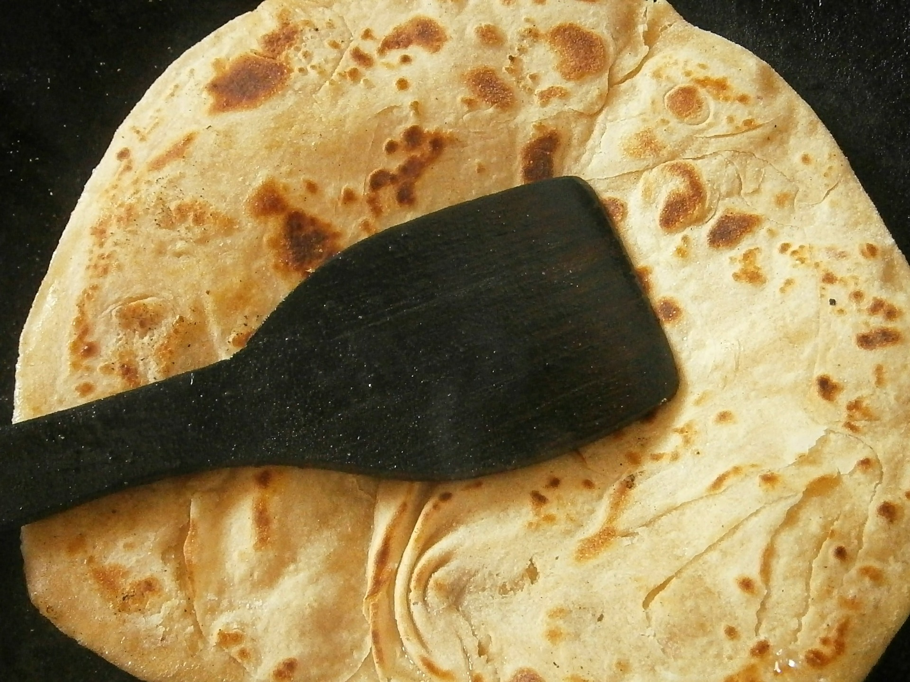
Who do you agree with?
Show your thinking using drawings, numbers or words.
Use the circle if it helps you.

3 Introduce Geoblocks, Feel and Guess

Student Task Statement
© CC BY 2021 Illustrative Mathematics®

