### Lesson 16 Practice Problems

1. A circle with a 12-inch diameter is folded in half and then folded in half again. What is the area of the resulting shape?
2. Find the area of the shaded region. Express your answer in terms of .

* 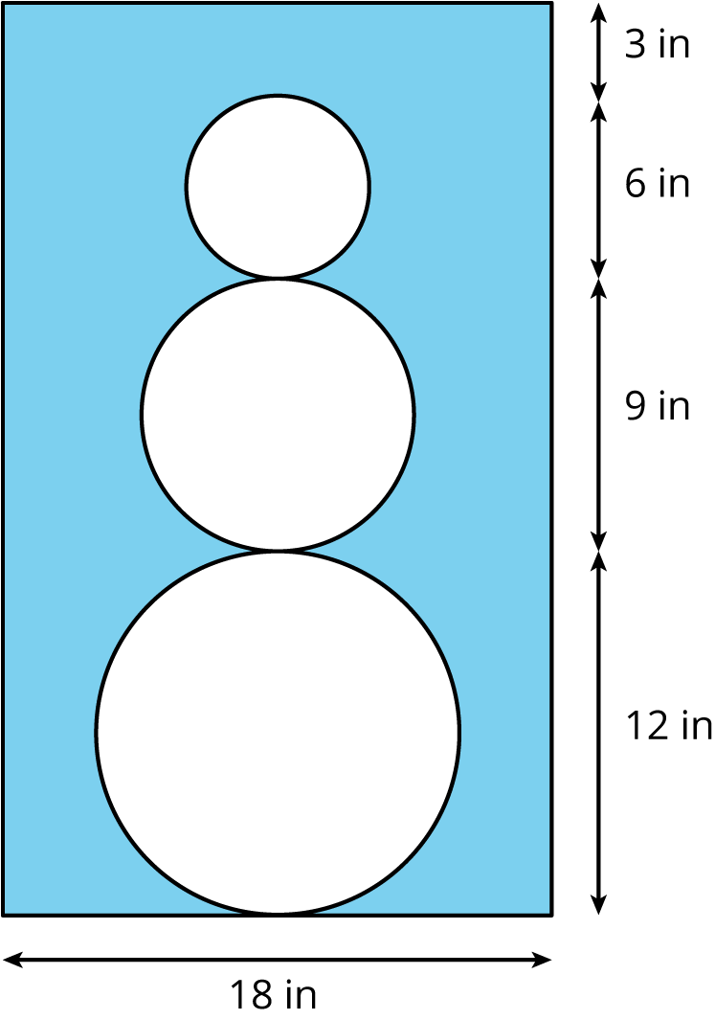

1. The face of a clock has a circumference of 63 in. What is the area of the face of the clock?

* (From Unit 5, Lesson 15.)

1. Which of these pairs of quantities are proportional to each other? For the quantities that are proportional, what is the constant of proportionality?
   1. Radius and diameter of a circle
   2. Radius and circumference of a circle
   3. Radius and area of a circle
   4. Diameter and circumference of a circle
   5. Diameter and area of a circle

* (From Unit 5, Lesson 15.)

1. Find the area of this shape in two different ways.

* 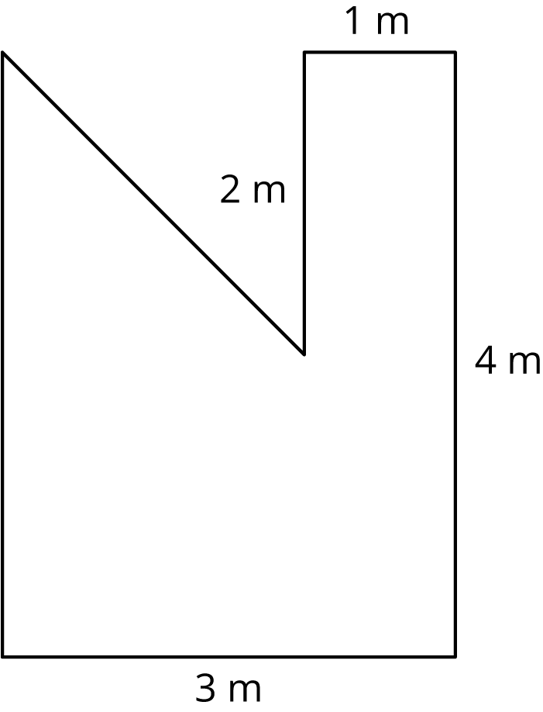
* (From Unit 5, Lesson 14.)

1. Elena and Jada both read at a constant rate, but Elena reads more slowly. For every 4 pages that Elena can read, Jada can read 5.
   1. Complete the table.

| * + pages read by Elena | * + pages read by Jada |
| --- | --- |
| * + 4 | * + 5 |
| * + 1 |  |
| * + 9 |  |
|  |  |
|  | * + 15 |
|  |  |

* 1. Here is an equation for the table: . What does the 1.25 mean?
  2. Write an equation for this relationship that starts
* (From Unit 5, Lesson 2.)



© CC BY Open Up Resources. Adaptations CC BY IM.