Lesson 9: Simetría en acción (Optional)

Standards Alignments
Addressing | 4.G.A.1, 4.G.A.2, 4.G.A.3, 4.MD.A.3

Teacher-facing Learning Goals
- Solve problems involving symmetry, side lengths, and perimeter of two-dimensional figures.

Student-facing Learning Goals
- Examinemos la simetría y el perímetro de figuras dobladas.

Lesson Purpose
The purpose of this optional lesson is for students to practice visualizing and drawing figures given lines of symmetry and to use symmetry to solve problems about side lengths and perimeter.
In this lesson, students continue to work with line-symmetric figures in the context of paper folding. Students are given the result of folding paper along their lines of symmetry and reason about the original figure and its perimeter. As they think about the lengths of segments in line-symmetric shapes and find perimeters, students practice looking for and making use of structure (MP7).
This lesson is optional because the work here deepens and extends students’ understanding of line-symmetric figures and perimeter beyond what is required by the standards.

Access for:

Students with Disabilities
- Action and Expression (Activity 1)

English Learners
- MLR8 (Activity 2)

Instructional Routines
Which One Doesn’t Belong? (Warm-up)

Materials to Gather
- Paper: Activity 1, Activity 2
- Patty paper: Activity 1, Activity 2
- Protractors: Activity 1
- Rulers or straightedges: Activity 1, Activity 2
- Scissors: Activity 1, Activity 2

Materials to Copy
- Before and After (groups of 6): Activity 1

Lesson Timeline
Warm-up | 10 min
Activity 1 | 15 min
Activity 2 | 20 min
Lesson Synthesis | 10 min
Cool-down | 5 min

Teacher Reflection Question
What was the best question you asked students today? Why would you consider it the best one based on what students said or did?

Cool-down
(to be completed at the end of the lesson) 5min
Dóblalo una vez

Standards Alignments
Addressing | 4.G.A.3

Student-facing Task Statement
Una hoja de papel se dobla una vez a lo largo de una línea de simetría. El resultado, después de doblar, es este triángulo con tres lados iguales.
- ¿Cuál podría ser la forma original del papel, antes de ser doblado?
- Haz un dibujo y muestra la línea de simetría.
- Escribe una expresión para el perímetro de la figura antes de ser doblada.

Student Responses
- Sample responses:
- 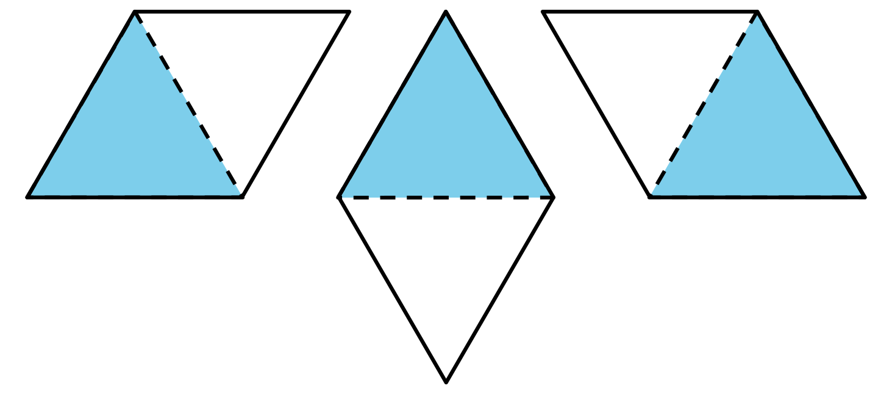
- Sample responses: $5\frac{1}{2}+5\frac{1}{2}+5\frac{1}{2}+5\frac{1}{2}$ or $4×5\frac{1}{2}$

