Unit 6 Lesson 3: Choose Objects to Compare Length Indirectly

Notice and Wonder: More Pencils (Warm up)

Student Task Statement
What do you notice?
What do you wonder?
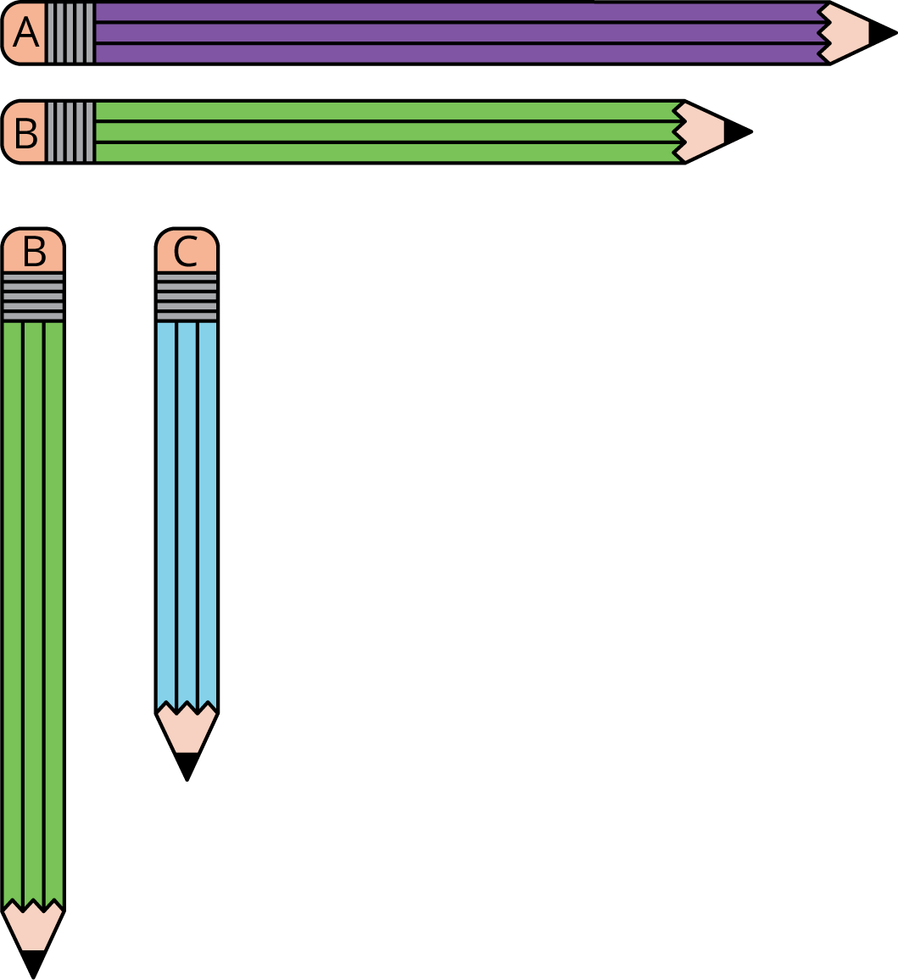

1 Mai and Clare Walk to School

Student Task Statement
Who has a shorter walk to school, Clare or Mai? How do you know?
Be ready to explain your thinking in a way that others will understand.
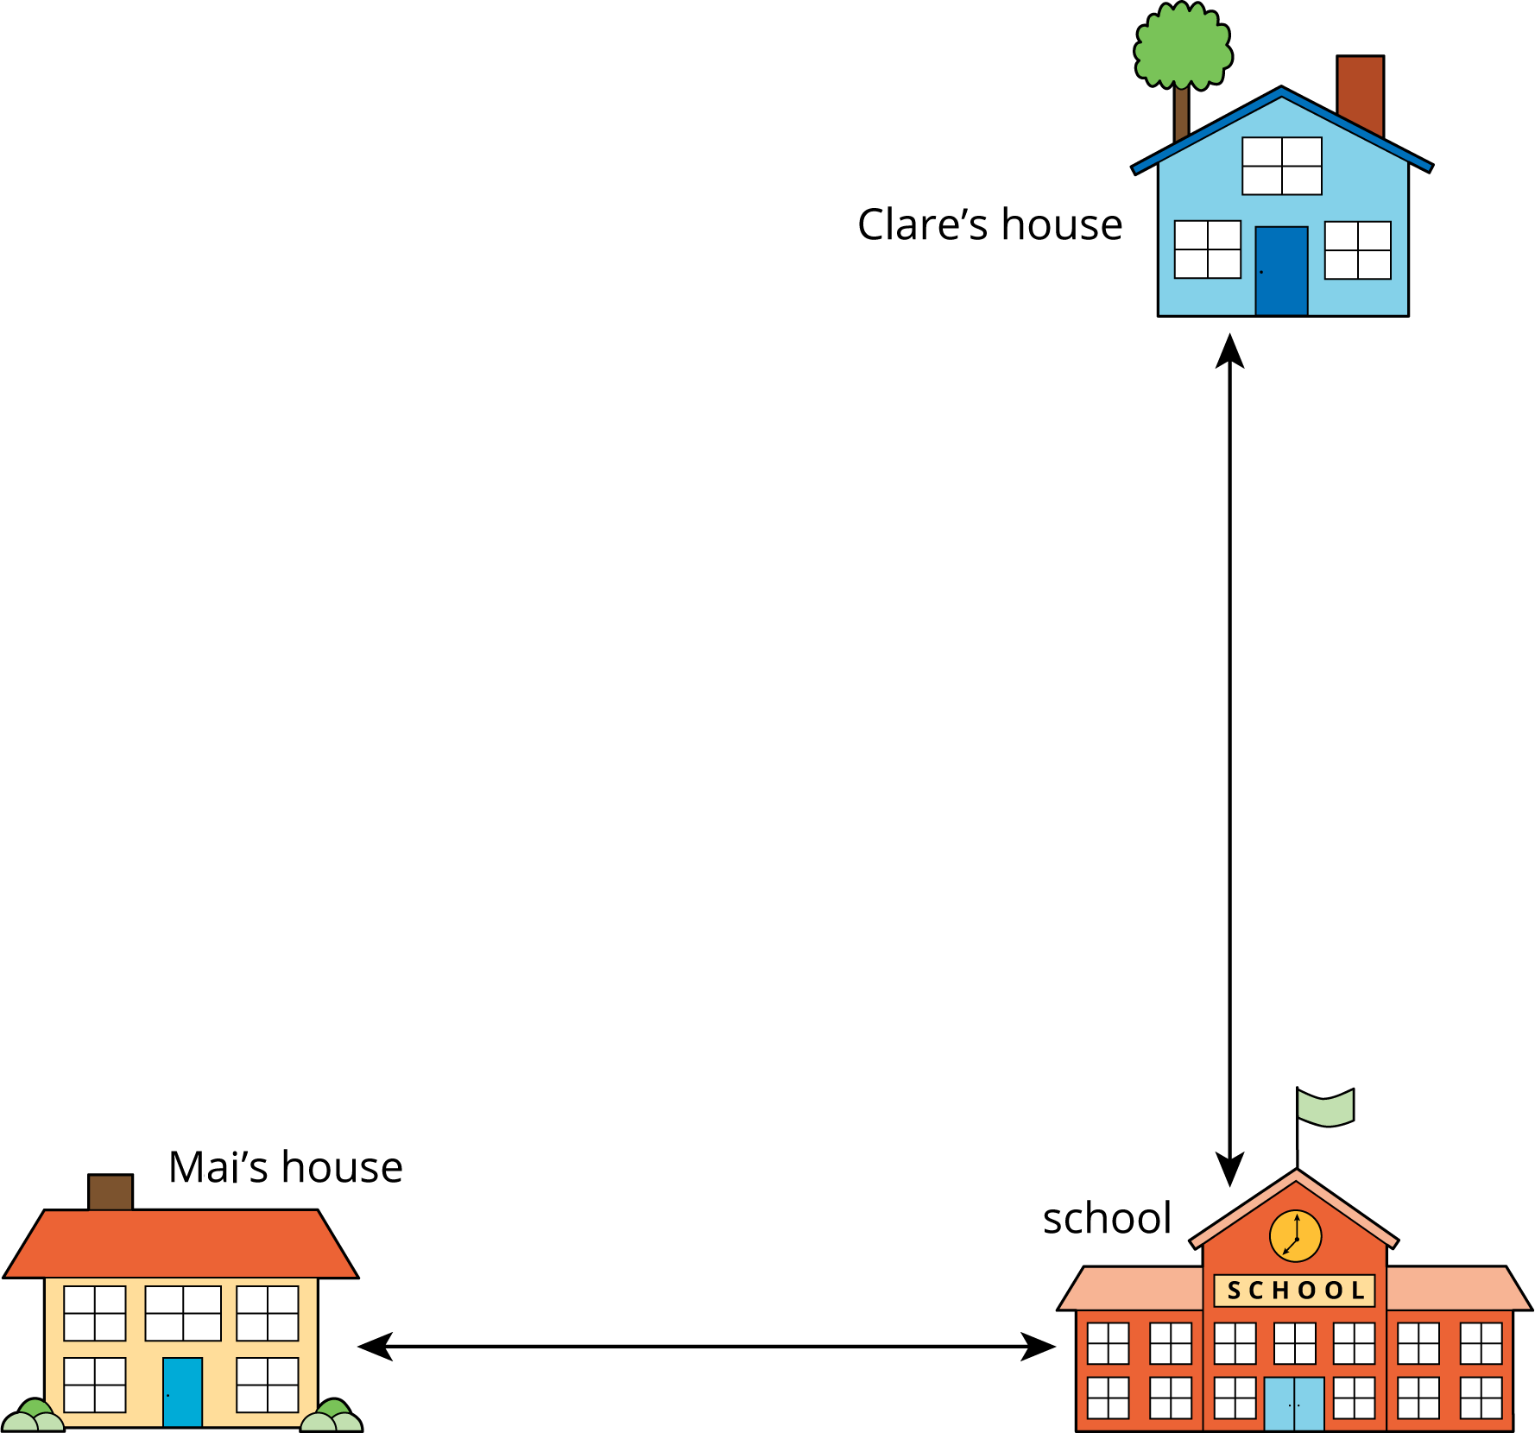

2 Will It Fit?

Student Task Statement
- Will the teacher’s desk fit through the door?
- Show your thinking using drawings, numbers, or words.
- Will a student desk fit through the door?
- Show your thinking using drawings, numbers, or words.
- Which is longer, the bookshelf or the rug?
- Show your thinking using drawings, numbers, or words.
- Which is longer, the file cabinet or the bookshelf?
- Show your thinking using drawings, numbers, or words.
- Which is shorter, the bookshelf or the teacher’s desk?
- Show your thinking using drawings, numbers, or words.
- Will the teacher’s desk fit next to the bookshelf?
- Show your thinking using drawings, numbers, or words.
© CC BY 2021 Illustrative Mathematics®

