Lesson 3: Resolvamos problemas de comparación multiplicativa

Standards Alignments
Addressing | 4.OA.A.1, 4.OA.A.2

Teacher-facing Learning Goals
- Represent and solve multiplicative comparison problems, including those involving unknown factors.

Student-facing Learning Goals
- Resolvamos problemas de comparación multiplicativa.

Lesson Purpose
The purpose of this lesson is for students to interpret and represent multiplicative comparison situations in which a factor is unknown.
In previous lessons, students matched descriptions, equations, and discrete diagrams that represented multiplicative comparison. In this lesson, they write multiplication and division equations, draw diagrams, and use their understanding of the relationship between multiplication and division.

Access for:

Students with Disabilities
- Engagement (Activity 2)

English Learners
- MLR7 (Activity 1)

Instructional Routines
Number Talk (Warm-up)

Materials to Gather
- Connecting cubes: Activity 1, Activity 2

Lesson Timeline
Warm-up | 10 min
Activity 1 | 20 min
Activity 2 | 15 min
Lesson Synthesis | 10 min
Cool-down | 5 min

Teacher Reflection Question
Which representations best supported student learning in today's lesson? What evidence do you have this representation supported the understanding of most students?

Cool-down
(to be completed at the end of the lesson) 5min
De vuelta a la colecta de libros

Standards Alignments
Addressing | 4.OA.A.1, 4.OA.A.2

Student-facing Task Statement
Kiran donó 28 libros para la colecta de libros. Jada donó algunos libros también. Kiran donó 4 veces el número de libros que Jada donó.
¿Cuántos libros donó Jada? Explica o muestra cómo razonaste.

Student Responses
7 books. Sample responses:
- 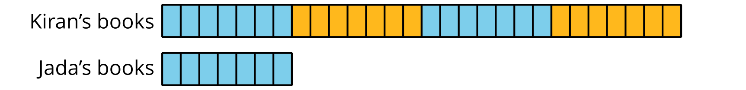
- $?×4=28$ or $4×?=28$

