Lesson 10: Maneras de encontrar medidas de ángulos (Optional)

Standards Alignments
Addressing | 4.G.A.3, 4.MD.C.7

Teacher-facing Learning Goals
- Find unknown angle measurements using the attributes of two-dimensional figures.

Student-facing Learning Goals
- Encontremos las medidas de los ángulos de figuras que son simétricas con respecto a una línea.

Lesson Purpose
The purpose of this optional lesson is for students to use the attributes of figures (symmetry, equal side lengths, right angles) to reason about angle measurements.
Previously, students analyzed the attributes of two-dimensional figures and used them to find side lengths and perimeters. In this lesson, students use the attributes of figures to find unknown angle measurements and to practice drawing line-symmetric shapes. Both activities in the lesson deepen students’ understanding of line symmetry. They also allow students to apply knowledge of angles from an earlier unit and integrate it with newer ideas from this unit. Because the work here is not required by the standards, however, this lesson is optional.

Access for:

Students with Disabilities
- Representation (Activity 2)

English Learners
- MLR8 (Activity 1)

Instructional Routines
How Many Do You See? (Warm-up)

Materials to Gather
- Paper: Activity 1
- Patty paper: Activity 1
- Protractors: Activity 1
- Rulers: Activity 1
- Scissors: Activity 1

Lesson Timeline
Warm-up | 10 min
Activity 1 | 25 min
Activity 2 | 15 min
Lesson Synthesis | 10 min
Cool-down | 5 min

Teacher Reflection Question
Today’s lesson presented many opportunities for divergent reasoning strategies. Think about which students haven’t shared their strategies in class lately. Were there missed opportunities to highlight their thinking during recent lessons? How can you take advantage of those opportunities when they arise?

Cool-down
(to be completed at the end of the lesson) 5min
Retoma la simetría del escenario

Standards Alignments
Addressing | 4.G.A.3, 4.MD.C.7

Student-facing Task Statement
Encuentra la medida de los ángulos $p$, $q$, $r$ y $s$. Explica o muestra tu razonamiento.
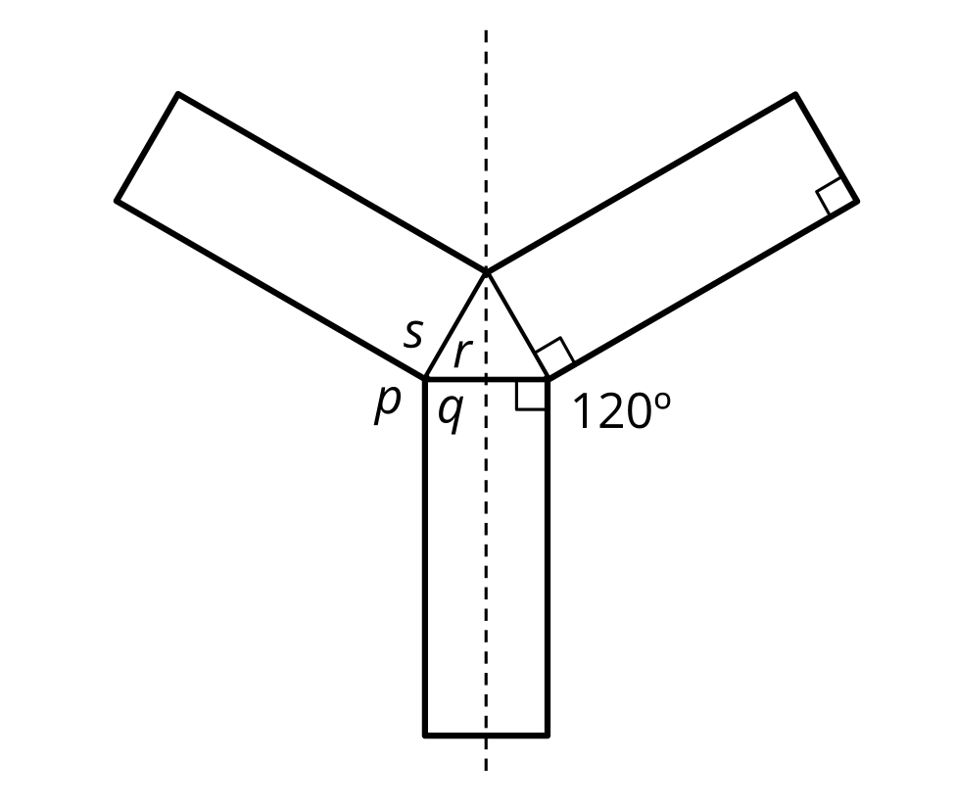

Student Responses
Angle $p$ is ${120}^{∘}$. Angles $s$ and $q$ are both ${90}^{∘}$. Angles $r$ is ${60}^{∘}$. Sample reasoning: The figure has 3 lines of symmetry.
- Angle $p$ matches the ${120}^{∘}$ angle on the other side of the line of symmetry.
- Angle $s$ matches up with the right angle on the other side of the triangle.
- Angle $q$ matches up with the right angle next to it.
- Angles $p$, $q$, $r$, and $s$ add up to ${360}^{∘}$. $p+q+s=120+90+90=300$, so $r$ is $360−300$, which is 60.

