Lesson 13: Solve Take From Story Problems

Warm-up: Number Talk: Add 2 Two-digit Numbers
Find the value of each expression mentally.
- $15+10$
- $15+15$
- $25+25$
- $25+28$

13.1: How Many to Start?
Elena bought a bag of beads to make bracelets.
She takes out 9 beads to make a bracelet.
There are 11 beads left in the bag.
How many beads were in the bag when Elena bought it?
Solve the story problem.
Show your thinking using drawings, numbers, or words.
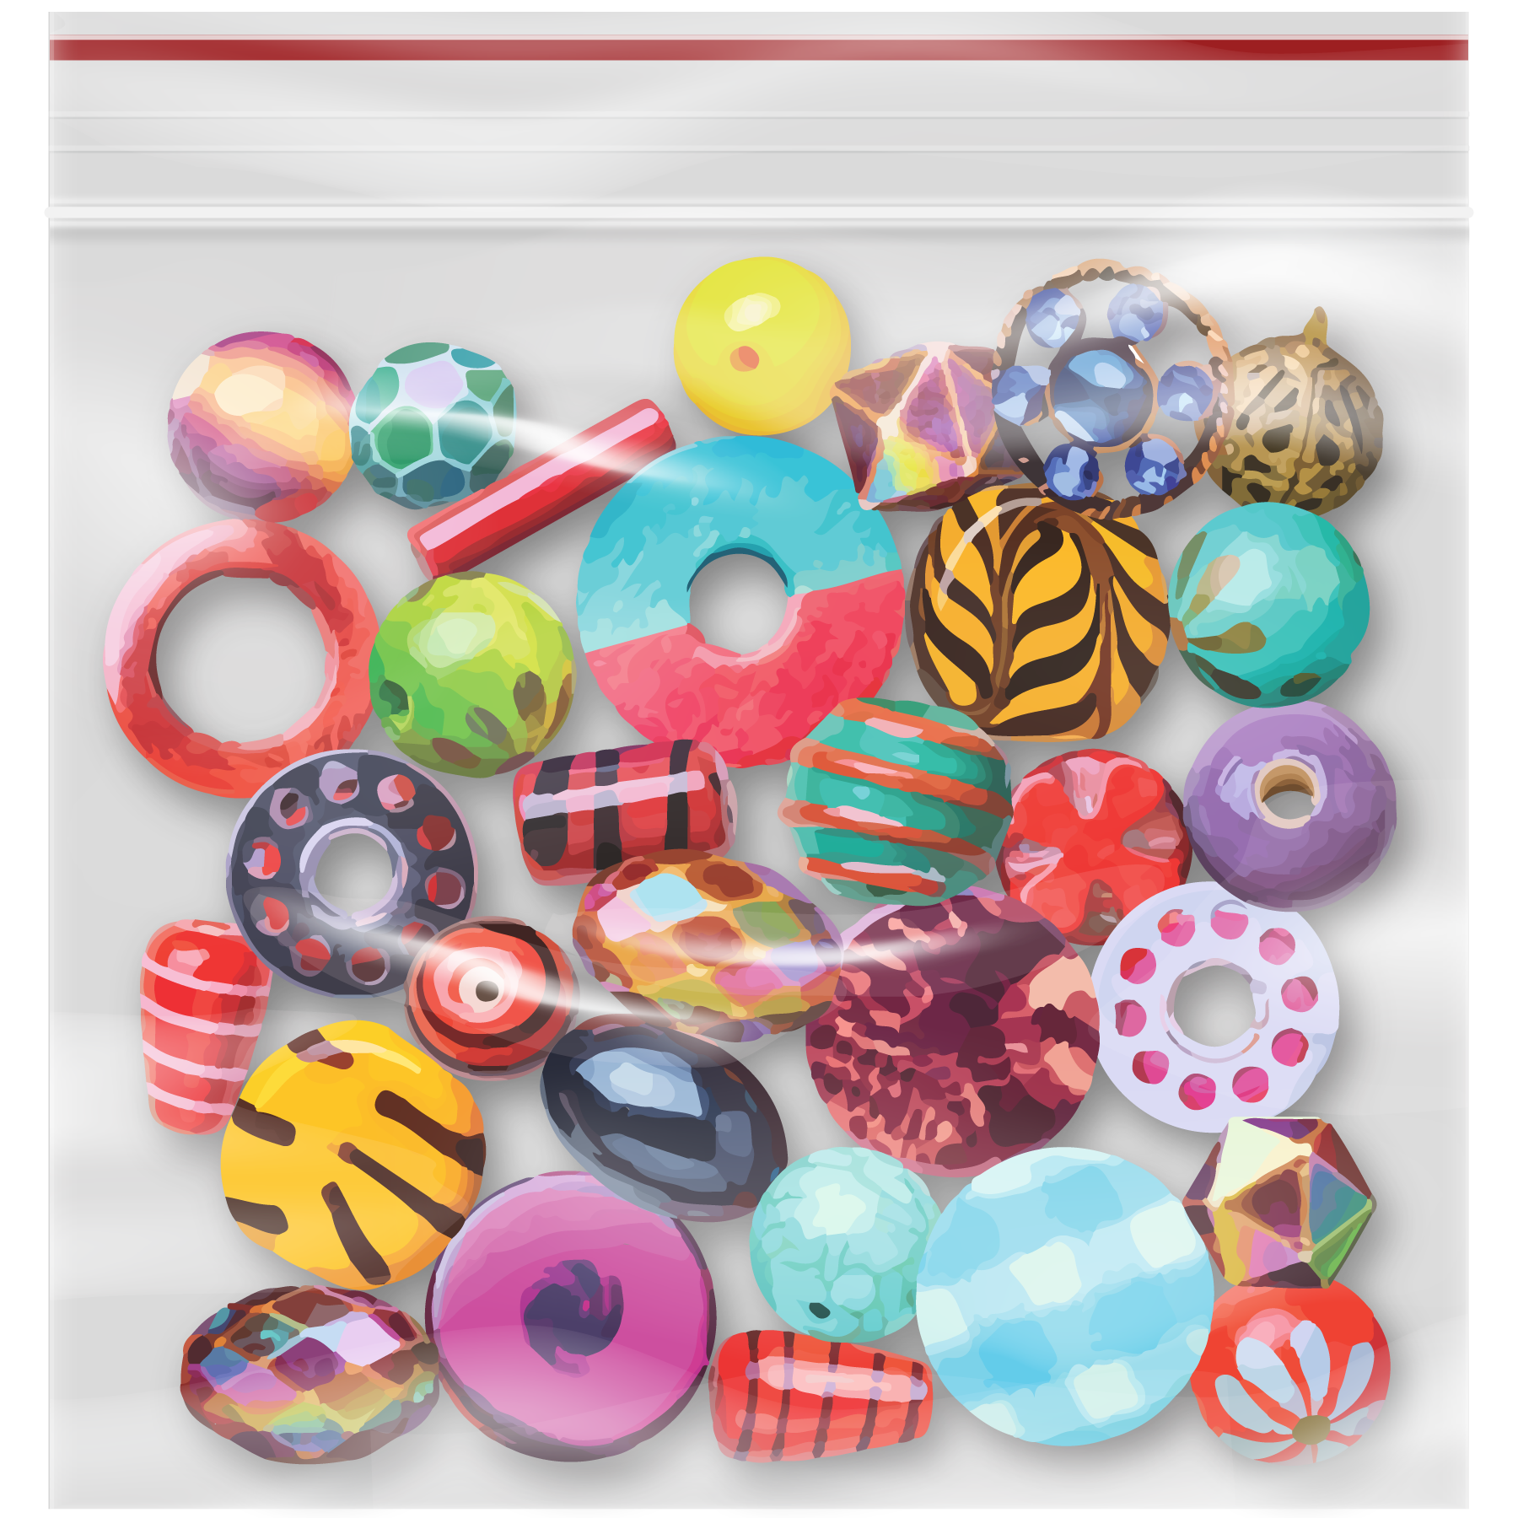

13.2: One Representation, Three Stories
- Discuss with your partner how the drawing shows each problem.
  - Elena has 15 beads in a box.
She uses 5 of them to make a bracelet.
How many beads does Elena have left?
  - Elena has some beads in a box.
She uses 5 of them to make a bracelet.
She has 10 beads left.
How many beads were in Elena’s box?
  - Elena has 15 beads in a box.
She uses some of them to make a bracelet.
She has 10 beads left.
How many beads did Elena use to make a bracelet?
© CC BY 2021 Illustrative Mathematics®

