Lesson 24: Solutions to Systems of Linear Inequalities in Two Variables
- Let’s look at situations where two constraints (that can be expressed by inequalities) must be met simultaneously.

24.1: A Silly Riddle
Here is a riddle: “I am thinking of two numbers that add up to 5.678. The difference between them is 9.876. What are the two numbers?”
- Name any pair of numbers whose sum is 5.678.
- Name any pair of numbers whose difference is 9.876.
- The riddle can be represented with two equations. Write the equations.
- Solve the riddle. Explain or show your reasoning.

24.2: A Quilting Project
To make a quilt, a quilter is buying fabric in two colors, light and dark. He needs at least 9.5 yards of fabric in total.
The light color costs $9 a yard. The dark color costs $13 a yard. The quilter can spend up to $110 on fabric.
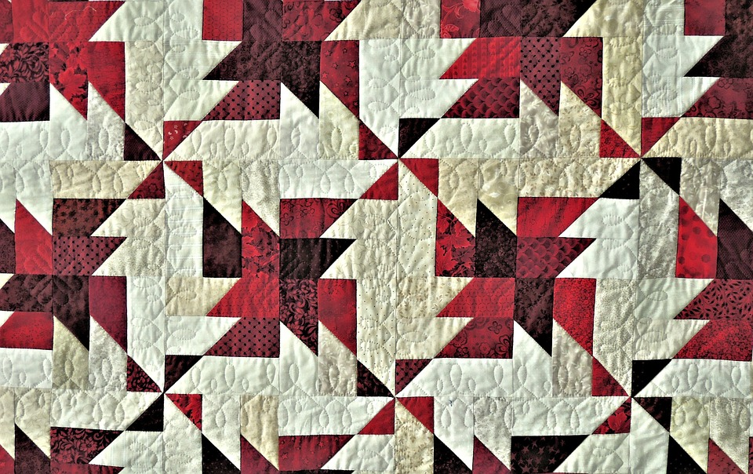
Here are two graphs that represent the two constraints.

A
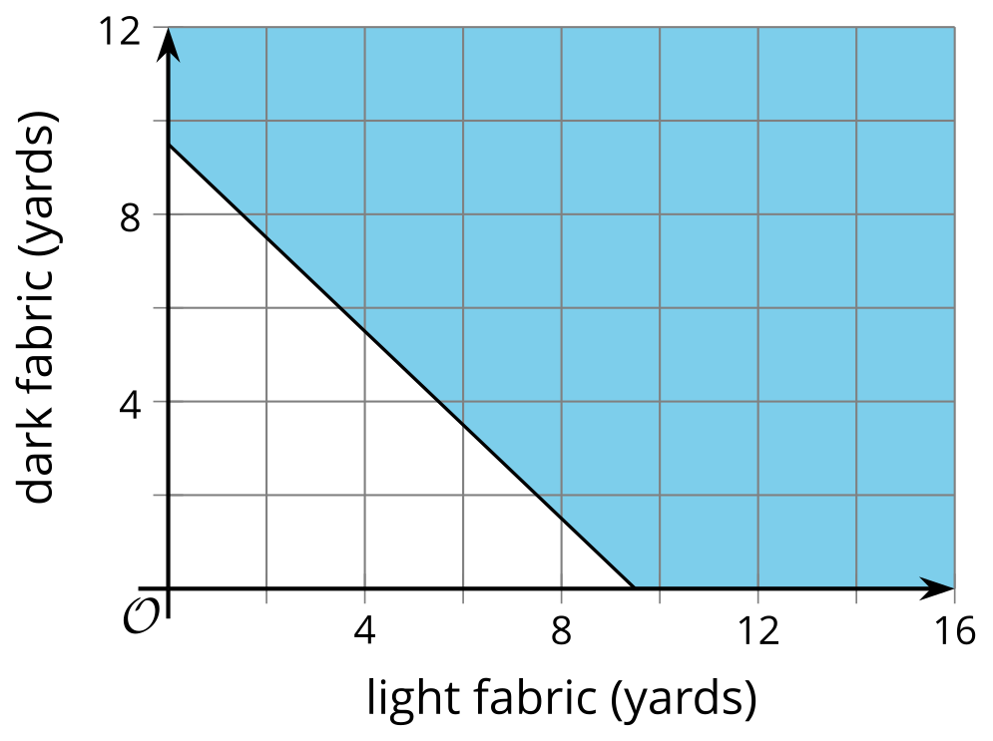

B
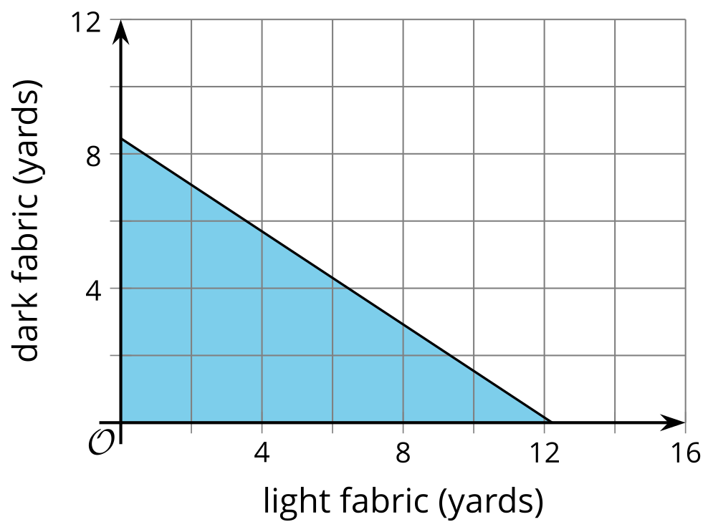
- Write an inequality to represent the length constraint. Let $x$ represent the yards of light fabric and $y$ represent the yards of dark fabric.
- Select all the pairs that satisfy the length constraint.
- $\left(5,5\right)$
- $\left(2.5,4.5\right)$
- $\left(7.5,3.5\right)$
- $\left(12,10\right)$
- Write an inequality to represent the cost constraint.
- Select all the pairs that satisfy the cost constraint.
- $\left(1,1\right)$
- $\left(4,5\right)$
- $\left(8,3\right)$
- $\left(10,1\right)$
- Explain why $\left(2,2\right)$ satisfies the cost constraint, but not the length constraint.
- Find at least one pair of numbers that satisfies both constraints. Be prepared to explain how you know.
- What does the pair of numbers represent in this situation?

24.3: Remember These Situations?
Here are some situations you have seen before. Answer the questions for one situation.
Bank Accounts
- A customer opens a checking account and a savings account at a bank. They will deposit a maximum of $600, some in the checking account and some in the savings account. (They might not deposit all of it and keep some of the money as cash.)
- The bank requires a minimum balance of $50 in the savings account. It does not matter how much money is kept in the checking account.
Concert Tickets
- Two kinds of tickets to an outdoor concert were sold: lawn tickets and seat tickets. Fewer than 400 tickets in total were sold.
- Lawn tickets cost $30 each and seat tickets cost $50 each. The organizers want to make at least $14,000 from ticket sales.
Advertising Packages
- An advertising agency offers two packages for small businesses who need advertising services. A basic package includes only design services. A premium package includes design and promotion. The agency's goal is to sell at least 60 packages in total.
- The basic advertising package has a value of $1,000 and the premium package has a value of $2,500. The goal of the agency is to sell more than $60,000 worth of small-business advertising packages.
1. Write a system of inequalities to represent the constraints. Specify what each variable represents.

2. Use technology to graph the inequalities and sketch the solution regions. Include labels and scales for the axes.
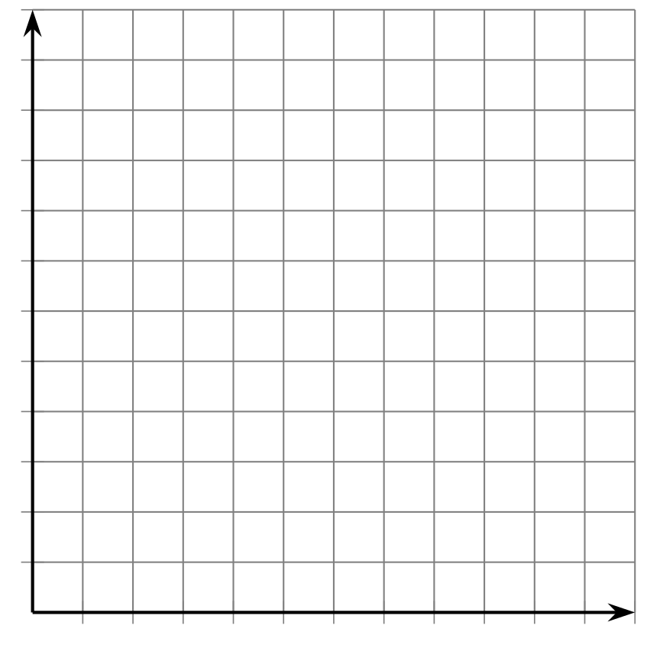
3. Identify a solution to the system. Explain what the numbers mean in the situation.

24.4: Scavenger Hunt
Members of a high school math club are doing a scavenger hunt. Three items are hidden in the park, which is a rectangle that measures 50 meters by 20 meters.
- The clues are written as systems of inequalities. One system has no solutions.
- The locations of the items can be narrowed down by solving the systems. A coordinate plane can be used to describe the solutions.
Can you find the hidden items? Sketch a graph to show where each item could be hidden.
Clue 1: $y>14 x<10$
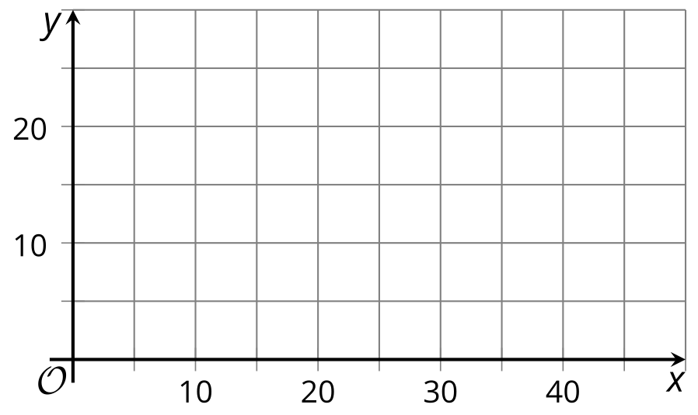
Clue 2: $x+y<20 x>6$
Clue 3: $y<\text{-}2x+20 y<\text{-}2x+10$
Clue 4: $y≥x+10 x>y$

Are you ready for more?
Two non-negative numbers $x$ and $y$ satisfy $x+y≤1$.
- Find a second inequality, also using $x$ and $y$ values greater than or equal to zero, to make a system of inequalities with exactly one solution.
- Find as many ways to answer this question as you can.

Lesson 24 Summary
In this lesson, we used two linear inequalities in two variables to represent the constraints in a situation. Each pair of inequalities forms a system of inequalities.
A solution to the system is any $\left(x,y\right)$ pair that makes both inequalities true, or any pair of values that simultaneously meet both constraints in the situation. The solution to the system is often best represented by a region on a graph.
Suppose there are two numbers, $x$ and $y$, and there are two things we know about them:
- The value of one number is more than double the value of the other.
- The sum of the two numbers is less than 10.
We can represent these constraints with a system of inequalities.
$\left\{\begin{matrix}y>2x \\ x+y<10\end{matrix}\right.$
There are many possible pairs of numbers that meet the first constraint, for example: 1 and 3, or 4 and 9.
The same can be said about the second constraint, for example: 1 and 3, or 2.4 and 7.5.
The pair $x=1$ and $y=3$ meets both constraints, so it is a solution to the system.
The pair $x=4$ and $y=9$ meets the first constraint but not the second ($9>2\left(4\right)$ is a true statement, but $4+9<10$ is not true.)
Remember that graphing is a great way to show all the possible solutions to an inequality, so let’s graph the solution region for each inequality.​​​​​​
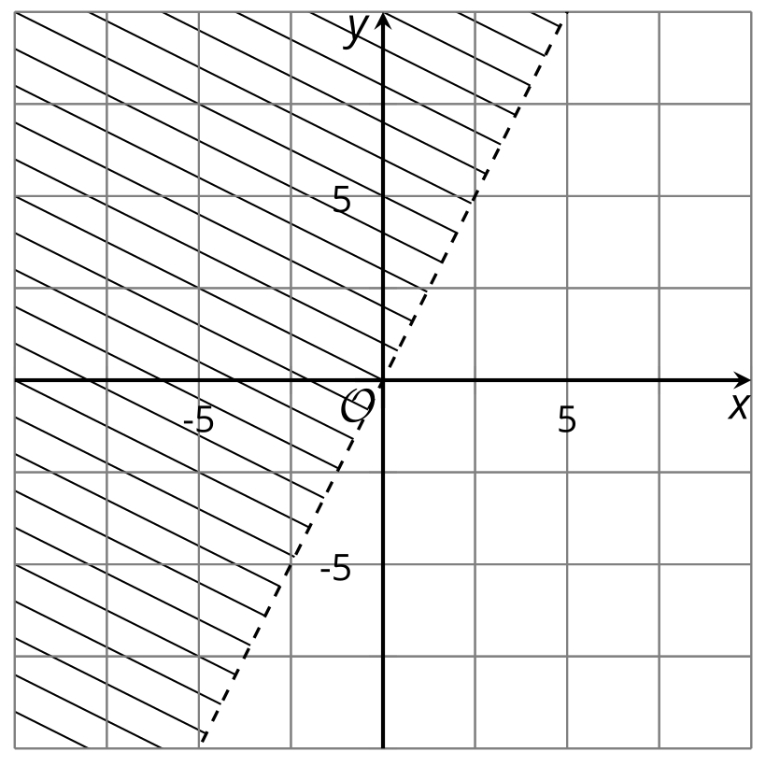
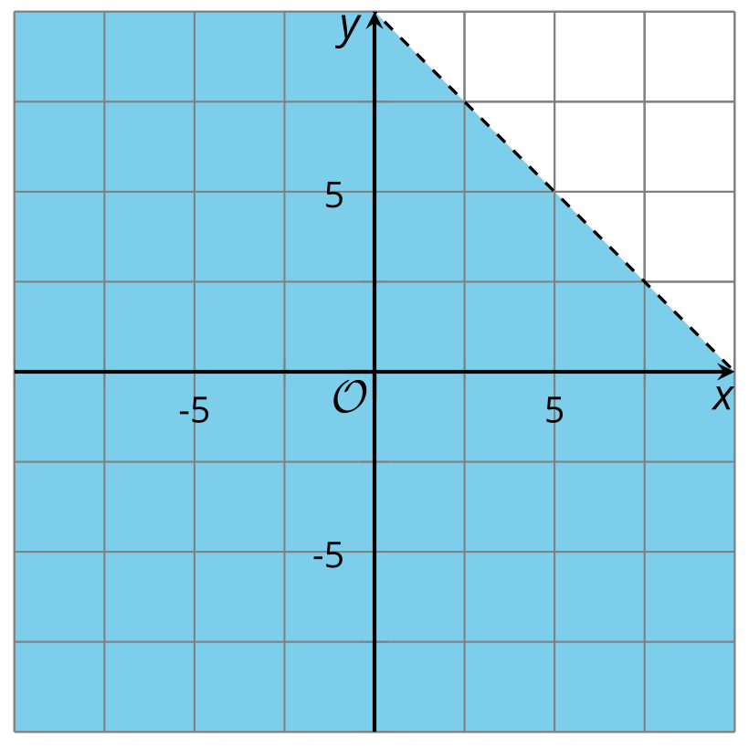
Because we are looking for a pair of numbers that meet both constraints or make both inequalities true at the same time, we want to find points that are in the solution regions of both graphs.
To do that, we can graph both inequalities on the same coordinate plane.
The solution set to the system of inequalities is represented by the region where the two graphs overlap.
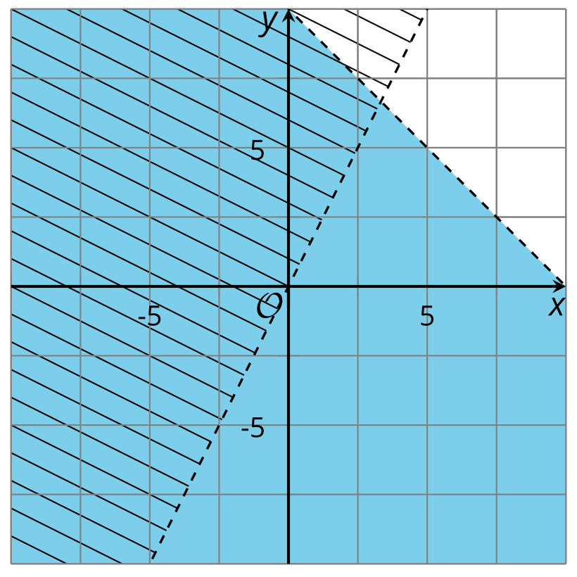
© CC BY 2019 by Illustrative Mathematics®

