Lesson 6 Practice Problems
- Which of the following constructions would help to construct a line passing through point $C$ that is perpendicular to the line $AB$?
  - Construction of an equilateral triangle with one side $AB$
  - Construction of a hexagon with one side $BC$
  - Construction of a perpendicular bisector through $C$
  - Construction of a square with one side $AB$
- Two distinct lines, $ℓ$ and $m$, are each perpendicular to the same line $n$. Select all the true statements.
  - Lines $ℓ$ and $m$ are perpendicular.
  - Lines $ℓ$ and $n$ are perpendicular.
  - Lines $m$ and $n$ are perpendicular.
  - Lines $ℓ$ and $m$ are parallel.
  - Lines $ℓ$ and $n$ are parallel.
  - Lines $m$ and $n$ are parallel.
- This diagram is a straightedge and compass construction of the bisector of angle $BAC$. Only angle $BAC$ is given. Explain the steps of the construction in order. Include a step for each new circle, line, and point.
- 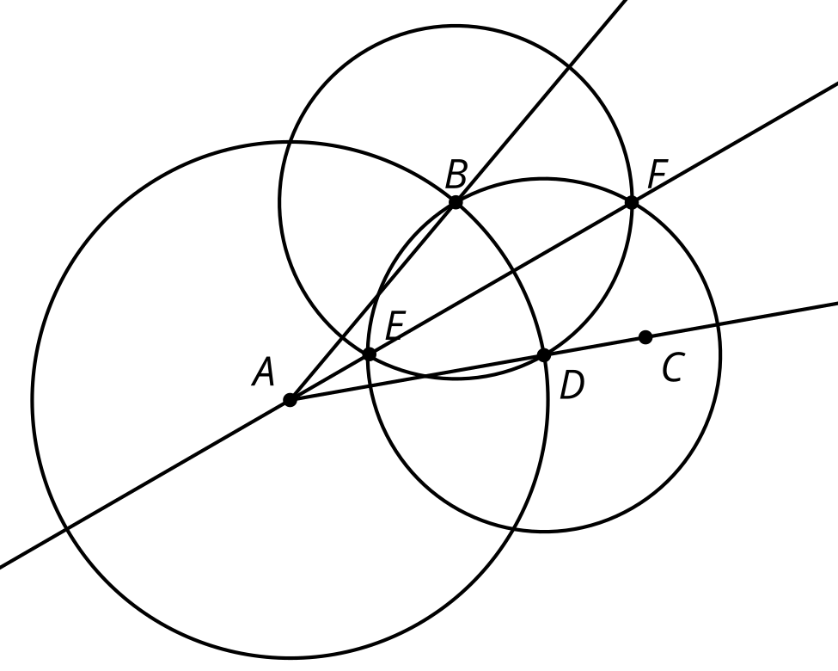
- (From Unit 1, Lesson 5.)
- This diagram is a straightedge and compass construction of a line perpendicular to line $AB$ passing through point $C$. Which segment has the same length as segment $EA$?
- 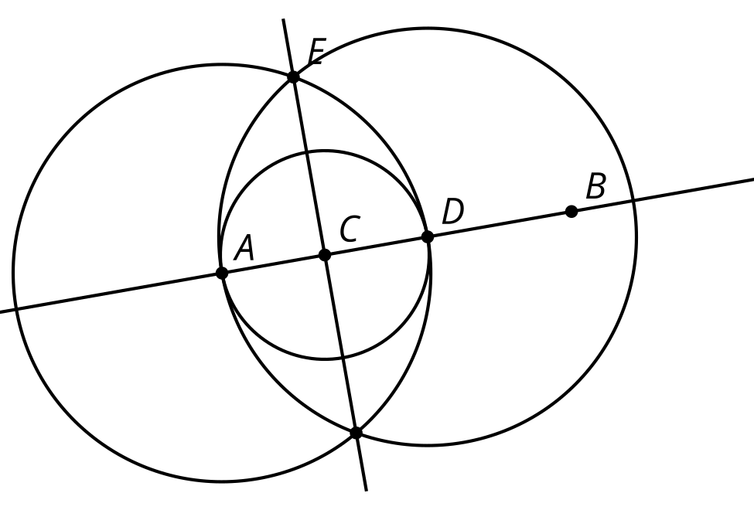
  - $EC$
  - $ED$
  - $BE$
  - $BD$
- (From Unit 1, Lesson 5.)
- This diagram is a straightedge and compass construction. Which triangle is equilateral? Explain how you know.
- 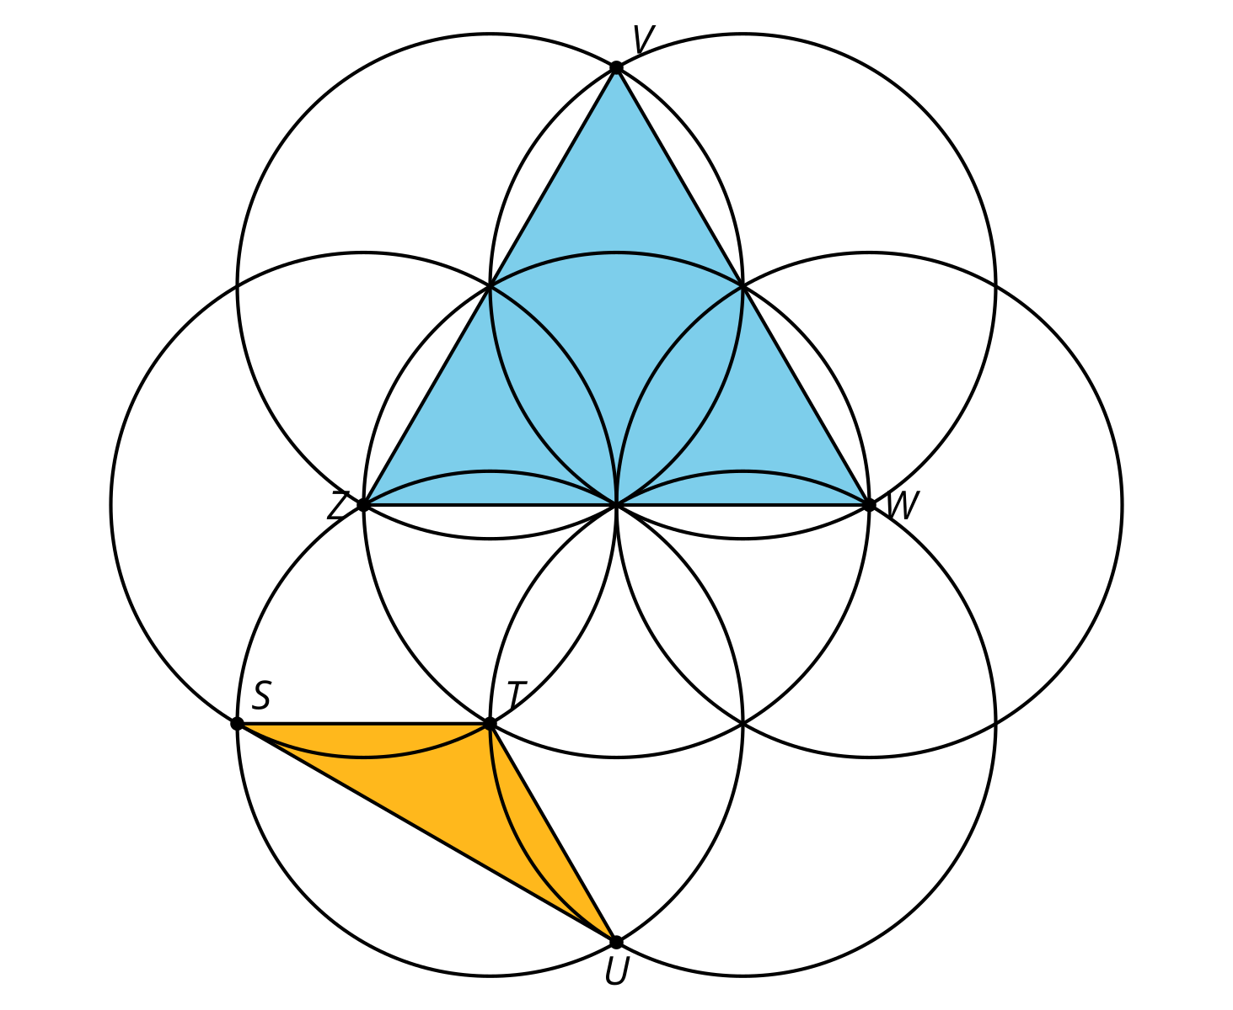
- (From Unit 1, Lesson 4.)
- In the construction, $A$ is the center of one circle, and $B$ is the center of the other. Name the segments in the diagram that have the same length as segment $AB$.
- 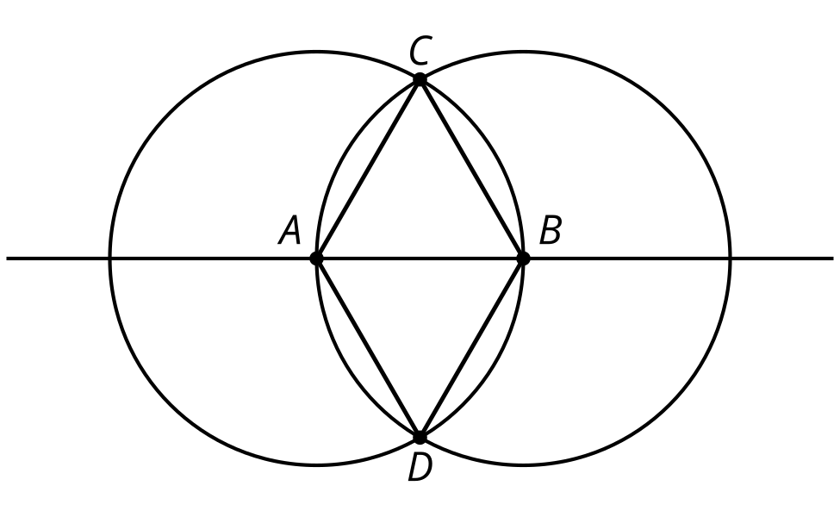

- (From Unit 1, Lesson 2.)
- This diagram is a straightedge and compass construction. $A$ is the center of one circle, and $B$ is the center of the other.
  - Name a pair of perpendicular line segments.
  - Name a pair of line segments with the same length.
- 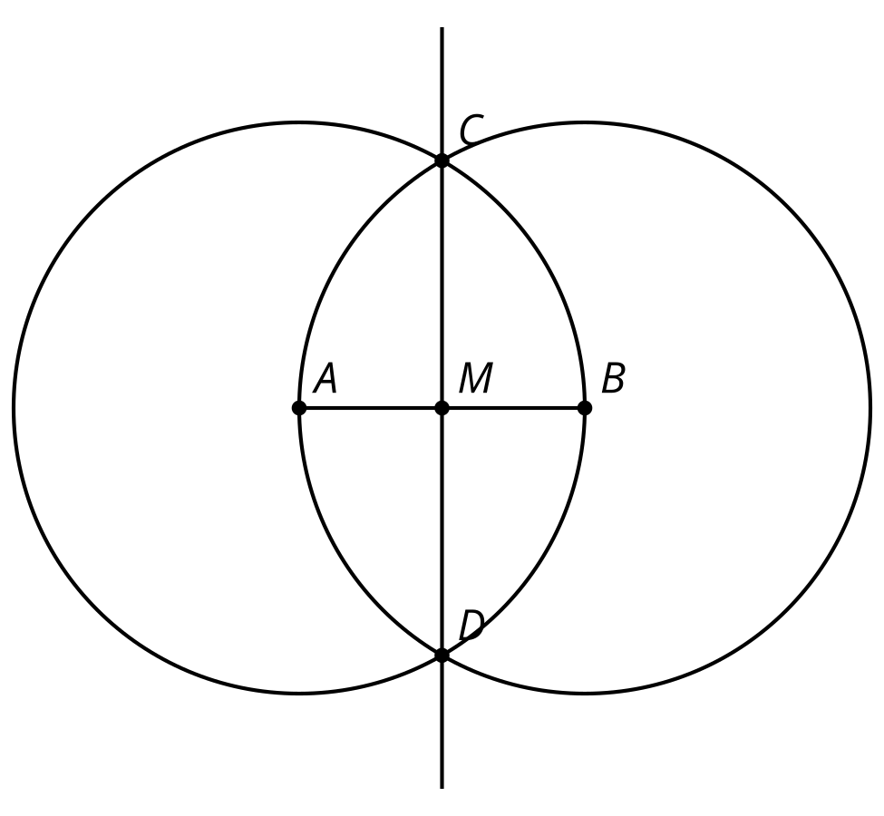
- (From Unit 1, Lesson 3.)
- $A$, $B$, and $C$ are the centers of the 3 circles. Select all the segments that are congruent to $AB$.
- 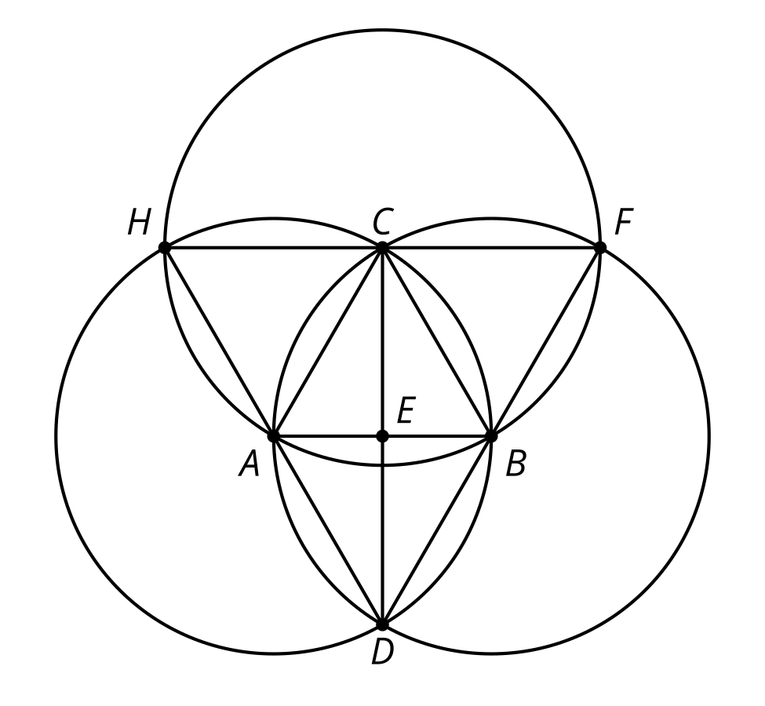
  - $HF$
  - $HA$
  - $CE$
  - $CD$
  - $BD$
  - $BF$
- (From Unit 1, Lesson 4.)
© CC BY 2019 by Illustrative Mathematics®

