Unit 2 Lesson 6: Problems about Pets

WU Notice and Wonder: The Fish Tank (Warm up)

Student Task Statement
What do you notice?
What do you wonder?
There are some fish in the tank.
Some of the fish are red and some are blue.

1 Three Reads: Kiran’s Fish

Student Task Statement
Kiran has some fish in his fish tank.
He has 4 red fish and 5 blue fish.
How many fish does he have in all?
Show your thinking using drawings, numbers, or words.
Equation: ________________________________

2 Tyler's and Clare’s Pets

Student Task Statement
Tyler and Clare want to know how many pets they have together.
Tyler has 2 turtles.
Clare has 4 dogs.
Tyler wrote the equation $4+2=\boxed{6}$.
Clare wrote the equation $2+4=\boxed{6}$.
Do both equations match the story?
Why or why not?
Show your thinking using drawings, numbers, or words.

3 Centers: Choice Time

Student Task Statement
Choose a center.
Math Stories
Find the Pair
What’s Behind My Back
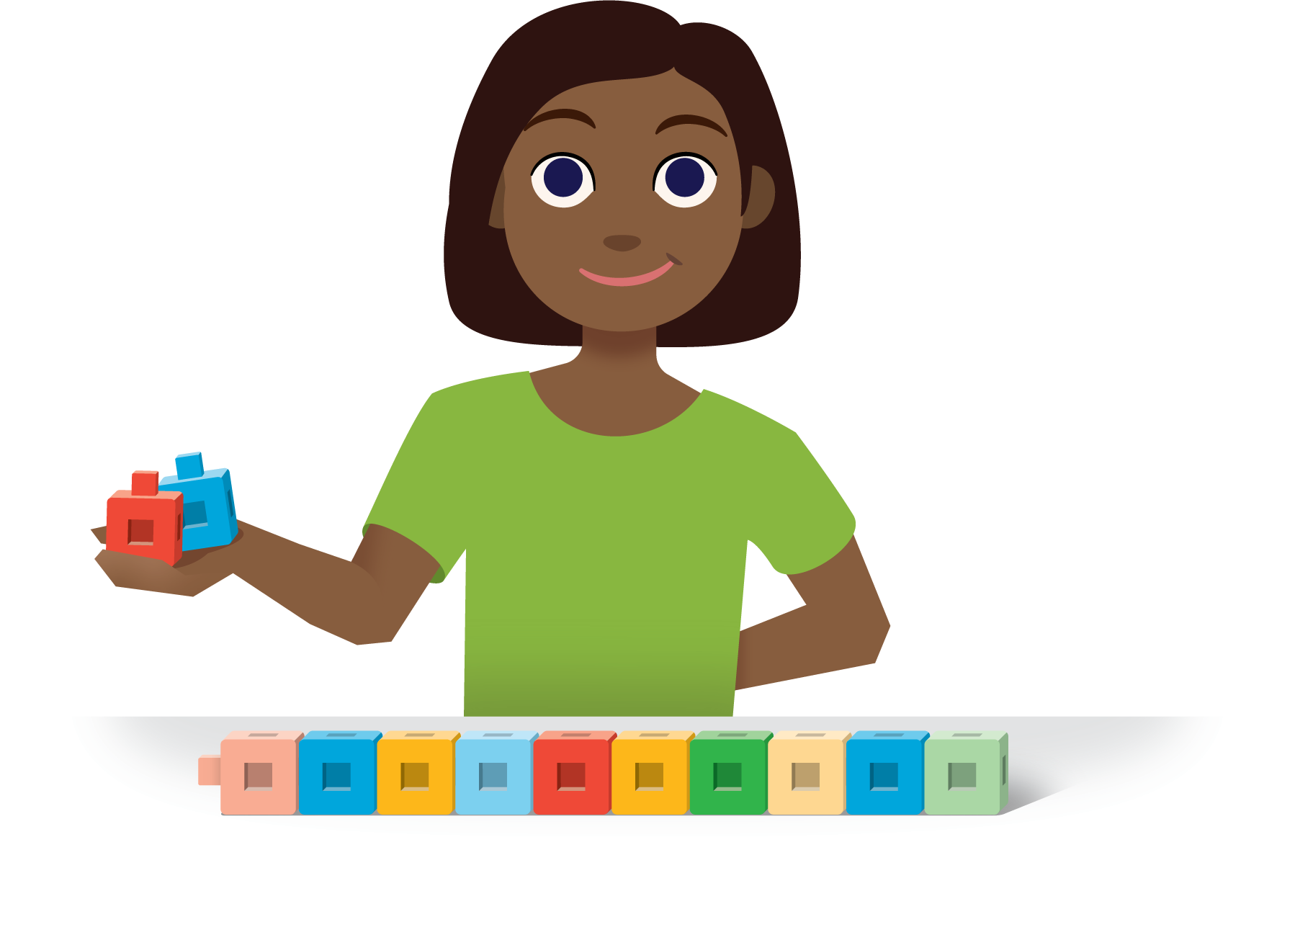
© CC BY 2021 Illustrative Mathematics®

