Lesson 5: Measure with Connecting Cubes
- Let’s use connecting cubes to measure length.

Warm-up: Notice and Wonder: Measure a Pencil
What do you notice?
What do you wonder?
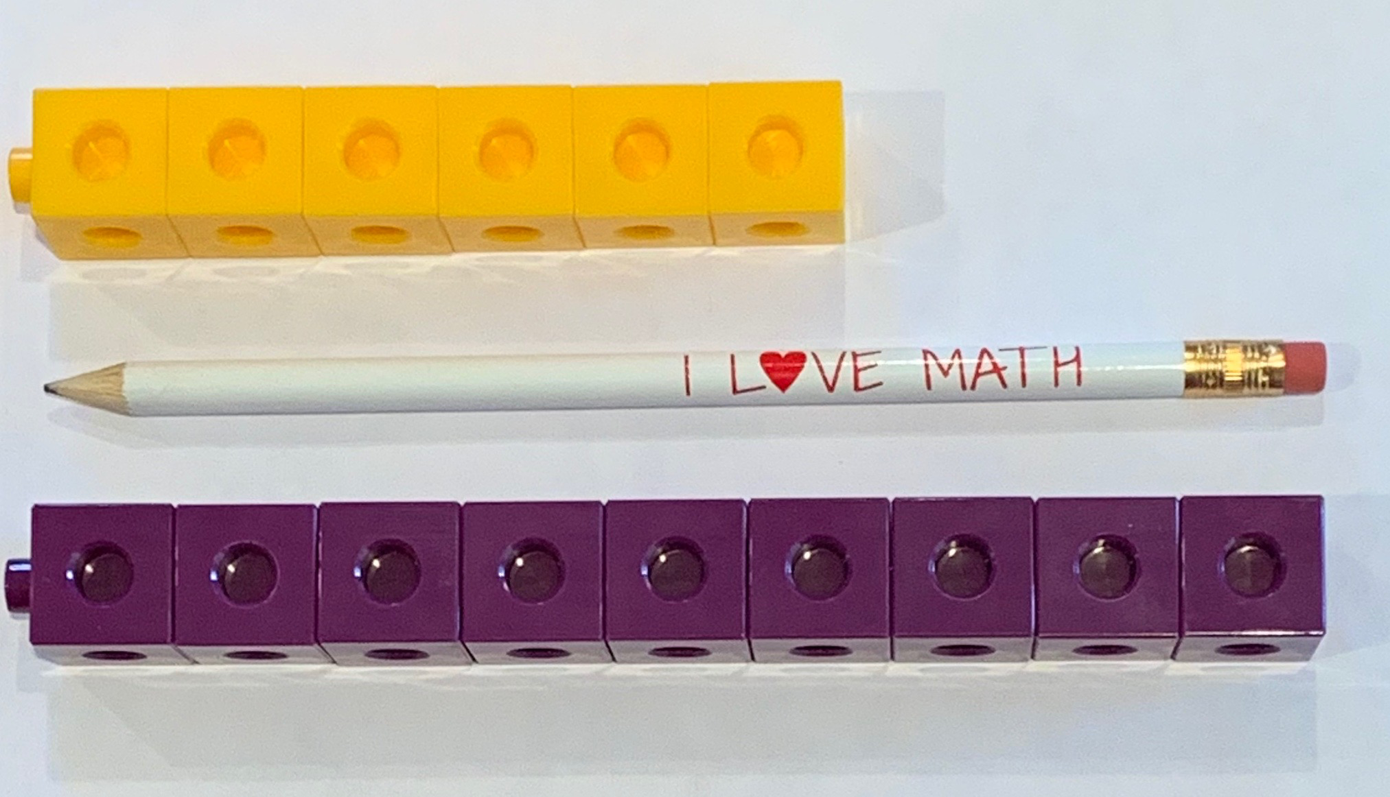

5.3: Centers: Choice Time
Choose a center.
How Close?
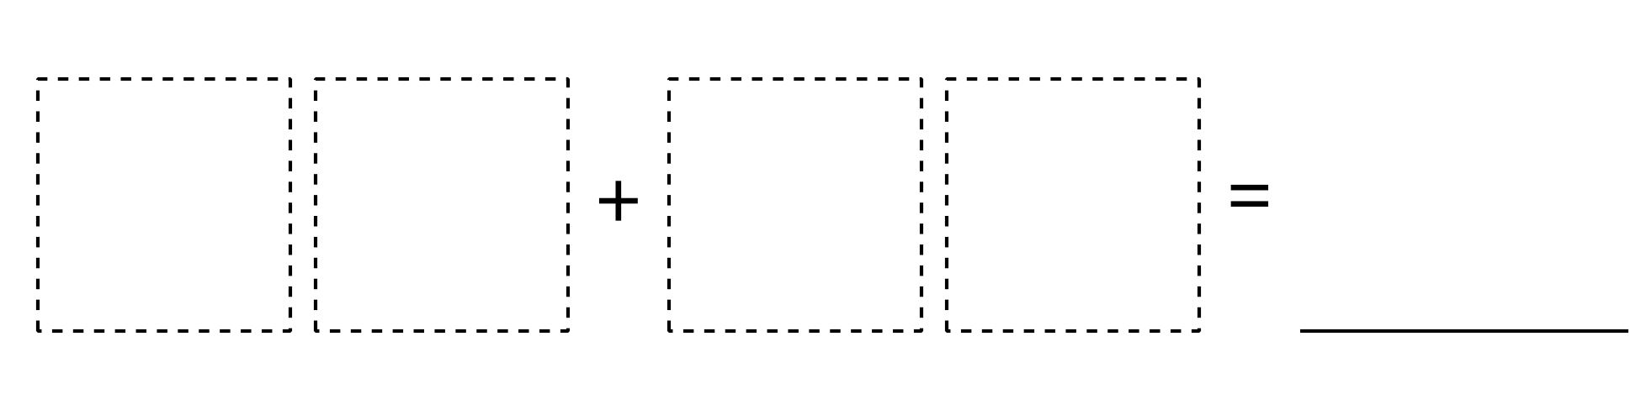
Target Numbers
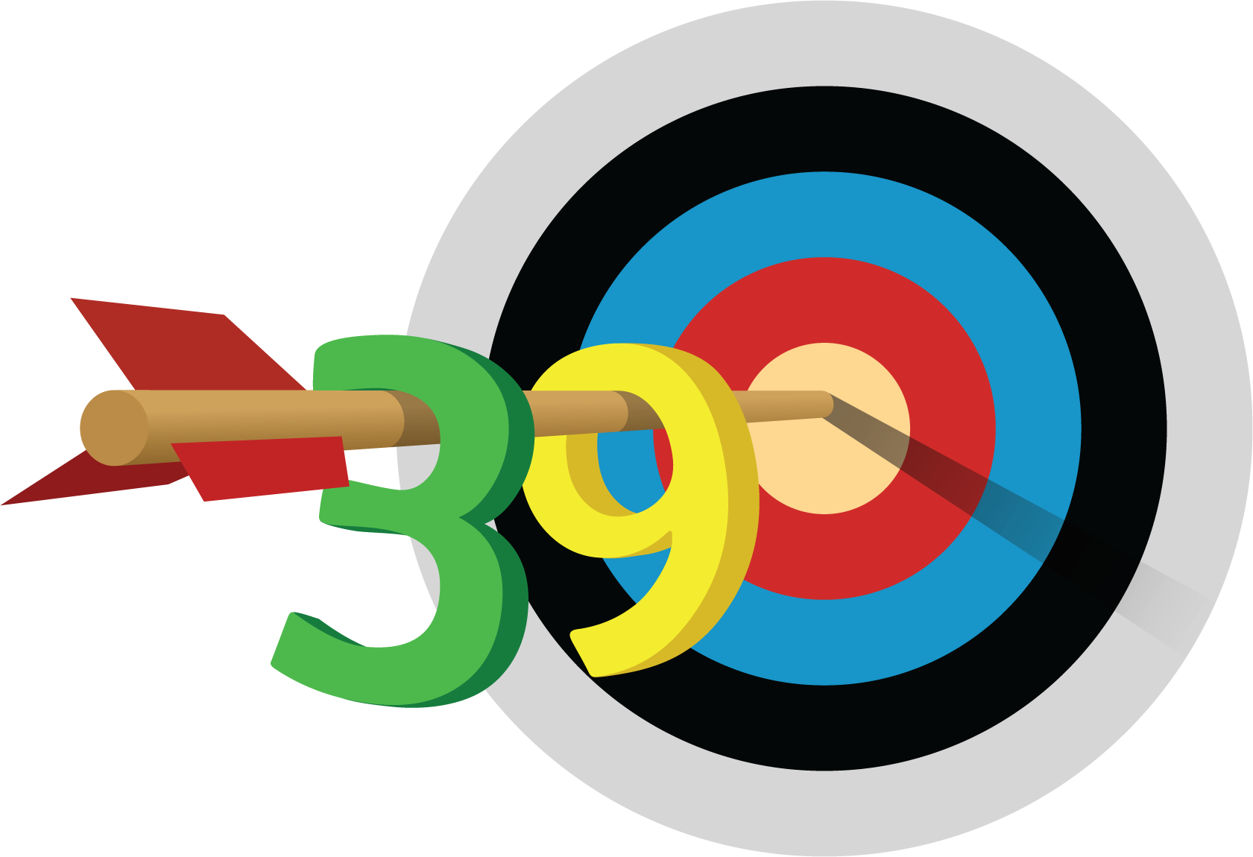
Five in a Row
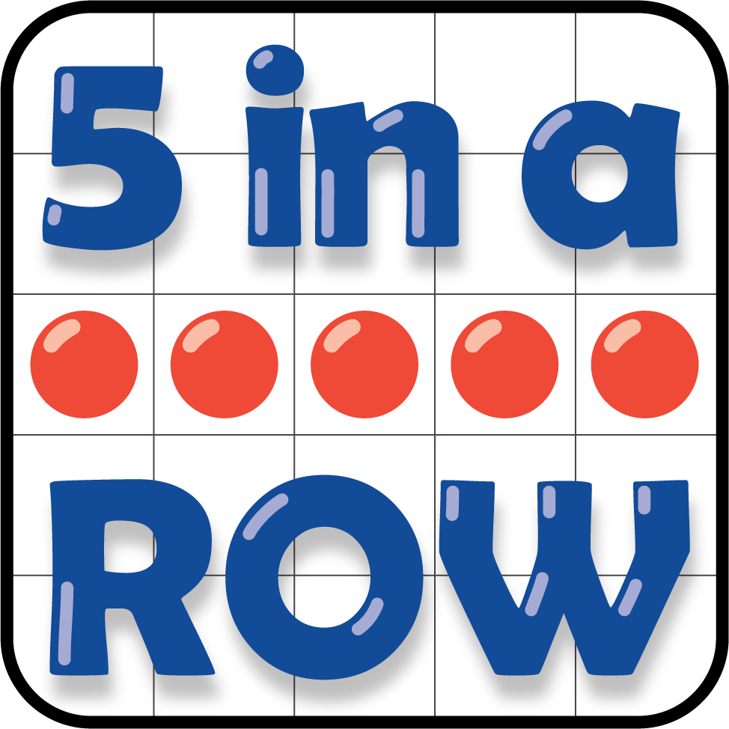
© CC BY 2021 Illustrative Mathematics®

