Unit 4 Lesson 3: Using Function Notation

1 Which One Doesn’t Belong: Function Notation (Warm up)

Student Task Statement
Which one doesn’t belong?
- $f(0)=2$
- $(0,5)$
- $y=x+2$
- 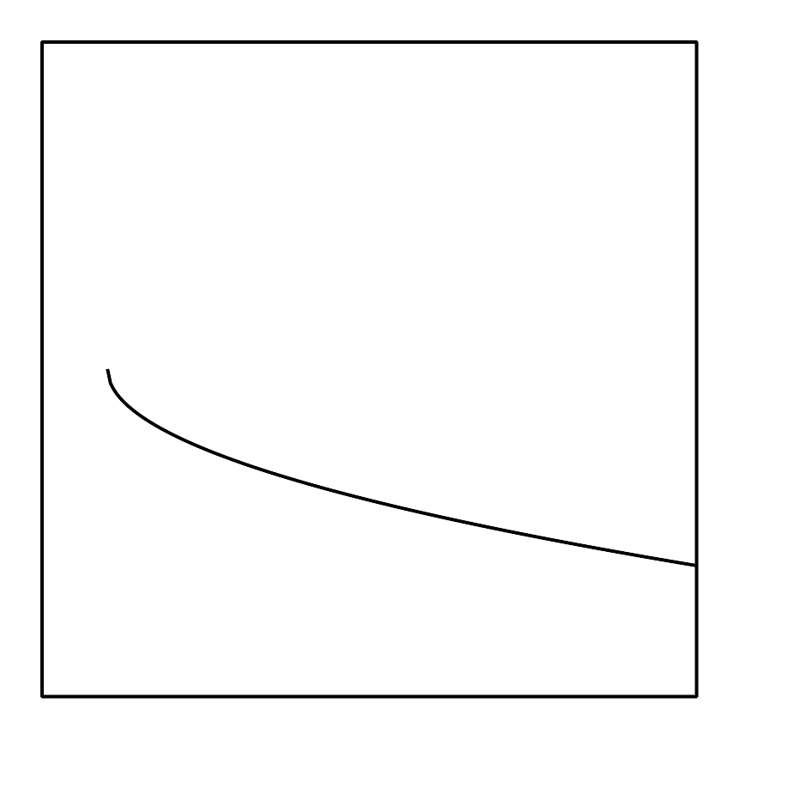

2 Points into Function Notation and Back

Student Task Statement
- A function is given by the equation $y=f(x)$. Write each of these coordinate pairs in function notation.
  - $(2,3)$
  - $(\text{-}1,4)$
  - $(0,3)$
  - $(4,0)$
  - $\left(\frac{2}{3},\frac{3}{4}\right)$
- A function is given by the equation $h(x)=5x−3$. Write the coordinate pair for the point associated with the given values in function notation.
  - $h(3)$
  - $h(\text{-}4)$
  - $h\left(\frac{2}{5}\right)$

3 A Graph with Properties

Student Task Statement
- Draw a graph of function $y=g(x)$ that has these properties:
  - $g(0)=2$
  - $g(1)=3$
  - $(2,3)$ is on the graph
  - $g(5)=\text{-}1$
- 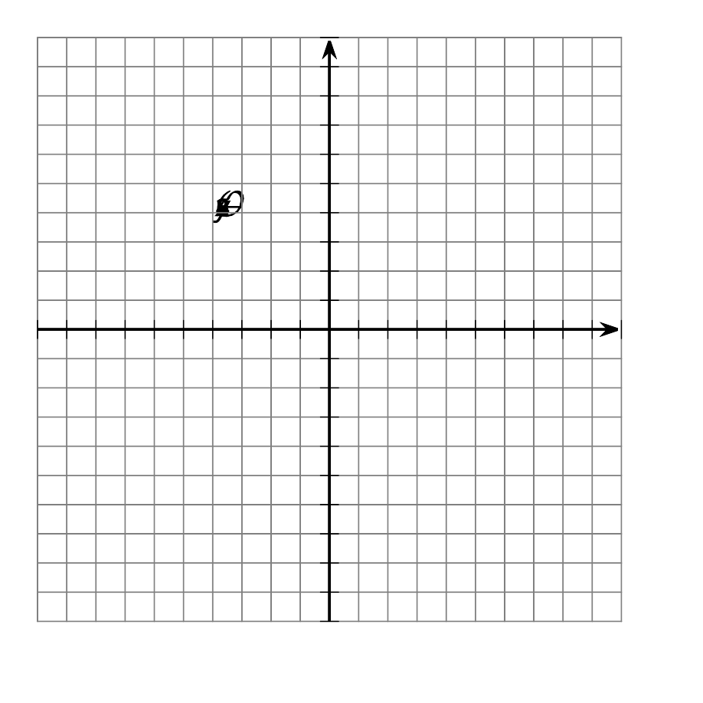
- Han draws this graph for $g(x)$. What is the error?
- 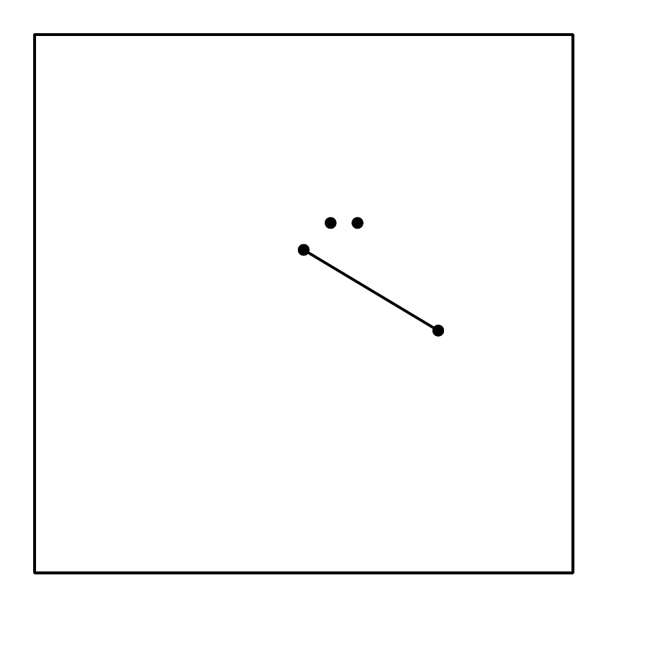

Activity Synthesis
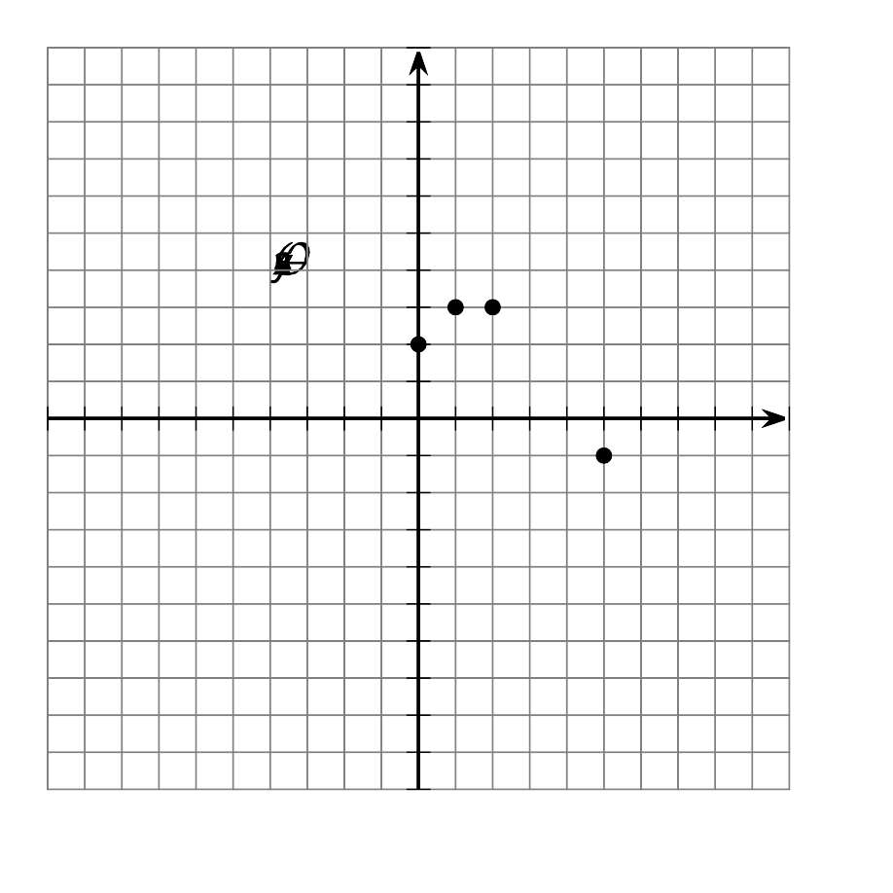
© CC BY 2019 by Illustrative Mathematics®

